Sodium Lamp  “Pass the Sodium” “…Please!” “Dang! Salty or nah?!”  What is Sodium?  - It’s an element on the periodic Table, represented by the Chemical Symbol Na  - Sodium is an element within what most know as table salt  - Sodium is actually deadly poisonous to humans when consumed by itself and can ignite when in contact with WATER! |  |  | Who We Are  About Us  Iyawo Ogun Esugbola Oyagbile  Black Body Khemistry  Due Date: 3/12/15  References:  http://education.jlab.org/itselemental/ele011.html  http://www.nlm.nih.gov/medlineplus/ency/article/002415.htm  Sodium  (6) |  |  | Sodium  - Sodium, the best element on the table! (Oh yes we did! Don’t be Salty!)
(2) (1)
Where is the word “Sodium” from?  It comes from the English Word “soda” and from the Medieval Latin word “sodanum” which means “headache remedy”.  So what’s it used for?  The Earth uses it to compromise over 26% of its crust.  It is used in the processing of titanium, sodium peroxide, sodium cyanide, and sodium hydride.  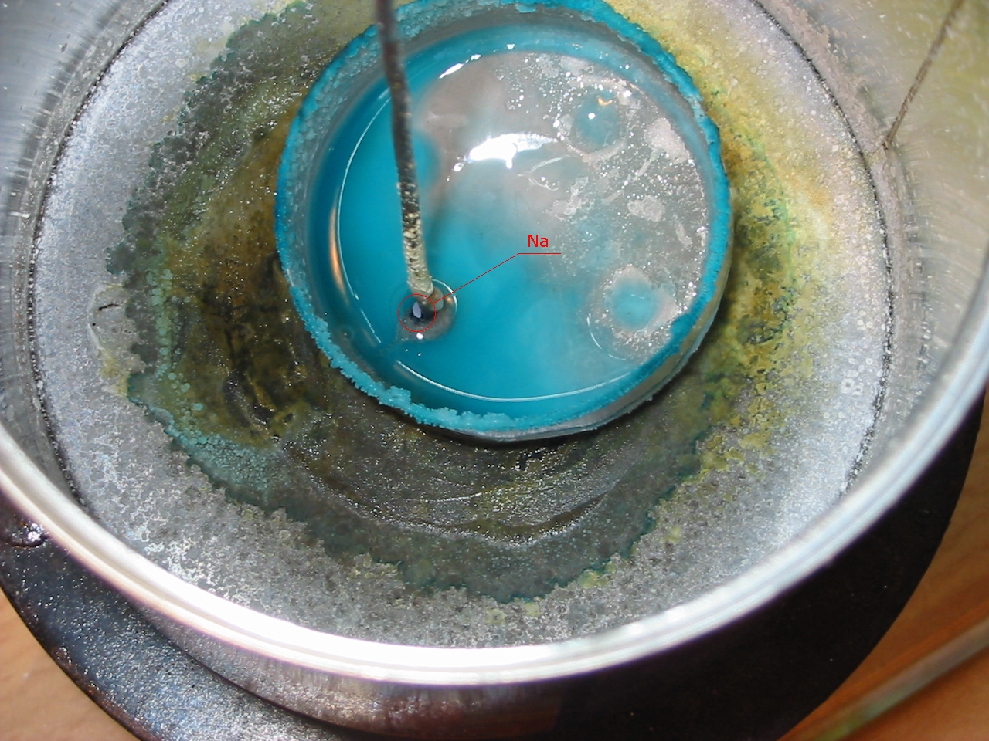  Sodium helps form Baking Soda’s chemical compound.  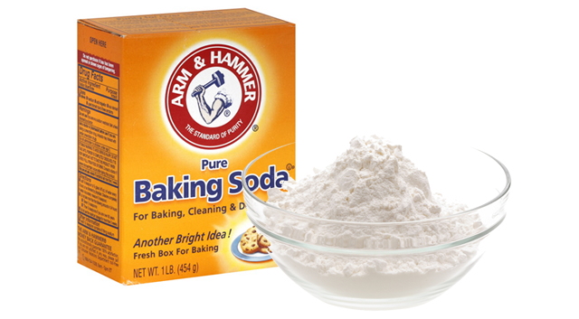 |  |  | Atomic Model and Periodic Table Square  P = 11  N= 12  ¹¹ Na  Sodium  22.990 |  |  | How Else do we use Sodium?  Table Salt  Sodium Vapor used to make yellow lights in streetlights.  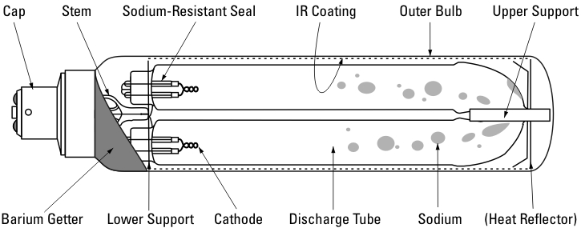  Caustic Soda  