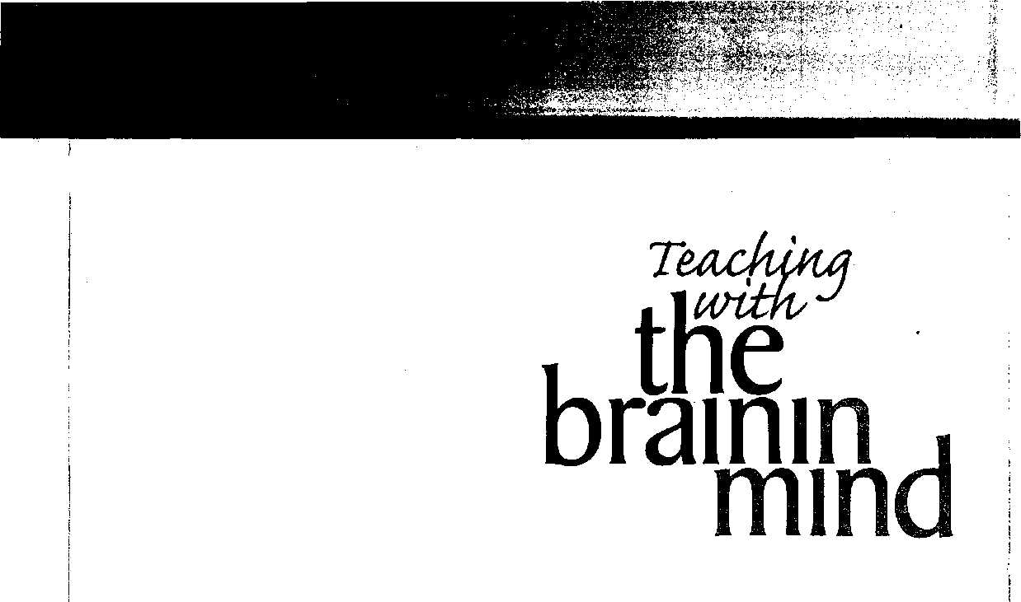

Eric Jensen
j
j
£
1
1:
j
i
Association For Supervision and Curriculum Development
Alexandria, Virginia USA

Association for Supervision and Curriculum Development j
1703 N. Beauregard St. •'Alexandria, VA 22311-1714 USA : 1
Telephone: 1-800-933-2723 or 703-578-9600 • Fax: 703-575-5400 ,
Web site: http://www.ascd.org • E-mail: member@ascd.org
|
Gene R. Carter, Executive Director '
Michelle Terry, Assistant Executive Director, Program Development j
Nancy Modrak, Director, Publishing j
John O’Neil, Acquisitions Editor J
Mark Goldberg, Development Editor j
Julie Houtz, Managing Editor oj Books j
Jo Ann kick Jones, Senior Associate Editor j
Ren£ Bahrenfuss, Copy Editor \
Stephanie justen, Proofreader j
Charles D. Halverson, Project Assistant
Gary Bloom, Director, Editorial, Design, and Production Services
Karen Monaco, Senior Designer
Tracey A. Smith, Production Manager
Dina Murray, Production Coordinator
John Franklin, Production Coordinator
Barton, Matheson, Willse & Worthington, Desktop Publisher
Copyright © 1998 by the Association for Supervision and Curriculum Development.
Alt rights reserved, No part of this publication may be reproduced or transmitted in any form or by any means, electronic or mechanical, including photocopy, recording, or any information storage and retrieval system, without permission from ASCD.
Figures 1.1, 1.2, 2.1, and 2.4 are LifeArt Images copyrighted © 1989-97 by Tech- .
pool Studios, Inc,, USA (in Cleveland, Ohio). Figures 2.6, 3.1, 6.1, 8.4, 9,2, and 11.1 are LifeArt Images adapted by Eric Jensen. These 10 figures may not be reproduced in any form without the consent of LifeArt Images. All other figures are by Eric Jensen. Readers who wish to duplicate material copyrighted by ASCD may do so for a small fee by contacting the Copyright Clearance Center, 222 Rosewood Dr.,
Danvers, MA 01923, USA (-telephone: 978-750-8400; fax: 978-750-4470). ASCD has authorized the CCC to collect such fees on its behalf. Requests to reprint rather than photocopy should be directed to ASCD’s permissions office at 703-578-9600.
ASCD publications present a variety of viewpoints. The views expressed or implied
in this book should not be interpreted as official positions of the Association. ,
Printed in the United States of America.
April 1998 member book (per). ASCD Premium, Comprehensive, and Regular members periodically receive ASCD books as part of their membership benefits.
No. FY98-6.
ASCD Stock No.: 198019
ASCD member price: $17,95 nonmember price: $21.95 Library of Congress Cataloging-in-Publication Data
Jensen, Eric.
Teaching with the brain in mind / Eric Jensen, p. cm.
Includes bibliographical references and index.
ISBN 0-87120-299-9 (pbk.)
1. Learning, Psychology of. 2. Teaching—Psychological aspects.
3. Brain. I, Title.
LB1060J46 1998
370.15823—dc21 97-45424
CIP

02 01
876

Dedication
To my colleagues in the brain-compatible movement; Renate and Geoffrey Caine, Jane Healy,
Leslie Hart, Susan Kovalik, David Sousa, Robert Sylwester, and Pat Wolfe. Also thank-you’s to William Greenough, Dolly Lambdin, Larry Squire, Pamela Moses, Katherine Roe, and Norman Weinberger for their technical review. Much gratitude to Ron Brandt for his commitment to this topic. Appreciation to Karen Markowitz for her research and editorial contributions and to Mark Goldberg for his support and editing. And many thanks to my wife Diane for her priceless support.

Teaching with the Brain in Mind

H'
t
Dedication iii
Introduction vii
1. The New Winds of Change i
retrieval. Making learning last.
Postscript 113
Glossary of Brain Terms 115
Bibliography 119
Follow-Up Resources 126
Index 127
About the Author 133
Background and theory update on brain research. The state and direction of research today Tools for learning about the brain. How to interpret the new brain research.
- The Learning Brain 7
Brain basics: size, content, lobes, and basic operations.
Key vocabulary. What is built in and what’s not? How we actually learn and remember.
- Getting Students Ready to Learn 17
The developing brain. Getting students ready for school. Emotional readiness, Motor skill readiness.
The role of threat, sleep, and nutrition. How we can influence parents.
- Enriched Environments and the Brain 29
How enrichment affects the brain. Two conditions for enrichment: challenge and feedback. The role of language, motor activity, music, and the arts. What really builds better brains?
- Getting the Brain’s Attention 41
The biology of attention. Getting attention but not keeping it. The brain’s high- and low-attention cycles.
An ADD/ADHD update. Implications.for classroom discipline,
- How Threats and Stress Affect Learning 52
What is stressful to the brain? How does stress affect students? How threats affect learning. What is learned helplessness? Reducing the impact of stress and threat.
- Motivation and Rewards 62
What's the new research on motivation? What causes temporary demotivation? What does brain research tell us about rewards? How can we boost intrinsic motivation?
- Emotions and Learning 71
The role of emotions in the thinking and learning process. Why use the more emotionally laced learning? Differences between emotions and feelings. Specific strategies for emotional engagement.
- Movement and Learning 82
The mind-body link. What does research say about the links between movement and cognition? Physical states; how does our body actually learn? The specific roles for movement, the arts, and physical education. Why movement makes sense.
- The Brain as a Meaning-Maker 90
The natural mechanisms of making meaning. Three ingredients for optimal learning. How to encourage these ingredients,
- Memory and Recall 99
Why don’t students remember more? Exploding the memory myths. How to use the brain's best systems for

i

Introduction
I first discovered the concept of “brain-compatible learning” during a business development workshop facilitated by Marshall Thurber, a futurist and entrepreneur, in June 1980. The impact was so powerful that even today, almost two decades later, I can fill the page of a flip chart with ideas I remember (and still use!). Without a doubt, both the content and process of that day were deeply embedded in my brain. The presenters clearly understood—and knew how to use-important principles about learning and the brain.
After that day, I became so enthusiastic (some would say a zealot) that 1 decided to share my excitement with others. Because I was teaching, my first response was, “Why don’t my own students have this kind of learning experience every day?” The question was both humbling and promising.
I decided to use this newfound brain/leaming connection. I cofounded an experimental, cutting- edge academic program in San Diego, California, called SuperCamp. Our purpose was to use the latest research on the brain to empower teens with life skills and learning tools. We held our first session in August 1982. It was an immediate success, and we offered it in other states and countries. We
VIII

were flooded with media attention and soon found ourselves in USA Today and The Wail Street Journal. later, we appeared on CNN and “Good Morning America."
Long-term follow-up research validated that the benefits of our program lasted years after the 10-day program itself (DePorter and Hemacki 1992, p. 19). Students’ grades and school participation went up, and the students reported greater self-confidence. The experiment we began years ago is now an international fixture with more than 20,000 graduates. Today it’s still growing and based in Oceanside, California.
I have seen, felt, and heard firsthand the difference brain-compatible learning makes. Students of all backgrounds and ages, with every imaginable history of failure, and with lifelong discouraged attitudes can and have succeeded with this approach. While brain-compatible learning is not a panacea, it does provide some important guidance as we move into the 21st century. Programs that are compatible with the way humans naturally learn will stand the test of time. The principles of brain-compatible learning will flourish when many other fad-like educational programs have long faded from memory.

t

The New Winds of Change

Key Concepts
I Background and theory update on brain research

We are on the verge of a revolution: the application of important new brain research to teaching and learning. This revolution will change school start times, discipline policies, assessment methods, teaching strategies, budget priorities, classroom environments, use of technology, and even the way we think of the arts and physical education. But before we consider the practical applications of this research, we must have a useful model for deciphering it.
I The state and direction of research today
I Tools for learning about the brain
} How to interpret the new brain research

Models of Education
The educational model that dominated much of human history was uncomplicated. If you wanted to learn about something, you became an apprentice to someone who possessed skills or knowledge in that area. The path was simple: find people who knew more than you and learn from them. This worked for peasants and royalty, parents and children, blacksmiths and monks.
The Industrial Revolution changed this path. A new model soon emerged with the notion that you could bring everyone together in a single place and offer a standardized, “conveyor belt” curriculum.

2

This paradigm of schooling was developed in the 1800s and popularized throughout most of the 20th century. Often called the “factory model,” it drew from fields of sociology business, and religion. It emphasized useful skills like obedience, orderliness, unity, and respect for authority.
A peculiar twist to this paradigm emerged during the 1950s and 1960s. In those decades, the dominant theory of human behavior was influenced by the doctrines of psychologists John Watson and B,F. Skinner. Their behaviorist theories went something like this: “We may not know what goes on inside the brain, but we can certainly see what happens on the outside. Let’s measure behaviors and learn to modify them with behavior reinforcers. If we like it, reward it. If we don't, punish it.” Considering what we knew about the brain at that time, this approach made some sense.
Recently, a new paradigm began emerging. History will likely record that it began in the final two decades of the 20th century. Technology paved the way for this paradigm shift; it changed the way we think, live, and learn. In the 1970s, 1980s, and 1990s, phrases like “super learning” and “accelerated learning" became mainstream as the Information Age blossomed. “Brain scanners” like Magnetic Resonance Imaging (MRl) and Positron ' Emission Tomography (PET) gave us new ways to understand and see inside the brain. For the first time in history, we could analyze the brain while its owner was still alive. A new breed of “inner science” developed: neuroscience, which is an exciting interdisciplinary approach to questions about the brain.
In 1969, 500 neuroscientists were registered in the International Society of Neuroscience. Today more than 30,000 are members. A bonanza of neuroscience discoveries now reveals astonishing
insights about the brain and learning. Schizophrenia and Tourette’s syndrome can be treated with medication. We are closing in on the causes of Parkinson’s and Alzheimer’s diseases. The ability to walk again after a spinal cord injury is becoming a very real possibility A memory pill, Nimodipine, helps students better recall what they read. We now know the biological roots of impulsive and violent classroom behavior. Many of our conventional educational beliefs are being shattered like glass.
How Do We Learn About the Brain?
We are learning about the brain at an unprecedented rate. Jen Janowsky, a top learning and memory neuroscientist at Oregon Health Sciences University in Portland, says, “Anything you learned two years ago is already old information. . . . Neuroscience is exploding” (Kotulak 1996, p. 124). In the coming years, we can expect new and more accurate technologies to further illuminate the brain’s mysteries. For now, the following are the “workhorses” of neuroscience.

Brain Imaging Devices
Magnetic Resonance Imaging (MRI) machines provide high-quality cross-sectional images of soft tissue like the brain without X-rays or radiation. This tool has two new variations. Functional MRl (fMRI) is a lower budget variation, cheaper, and much faster. Another is NMRI (Nuclear Magnetic Resonance Imagery), which is 30,000 times faster and captures an image every 50 milliseconds. That speed allows us, foT example, to measure the sequence of thinking across very narrow areas of the brain (see fig. 1.1).

Brain Imaging Technology

3
(Includes PET, fMRI, and CAT scars)
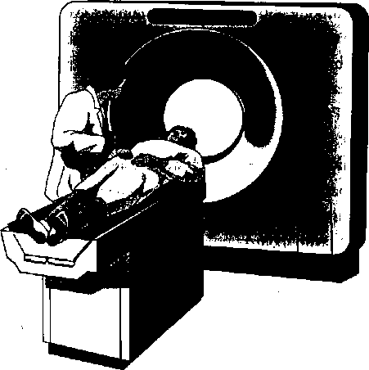
Copyright © 1989-97 by Techpool Studios, Inc., USA.

Animals
Lab experiments with rats, dogs, cats, slugs, apes, and other animals provide a rich source of information about how similar brains work. For example, we have learned much about the role of enriched environments from studying rat brains.

Computerized Electrodes
The electroencephalogram (EEG) gives us readings about the electrical output of the brain. Magnetoencephalography (MEG) uses high-tech sensors that are super-cooled, liquid-helium, and superconductive to locate faint magnetic fields that are generated by the brain’s neural networks. They’ve been used to detect brainwave patterns and abnormal cerebral functions such as seizures or dementia. These tools also can help us track, for example,
how much brain activity occurs during problem solving (see fig. 1.2).

Clinical Studies
We can learn much using human volunteers, often from university psychology classes. For example, flashing slides at high speeds can tell us about reaction times of the visual system. We’ve learned a great deal about what is “nature” and what is “nurture” from studies of twins.

PET
Positron Emission Tomography (PET) is an imaging device. The process of PET begins when a sub-

Common Electrode Placements for EEG
(Electroencephalogram)
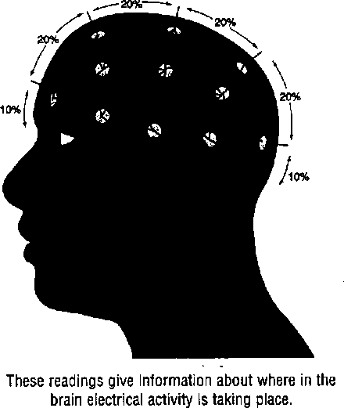
Copyright © 1989—97 by Techpool Studios, Inc., USA.

ject drinks some “spiked water” (O¹⁵) or radioactive glucose. Then the PET reads the amount of radioactive substances released when certain areas of the brain consume glucose. If you were reading, for example, it would show glucose activity in the temporal and parietal lobes, with some in the occipital. (For a brief definition of any unfamiliar terms not defined in the text, please refer to the glossary on page 115.) A new variation on this tool, developed at the University of California at Los Angeles (UCLA), uses radioactive probes to hone in on genes specially “tagged” by researchers.

4

Autopsies
Weight, stages of development, and amount of decay or lesions can all be observed or measured by a neurological pathologist. Using autopsies, UCLA neuroscientist Bob Jacobs discovered that students with more challenging and demanding school lives had more dendritic branching than those who didn't. In other words, their brains had physically changed and were more enriched and complex.

Spectrometers
Ignored for decades, spectrometers are fast on the rise. These devices measure the specifics of brain chemicals, or neurotransmitters, as an activity occurs. For example, if I’m feeling depressed, it can tell me if there’s been a change in the levels of specific neurotransmitters in my frontal lobes,
The Knowledge Explosion
During the ’90s, brain research exploded into dozens of subdisciplines. Seemingly unrelated
fields like genetics, physics, and pharmacology were seamlessly woven into scientific journal articles on the brain. Drawing from a body of technical knowledge about the brain, a whole new way of thinking about the organ developed. While we don’t yet have an inclusive, coherent model of how the brain works, we do know enough to make significant changes in how we teach.
Primitive models on the workings of the brain have been around for 2,000 years. The brain has been referred to as a hydraulic system (the Greco- Roman model), a fluid system (Renaissance), an enchanted loom (the early Industrial Revolution), a city’s switchboard (early to mid-1900s), and a computer (1950-1980s). Brain theory of the 1970s told us that we just needed more right-brained learning, Later, educators were introduced to the triune brain theory. This three-part evolutionary schema told us survival learning was in the lower brain, emotions were in the mid-brain, and higher- order thinking in the upper brain area. This model, first introduced in 1952, and popularized during the ’70s and ’80s, is now outdated. Today’s educators should embrace a more complex “whole- systems approach” to understanding the brain. Much of this book will provide a more sound biological footing for this new interdisciplinary model grounded in brain research.
Before the “Decade of the Brain” ends, the ’90s may be remembered as the emergence of the “chemical learner.” Those with just the right “brain chemicals” (more or less serotonin, dopamine, or other related compounds) will succeed while those whose chemistry is not quite right will be inattentive, unmotivated, or violent. Brain-altering medications, mind food, and smart drugs already contribute to a billion-dollar, worldwide industry, and

5

they may soon become the rule of the day. We see kids on Ritalin, dads on Prozac, and moms on Provera. Grandmothers are taking estrogen supplements to reduce the effects of Alzheimer’s, and grandfathers are taking GM1 (ganglioside) or GDNF (glial-derived growth factor) to combat Parkinson’s. It’s a brave, new world, indeed.
Interpreting Brain Research
The military has a system for coding the level of certainty about surveillance information. At the weakest or lowest level you have unreliable sources, outdated information, and a lack of alternative confirming sources. At the other end of the spectrum is “high confidence." This means you have reliable original sources, fresh confirming sources, a variety of quality data gathering, and personal verification of data, perhaps even eyewitnesses.
Figure 1.3 demonstrates a similar classification system for interpreting brain research. At the lowest level of confidence, Level 1, is simple theory. There’s nothing wrong with theory, as long as you recognize it for what it is, Level 2 means some discovery or experiment has illuminated the theory.
It’s better than Level 1, but it has a way to go. As a Level 2 example, consider neuroscientist Daniel Schacter’s discovery that the brain stores real-life experiences differently than it does a fabricated story (1996). In medical experiments, PET scans revealed a visible difference in the brain between telling the truth and fabricated stories. Additional research to determine potential applications for this finding is necessary.
A Level 3 of confidence comes through widespread, documented clinical trials. Usually done at universities, these studies give us moderate levels

How to Interpret Brain Research
These levels are listed from most to least reliable,
from top to bottom
Level 4: In-Context Applications
Done in schools or businesses, this documented
action research gives us testing results under
actual, real-life conditions.
Level 3: Clinical Studies
Usuaily university-supported, these studies are
best with multiple experimenters, large, diverse,
multi-age, multicultural populations
(double-blind is preferable).
Level 2: Laboratory Discovery
Could come from autopsies^ experiments,
fMRI, PET, or EEG scans.
Level 1: Brain/Learning Theory
Any theory about learning and the brain that
-explains recurring behaviors.
of confidence in the research. Level 4 confidence means that action research, by you or other colleagues, has confirmed that the idea works across the board, for most anyone, most anywhere, reflecting a high confidence in the method. Most of the strategies described in this book will be at the higher end confidence levels (3-4 range).
Unfolding brain research is both exciting and full of pitfalls. The implications can be exhilarating, but it’s just as important to consider the pit- falls. For example, educators can apply only a small percentage of brain research. Much of it is
highly esoteric or disease oriented. Also, brain . research doesn’t necessarily “prove” anything. It merely suggests ideas or paths that have a higher probability of success. Nevertheless, a great deal of action research is necessary to advance our thinking. More important, we must not expect neuroscientists to present us with the “holy grail” to learning. Most paradigm-shaking breakthroughs have been an outside-the-box multidisciplinary insight.
While that news is old hat for some, it’s a discouraging revelation for others. In fact, a great deal of what’s useful and what’s not will be uncovered by thoughtful educators like yourself who seriously turn to action research. We need more action research—not academic. As Frank Vellutino of the State University of New York at Albany observes, “We do more educational research than anyone else in the world, and we ignore more of it as well” (in Hancock 1996, p. 58).
Practical Suggestions
What’s an educator to do with all this information? Three steps are indicated. First, become “consumer literate” in the field of brain research. Learn the major terms and the sources of research; decide who’s credible and who isn’t. Second, we need more action research, not learning theories. Begin in your own workplace. Start small and keep track of your results. Third, take this information to the public. Let your students in on what you’re doing. Talk to parents about the brain, and make sure other staff members know about the information,
too. Get or give administrative backing. This helps generate the long-term resources and support needed for transformation.
Let’s not jump to embrace any idea just because someone, somewhere has labeled it as “brain compatible.” We all want solutions to educational challenges, but we must be careful about how we apply new discoveries. We’ve already gone through this in many areas. Howard Gardner’s Theory of Multiple Intelligences has been used as “proof” for all kinds of things that he never proposed, said, or implied.
Your own questions ought to be, “From where did this idea originate? Is it still just theory?
Where’s the research on it?” You’ll want to know, “What was the scientific discovery that illuminated the theory? What clinical trials have been done? Is there any evidence of successful applications in the classroom?” If you can get answers that satisfy you, then you are ahead of the "bandwagon” of educators who are still looking for some magic pill to solve their problems. The more you understand, the better you’ll be able to decide what is and is not truly brain compatible.
Expect this book to help you sort the theories from the facts and the discoveries from the well- designed clinical trials. Use it as a study guide. Brain- compatible learning is here to stay You can bet it will affect nearly everything we do including teaching strategies, discipline policies, the arts, special education, curriculum, technology, bilingual programs, music, learning environments, staff development, assessment, and even organizational change.
i;
:!
fi
fe

6
r

The Learning Brain

Key Concepts
I Brain basics: size, content, lobes, and basic operations
I
f you wanted to get your car fixed, you’d likely go to a mechanic. For legal help, you’d find an attorney To understand the brain and how we learn, would you go to a teacher? Probably not. Yet every year, millions of parents trust that the professionals who teach their children know something about the brain and processes of learning.
In defense of teachers, even neuroscientists still disagree on some of the inner workings of the brain. Most schools of education offer psychology, not neurology courses. And these psychology courses, at best, provide indirect information about how children learn. Inservice training is directed at symptoms of problems not a working knowledge of the brain. Popular articles rarely offer the depth or point of view that today’s educator needs.
Can we summarize the basics of how our brain learns? That’s the goal of this chapter. Questions about the brain remain, but we know enough to help educators do a better job. By understanding how the brain learns, we can better allocate educational resources. Not only will we save money, but, more important, we will improve our successes with children.
I Key vocabulary
I What is built In and what's not?
I How wa actually loam and remember

8

The Human Brain
The adult human brain weighs about 3 pounds (1300-1400 grams). By comparison, a sperm whale brain weighs about 7800 grams, or 17 pounds! A dolphin brain weighs about 4 pounds and a gorilla brain about 1 pound. Your dog’s brain weighs about 72 grams, which is only about 6 percent of your own brain’s total weight.
Humans have large brains relative to body weight. Close to the size of a large grapefruit or cantaloupe, it's mostly water (78 percent), fat (10 percent), and protein (8 percent). A living brain is so soft it can be cut with a butter knife.
From the outside, the brain’s most distinguishing features are its convolutions, or folds. These wrinkles are part of the cerebral cortex (Latin for “bark” or “rind"). The cerebral cortex is the orange- peel thick outer covering of the brain. The folds allow the covering to maximize surface area (more cells per square inch). In fact, if it were laid out, the cortex would be about the size of an unfolded single page from a daily newspaper. Yet it is only a grapefruit-sized organ. Its importance can be attributed to the fact that it makes up critical portions of the nervous system, and its nerve cells are connected by nearly 1 million miles of nerve fibers. The human brain has the largest area of uncommitted cortex (no specific function identified so far) of any species on earth (Howard 1994). This gives humans extraordinary flexibility for learning,
Taking Sides in Learning
We have two cerebral hemispheres, the left and the right. They are connected by-bundles of nerve
fibers, the largest known as the corpus callosum. The corpus callosum has about 250 million nerve fibers. Patients in whom it has been severed can still function in society. This interhemispheric freeway allows each side of the brain to exchange information more freely. While each side of the brain processes things differently, some earlier assumptions about the left and right brain are outdated.
In general, the left hemisphere processes things more in parts and sequentially. But musicians process music in their left hemisphere, not right as a novice would. Among left-handers, almost half use their right hemisphere for language. Higher-level mathematicians, problem solvers, and chess players have more right hemisphere activation during these tasks, while beginners in those activities usually are left-hemisphere active. For right-handers, gross motor function is controlled by the right hemisphere while fine motor is usually more of a left hemisphere activity The right hemisphere recognizes negative emotions faster; the left hemisphere notices positive emotions faster (Omstein and Sobel 1987). Studies indicate the left hemisphere is more active when we experience positive emotions. The importance of this information will become evident later in the book. But for now suffice it to say that the old biases about music and arts being “right-brained frills” are outdated (see fig. 2,1).
Scientists divide the brain into four areas called lobes, as illustrated in Figure 2.2. They are occipital, frontal, parietal, and temporal. The occipital lobe is in the middle back of the brain.
It’s primarily responsible for vision. The frontal lobe is the area around your forehead. It’s involved with purposeful acts like judgment, creativity, problem solving, and planning. The parietal lobe is

9

Key Functional Areas of the Brain
Lobes of the Brain

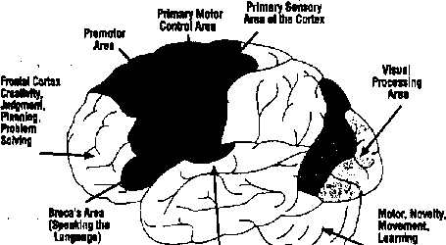
vtmrn'tfm \ \
(Language \ \
Comprehension)

Copyright © 1989-97 by Techpool Studios, Inc., USA.
on the top back area. Its duties include processing higher sensory and language functions. The temporal lobes (left and right side) are above and around the ears. This area is primarily responsible for hearing, memory, meaning, and language.
There is some overlap in the functions of the lobes.
The territory in the middle of the brain includes the hippocampus, thalamus, hypothalamus, and amygdala (see fig. 2.3). This mid-brain area (also known as the limbic system) represents 20 percent of the brain by volume, and is responsible for emotions, sleep, attention, body regulation, hormones, sexuality, smell, and production of most of the brain’s chemicals. However, others say there is no “limbic’¹ system, only specific structures that process emotion, like the amygdala (LeDoux 1996 pp. 97—100). Still others, like Paul MacLean, disagree and still call the middle of the brain “the limbic (or emotional) area” (1990). u The location of the brain area that allows you to know that you are “you” (consciousness) is dis
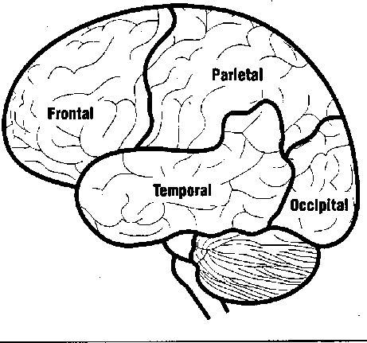

puted, It might be dispersed throughout the cortex, in the thalamus, or it may be located near the reticular formation atop the brain stem. Much of the cerebrum, which makes up 75 percent of the total volume, has no yet identified single purpose and is often referred to as the “association cortex.” Gray neurons or cell bodies form the cerebral cortex and other nuclei. The white in the brain is the myelin sheath that coats the connective fibers (axons).
The sensory cortex (monitoring your skin receptors) and the motor cortex (needed for movement) are narrow bands across the top middle of the brain. In the back lower area of the brain is the cerebellum (Latin for "little brain”), which is primarily responsible for balance, posture, motor movement, and some areas of cognition (see fig. 2.3). Recent experiments strongly support the con-

Medial View of the Brain

10
Corpus Callosum
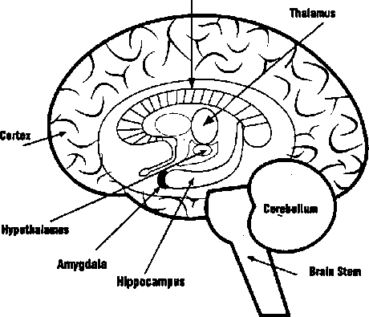

elusion that essential long-term memory traces for motor learning are located in the cerebellum (Thompson 1993).
Energy for Learning
The brain is energy inefficient. It is about 2 percent of the body’s adult weight, but it consumes about 20 percent of the body’s energy. How does the brain get its energy to leam? Its primary source is blood, which supplies nutrients like glucose, protein, trace elements, and oxygen. The brain gets about 8 gallons of blood each hour, about 198 gallons per day. In addition, water provides the electrolytic balance for proper functioning. The brain needs 8 to 12 glasses of water a day for optimal functioning. Dehydration is a common problem in school classrooms, leading to lethargy and impaired learning (Hannaford 1995). The role of nutrition will be
explored in the next chapter, but for the moment we can say that good diets do help learning.
Oxygen is, of course, critical to the brain. The brain uses one fifth of the body’s oxygen. If the blood supply to the brain is interrupted, we lose consciousness in seconds. Fortunately, the brain usually gets enough oxygen for basic functioning because the carotid artery ensures the brain gets freshly oxygenated blood first after leaving the heart-lung area. Higher levels of attention, mental functioning, and healing are linked to better quality air (less carbon dioxide, more oxygen). Many of the so-called "smart drugs" that boost alertness, cognitive functioning, and memory enhance oxygen flow to the brain. With only 36 percent of K-12 students in a daily physical education class, are they getting enough of the oxygen-rich blood needed for highest performance? Many worry that they are not.
Where Learning Begins
There are two kinds of brain cells: neurons and glia. While the majority of brain cells (90 percent) are glia, it is the remaining 10 percent—the neurons— are much better understood. The most studied brain cells are neurons (Greek for "bowstring’’). For the sake of comparison, a fruit fly has 100,000 neurons, a mouse has 5 million, and a monkey has 10 billion. You have about 100 billion neurons. A single cubic millimeter (1/16,000th of an inch) of brain tissue has more than 1 million neurons. They are about 50 microns in diameter. You lose your brain cells every day through attrition, decay, and disuse. Scientists differ on exactly how many; estimates vary from 10,000 to 100,000 per day (Howard 1994). You’ve got enough for your lifetime, though. Even if you lost a half million neurons per day, it would take centuries to, literally, lose your mind.

11

The most numerous of your brain’s cells are called intemeurons, or glial (Greek for “glue”). They have no cell body. You have about 1,000 billion of them. The role of glial cells may include formation of the blood-brain barrier, transport of nutrients, and regulation of the immune system. They also remove dead cells and give structural support that improves firmness (see fig. 2.4).
Though the brain contains fewer neurons, they are essential to performing the brain’s work. Neurons consist of a compact cell body, dendrites, and axons (see fig. 2.5). They are responsible for
information processing, and converting chemical and electrical signals back and forth. Two things are critical about a neuron when compared with other cells in the body. First, new research at Salk Institute in La Jolla, California, reveals that some areas of the brain can and do grow new neurons (Kempermann, Kuhn, and Gage 1997). Second, a normal functioning neuron is continuously firing, integrating, and generating information; it’s a virtual hotbed of activity,
Although the cell body has the capacity to
move, most adult neurons stay put; they simply

Common Types of Glial Cells
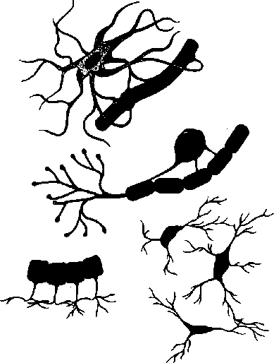

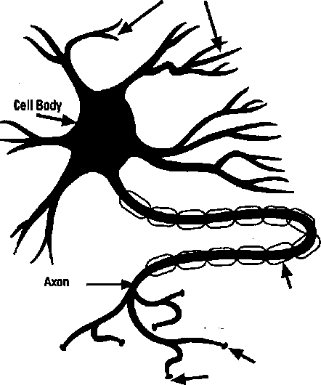
Glial are the most common cells in your brain, outnumbering neurons by a sizable 10-1 margin.
Brain Cells (Neurons)
Dendrites
Myelin Sheath
Axon Terminals
Copyright © 1989-97 by Techpool Studios, Inc., USA.

12
extend axons outward. While many dendrites, or fibers, may extend from a neuron, each has only one axon. The axon is a thinner, leg-like extension that connects with other dendrites. Most axons only connect with dendrites; normally, dendrites don’t connect with one another. To connect with thousands of other cells, the axon splits to subdivide itself and branches in two, over and over again. Neurons only serve to pass along information; none of them is just a receiver alone or the end of the connection. Information flows in one direction only; at the neuronal level, it’s always going from the cell body down the axonto the synapse. It never goes from the tip of the axon back up to a cell body.
The axon has two essential functions: to conduct information in the form of electrical stimulation and to transport chemical substances. The longest axons (running down a spinal cord) may be up to a meter long, but most are closer to a centimeter. The thicker the axon, the faster it conducts electricity and information. Myelin is a fatty substance that forms around well-used axons, and all of the larger axons are myelinated. This seems not only to speed up the electrical transmission (up to 12-fold), but it also reduces interference from other nearby reactions. Nodes along the axons, along with myelination, can boost electrical impulses to speeds of 120 meters per second, or 200 miles an hour. The shortest axons probably have no advantage in being myelinated; it would be like having a speedy carpool lane for only a half-mile stretch.
No neuron is an end point or termination for information; it only serves to pass it on. A single neuron can receive signals from thousands of other cells, sometimes as far as a meter away, and its axon can branch repeatedly, sending signals to thousands more. But, in general, neurons connect
most with other close-by neurons. More connec- j
tions makes for more efficient communications. 1
Just as city traffic can develop bottlenecks, altema- j
tive routes can provide an escape valve. The sum j
total of all the synaptic reactions arriving from all j
the dendrites to the cell body at any moment will determine whether that cell, will in fact, fire itself. j
If enough arriving signals stimulate the neuron, it |
will fire. Dendrites are branch-like extensions that j.
grow outward from the cell body when the envi- j
ronment is enriched. Information is carried inside a neuron by electrical pulses and is transmitted across the synaptic gap from one neuron to another by chemicals called neurotransmitters (see fig. 2.6). Learning is a critical function of neurons
How Neurons Make Connections: Axon-Synapse-Dendrite Pathways Are Electrical to Chemical to Electrical
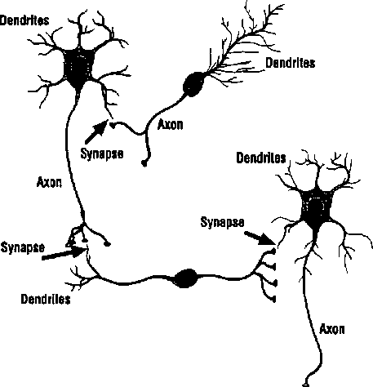
Copyright © 1989-97 by Techpool Studios, Inc., USA.

13

that cannot be accomplished individually—it requires groups of neurons (Greenfield 1995).
How Do We Learn?
What the human brain does best is leam. beaming changes the brain because it can rewire itself with each new stimulation* experience, and behavior. Scientists are unsure precisely how this happens, but they have some ideas what happens.
First, some kind of stimulus to the brain starts the process. It could be internal (a brainstorm!) or it could be a new experience, like solving a jigsaw puzzle. Then, the stimulus is sorted and processed at several levels. Finally, there’s the formation of a memory potential. That simply means the pieces are in place so that the memory can be easily activated. As educators, it’s well worth our time to understand the basics of these. It may give us some useful insights into how students leam.

The Stimulus
To our brain, we are either doing something we already know how to do or we are doing something new. If we are repeating an earlier learning, there’s a good chance the neural pathways will become more and more efficient. They do that through myelination, which, as noted earlier, is the process of adding a fatty coating to axons. Once myelination has occurred, the brain gets more efficient. Washington University School of Medicine researchers Hanneke Van Mier and Steve Peterson discovered that while many areas of the brain will “light up” on a PET scan when a new task is initiated, the brain “lights up" less and is used less the better the task is learned. Novices use more of their brain, but they are less efficient at how they
use it. This quality illustrates how quickly our brain adapts and rewires itself.
While exercise is doing what we already know how to do, stimulation is doing something new. Seeing a new movie, listening to new music, singing a new song, visiting a new place, solving a new problem, or making new friends can all stimulate the brain. As long as it’s coherent, this novel mental or motor stimulation produces greater beneficial electrical energy than the old-hat stuff. This input is converted to nervous impulses. They travel to extraction and sorting stations like the thalamus, located in the middle of the brain. In intentional behavior, a multisensory convergence takes place and the "map" is quickly formed in the hippocampus (Freeman 1995). From there, signals are distributed to specific areas of the brain.
Once this input is received, each brain cell acts as a tiny electrical battery. It’s powered by the difference in concentration of sodium and potassium ions across a cell membrane. Changes in voltage help power the transmitting of signals for dendritic growth. Neurotransmitters are stored in the ends of the cell’s axon, which nearly touches the dendrites of another cell. Typically, they’ll either be excitatory (like glutamate) or inhibitory (like GABA, or gamma-aminobutyric acid). When the cell body sends an electrical discharge outward to the axon, it stimulates the release of those stored chemicals into the synaptic gap, which is the space between the end of an axon and tip of a dendrite, as represented in Figure 2.7.
Once in that gap, the chemical reaction triggers (or inhibits) new electrical energy in the receptors of the contacted dendrite. It’s electrical to chemical and back to electrical. There, the process is repeated to the next cell. Eventually, the repeated electrical stimulation fosters, along with an increased input of

14

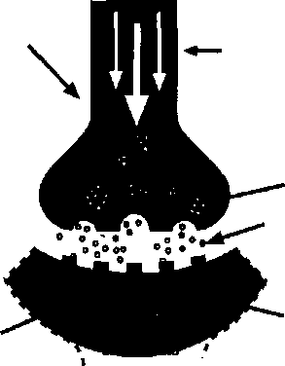
The tip of the axon that Is sending the message to another cell
Neuron #1
Synaptic gap
Receptor sites
of another neuron

Learning Takes Place at the Synapse
Electrical charges travel down the axon, from the cell body to the tip
Axon tip filled with neurotransmitters that are released
Neuron #2
nutrients, cell growth by way of dendritic branching. These branches help us make even more connections until, in some cases, whole “neural forests” help us understand better and, maybe someday, make us an expert in that topic. When we say cells "connect” with other cells, we really mean that they are in such close proximity that the synapse is easily, and almost effortlessly, “used” over and over again. New synapses usually appear after learning.

The Formation of Lasting Learning
Learning and memory are two sides of a coin to neuroscientists. You can’t talk about one without the other. After all, if you have learned something, the only evidence of the learning is memory. Unfortunately, this final part of the learning process has proved to be an enormous and frus
trating challenge for scientists. Just when they think they've figured it out, they discover it’s more like a house of mirrors. In short, they’re still looking for answers.
Donald Hebb, the great Canadian psychologist, correctly postulated more than 50 years ago that learning occurs when a cell requires less input from another cell the next time it’s activated. In other words, it has “learned” to respond differently More recently, a research team at MIT lead by Nobel laureates Susumu Tonegawa and Eric Kandel has identified a single, specific gene that activates this critical memory formation (Saltus 1997). This breakthrough may explain why some people have a better memory than others: It’s partly gene controlled.
Lasting learning, or long-term potentiation (LTP), has tentatively been accepted as essential to the actual physical process of learning. Since its discovery in 1973 by Bliss and Lomo, countless experiments have defined its intricacies. Briefly, here's the process.
A cell is electrically stimulated over and over so that it excites a nearby cell. If a weaker stimulus is then applied to the neighboring cell a short time later, the cell's ability to get excited is enhanced. Neural activity can have either an excitatory or inhibitory effect, Suppressing an inhibitory process can result in its activation. Another effect helps us learn too. LTD (long-term depression) occurs when a synapse is altered so that it is less likely to fire.
By making the wrong connection less likely, quicker learning is promoted. This occurs when we do trial-and-error learning (Siegfried 1997). In other words, cells change their receptivity to messages based on previous stimulation. That sounds like the cells have “learned” and changed their behavior. In short, our learning is done through the alteration of synaptic efficacy.

15

Learning and Behavior
While it’s exciting to make some sense out of the actual cell-to-cell connections, learning and behavior are often different. You might have- learned how to teach a better class from a book. But your behavior might still be the same as it has always been. Why and how does this happen? Certainly, we could point to outside circumstances like excess stress or a student’s behavior. Yet our behaviors are more likely governed by our complex emotional states and memories. The daily chemistry of our brain adds great complexity to the question, ‘‘How does our brain learn?”
Our everyday behaviors are heavily affected by other "floating" chemicals in the brain: the monoamines and peptides. In fact, one researcher estimates that over 98 percent of all your brain’s and body’s internal communications are through peptides, not synapses (Pert 1997, p. 139). If the neurotransmitters we mentioned earlier, like glutamate and GABA, act as “cellular phones” offering specific communications, the other chemicals act more like huge bullhorns that can broadcast to wide areas of the brain. These chemicals are usually serotonin, dopamine, and noradrenaline.
These produce the behaviors that you can actually see in class like attention, stress, or drowsiness. Later chapters will address these further. In short, learning happens on many complex layers at once, from the cellular to the behavioral.

Getting Smarter
The end result of learning for humans is intelligence. Regardless of how you define intelligences, having a bigger brain or more brain cells per cubic inch doesn’t help. A dolphin has a bigger brain, and a rat brain has more cell density than a human
brain. The key to getting smarter is growing more synaptic connections between brain cells and not losing existing connections. It's the connections that allow us to solve problems and figure things out.
What percentage of your physical brain do you use? On a given day, most areas are used because functions are well distributed throughout it. In addition, it has been customizing itself for your lifestyle since the day you were born. It generally works well for you because you’ve encouraged it to develop for your precise world. If you’re good at music, you’re likely to sing, compose, or play. If you’re good at sports, you’re likely to practice or play. If you’re good at numbers, you’re likely to do some computation daily In the real world, your brain’s just right for you.
On a more theoretical, mathematical basis, the story is much different. It is estimated that we use less than 1 percent of 1 percent of our brain’s projected processing capacity. Each of your 100 billion neurons ordinarily connects with 1,000-10,000 other neurons. But they could theoretically connect with far more. Since each neuron has several thousand synapses, your entire brain has trillions of them. Your brain is capable of processing as much as 10²⁷ bits of data per second (Hobson 1994). However, Paul Churchland (1995) postulates that the total possible configuration is 10 to the 100 trillionth power. That number far exceeds the number of known particles in the universe. Our brain is, indeed, quite a miracle. The brain is what we have; the mind is what it does. In other words, the “mind" is not a thing; it’s a process.
Could this potential neural connectivity be responsible for so-called “genius" behavior in. isolated individuals? We don’t know yet. Almost 10 percent of children under 5 have a photographic memory as do 1 percent of adults. Savants can

16

calculate huge numbers and, in some cases, do it as fast as a computer. There are documented cases where subjects have spoken a dozen or more languages, demonstrated thought transference, performed speed reading, or showcased a supermemory Others have shown us extraordinary use of ESP, remote viewing, or early musical gifts (Murphy 1992). Could these become commonplace in our classrooms? Could we engineer the development of another Albert Einstein, Maya Angelou, Amadeus Mozart, Martha Graham, or Bill Gates?
Finally, if learning is what we value, then we ought to value the process of learning as much as the result of learning. Our brain is highly effective and adaptive. What ensures our survival is adapting and creating options. A typical classroom narrows our thinking strategies and answer options. Educators who insist on singular approaches and the “right answer” are ignoring what’s kept our species around for centuries. Humans have survived for thousands of years by trying out new
things, not by always getting the “right,” tried-and- true answer. That’s not healthy for growing a smart, adaptive brain. The notion of narrowed standardized tests to get the right answer violates the law of adaptiveness in a developing brain.
Good quality education encourages the exploration of alternative thinking, multiple answers, and creative insights.
So what do we do about this brain knowledge? Is it useless theory? Not for the professional educator. As long as we are in “the business of learning,” the brain is relevant. We have finally learned enough to formulate some important action steps. Many areas require more research, but dozens of studies are clear and solid enough to be transformed into classroom practice. Share with your students how their brains leant and work. Talk to interested parents about it, too. Many solutions to everyday problems will be presented in the upcoming chapters. But be prepared: There also will be many questions.

Cl Getting Students Ready to Learn | *
 | Key Concepts
 | 1 The developing brain
T‘ * ducators continually complain that stu- | ft Getting students ready for school
rH dents are not ready to learn. They show up 1 4 for school underfed or malnourished, angry or apathetic, stressed, threatened, and sleepy. | ft Emotional readiness
 | ft Motor skill readiness
If they have been assigned homework, it’s often not done. Naturally, this makes the roles of both | ft The role of threat, sleep, and nutrition
teacher and learner much more difficult. It seems that schools must make a choice: leave it up to students to be ready to learn when they walk in the door, or become a “surrogate family," helping chil- - dren to prepare to learn each day. This chapter considers how educators and parents can and might better manage the influences that prepare children’s minds and brains for school. | ft How we can Influence parents
Are Kids Really Different Now?
It^s common to hear experienced teachers talk about “how kids used to be." But are children’s brains really any different today than they were 30 or 40 years ago? We don’t know for sure. No one has saved a variety of brains to compare, and today’s technology was unavailable back then (see
fig- 3-D.

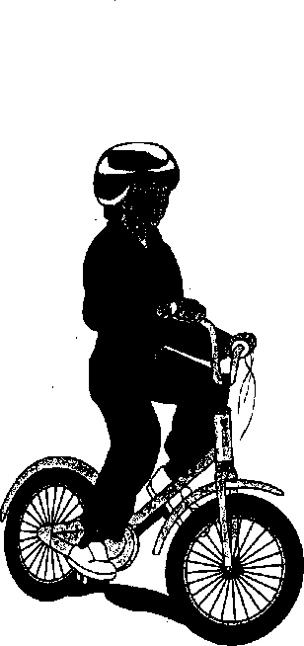
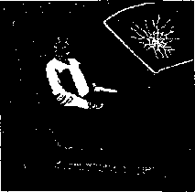
Copyright © 1989-97 by Techpool Studios, Inc., USA.
18
Are Kids Today Biologically Different Than They Were 30 Years Ago?
Fewer natural foods and more additives
More exposure to drugs and medications
More children raised in single parent households with fewer resources
More exposure to passive
babysitters and sedentary
entertainment like TV
Use of car seats and seat belts restricts movement but is safer
Less early motor stimulation from swings, see-saws, merry-go-rounds, and playground games because of safety and liability concerns

Getting Students Ready to Leant

19
!!

Interestingly, there is some evidence that children today really are less prepared for school than they were one or two generations ago (Healy 1990, pp. 13-46). If you’re wondering why children seem more violent, stressed, scattered, unfocused, and overall less ready for school, you’re not alone. Many scientists agree with you—for example,
Craig Ramey from the University of Alabama and Christopher Coe of the University of Wisconsin.
The evidence can be seen in many critical areas, including emotional development, motor-sensory development, and school-day readiness.
School Readiness Starts at Conception
The first opportunity to get children ready for school is in the womb. We know that drugs, smoking, nutrition, and heredity all affect the embryo (Van Dyke and Fox 1990). The most important things a pregnant woman can do are eat well, avoid drugs, and keep the stress down.
A developing fetus is very sensitive to stress and poor nutrition, Most brain cells are produced between the fourth and seventh month of gestation. Those fast-developing cells, called neurons, form a vast network, connecting to other cells. A newborn has more than a trillion connections in the brain.
The developing brain grows so fast, counting brain cells is hopeless (though fig. 3.2 attempts to illustrate the rate of growth). Neurobiologist Peter Huttenlocher of the University of Chicago says it’s like counting snowflakes in a blizzard or drops of water in a torrential rainstorm. At its peak, the embryo is generating brain cells at the rate of 250,000 a minute, or 15 million cells per hour. If
you knew your brain was being shaped at that rate, would you be cautious about what you did to it? Some parents are not careful, and we must work with their children in school every day.
Emotional Intelligence Begins Early
The book Emotional Intelligence (Goleman 1995) brought to public attention the importance of our emotional lives. But when does emotional intelligence develop, and is it too late to cultivate it by the time children arrive at school? The evidence suggests that emotional intelligence develops early, and the school years may be a time of last resort for nurturing emotional literacy.
An infant’s relationship with its primary caretaker often determines whether the child develops learning problems. Harold Rubenstein of the Dartmouth Medical School says that troubled early relationships cause the child’s brain to consume glucose in dealing with stress, glucose that instead could be used for early cognitive functions. Early exposure to stress or violence also causes the brain to reorganize itself, increasing receptor sites for alertness chemicals (Kotulak 1996). This increases reactivity and blood pressure, and the child will be more impulsive and aggressive in school.
Much of our emotional intelligence is learned in the first year. Children learn how to react in hundreds of simple cause-and-effect situations with parents. These situations guide them about being disappointed, pleased, anxious, sad, fearful, proud, ashamed, delighted, or apologetic. Children need this dose, connected interaction and handling (Wilson, Willner, Kurz, and Nadel 1986). Known as “attunement,” this process must happen during the critical first year of role modeling or children

20

Rapid Pace of Prenatal Brain Development

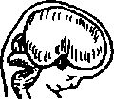

40 days
50 days
100 days

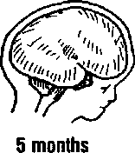
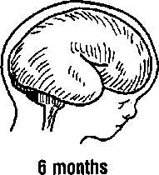
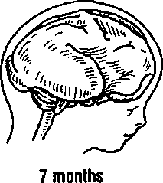
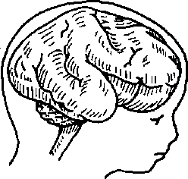
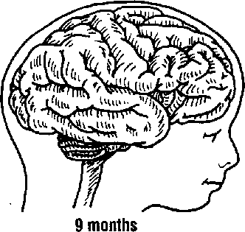
8 months

may end up emotionally corrupt. Even a parent’s gestures are important (Thai* Tobias* and Morrison 1991). ‘This is when the primary caregiver plays back the proper and critical emotional responses,” says psychiatrist Daniel Stem (Begley 1996).
We now understand that the first 48 months of life are critical to the brain’s development. While
researchers have always known that infant development was important, they never knew just how important, Wayne State neurobiologist Harry Chugani says the experiences of the first year “can completely change the way a person turns out” (Kotulak 1996, p. 46). But more often than not in today’s world, the first few years are spent in a
child-care center. Typical ratios of infants and toddlers to caregivers are from 3-1 up to 12-1. If parents understood the developmental opportunities in the infant’s brain during those months, they might change their decision about who’s minding their baby
How much temperament is learned and how much is inherited? Harvard psychologist Jerome Kagan has studied infants extensively and says it’s about half and half. The genetic part of our behavior is governed from our developing mid-brain area. “The physiological data implicate inherited variation in the excitability of the amygdala and its projections as one basis for the contrasting styles,” says J.M. Kagan (1994, pp. 35, 171). But the first 24 months of child-raising provides the difference between several dramatically different and possible futures. For example, parents who recognize appropriate risk taking and acknowledge it will usually get a more courageous child. Parents who are fearful will communicate that by placing limitations on crawling or walking (Kagan 1994).
Preparing the Early Brain
Do today’s children get the necessary stimulation for school readiness? “Not usually,” says Lyelle Palmer, professor of special education at Winona State University in Minnesota. “The human brain is the most responsive organ you could imagine. But even with a universe of learning potential awaiting us, we usually don’t even get around to doing the basics” (1997).
The brain is literally customizing itself for your particular lifestyle from the day you’re bom. Soon after, the brain prunes away unneeded cells and billions of unused connections. It’s a time of enor
mous selective receptiveness. The question is, “For what are you customizing your brain?” For educators, the question is even more pointed, “Exactly what talents, abilities, and experiences are students being exposed to and, on the other hand, what are they missing out on?” Here are a few examples.

The Motor Brain
Most educators know the value of “crawl time” in developing learning readiness. Yet many of today’s children don’t get the early motor stimulation needed for basic, much less optimal, school success. Today’s infant is “baby-sat” by television, seated in a walker, or strapped in a car seat for hundreds of precious motor development hours.
In 1960, the average 2-year-old spent an estimated 200 hours in a car. Today’s 2-year-old has spent an estimated 500 hours in a car seat!
While infant safety is vital, few parents ever compensate for the confined, strapped-in hours." Considering the tomes of evidence on the impact of early motor stimulation on reading, writing, and attentional skills (Ayers 1972, 1991; Hannaford 1995), it’s no wonder many children have reading problems. Although research on the general value of motor skills first surfaced many years ago, only today do we know about the specific value in reading, stress response, writing, attention, memory, and sensory development. As an example, the inner ear’s vestibular area plays a key role in school readiness. Restak (1979) says, “Infants who were given periodic vestibular stimulation by rocking gain weight faster, develop vision and hearing earlier.” Many link the lack of vestibular stimulation to dozens of learning problems including dyslexia (Cleeland 1984). How important is the timing of motor development? Felton Earls of the Harvard

22
Medical School says, “A kind of irreversibility sets in, ... By age four you have essentially designed a brain that is not going to change very much more" (Kotulak 1996, p. 7). And while much learning happens after age four, much of the brain’s infrastructure is now in place.

The Visual Brain
Neurobiologists tell us that much of our vision develops in our first year, particularly in the first 4 to 6 months, with a major growth spurt at age 2 to 4 months. This window is much earlier than previous studies indicated. With more than 30 distinct visual areas in the brain (including color, movement, hue, and depth), the growing infant must get a variety of stimulating input, including plenty of practice handling objects and learning their shapes, weight, and movement. A variety of objects, games, and responses from parents shape the way vision develops very early. “Children need a flood of information, a banquet, a feast,” says neuroscientist Martha Pierson of the Baylor College of Medicine (in Kotulak 1996).
The “flood" should not come from television, which often is used as a baby-sitter (Tonge 1990). Television provides no time for reflection, interactions, or three-dimensional visual development. Parents would be wise to invest the time talking to their babies, speaking in short sentences and pointing out objects that aTe here and now, or three dimensional.
Television is two dimensional, and the developing brain needs depth, says VL. Ramachandran, a neuroscientist and vision specialist at the University of California at San Diego. Television moves fast and talks about abstractions that are often nonexistent in the child’s environment. It allows the eyes
no time to relax. This stress can aggravate learning difficulties. Television is a poor replacement for sensory-motor development time and key relationship time. The exposure to violence and a too-fast vocabulary takes a toll (Healy 1990, Strasburger 1992). Many scientists and researchers say they would ban television for all children before age 8 (Hannaford 1995), This gives the brain time to better develop its language, social, and motor skills.

Early Thinking Skills
The brain is fully ready for thinking through tactile learning as early as nine months. The cortex is not fully developed yet, but the cerebellum is ready. This cauliflower-shaped organ at the back bottom of the brain works overtime in infants. And some researchers suggest that it is very sophisticated in its learning capacity (Greenfield 1995). Intriguing studies suggest infants may understand basic counting principles and simple physics before age 1. Neural circuits for math and logic are ready for “planting the seeds” at this age. Some have shown (Wynn 1992) that infants can leam simple math long before their brains are ready for abstraction. Even if infants can do only a fraction of what they seem to be “wired" to do, ids a great deal. Parents who explore these possibilities are laying the foundation for long-term success in school.

The Auditory Brain
Patricia Kuhl of the University of Washington (Begley 1996) says that infants develop in their first year a perceptual map of responsive neurons in the auditory cortex. Circuits in the auditory cortex allocate both cells and receptor sites for what are quickly deemed the early survival sounds. This map is formed by hearing early sounds, and accents

23

and word pronunciations are a big part of it. These phonemes alert infants to the particular inflections like a Spanish rolled V or a sharp Japanese “Hi!”
As a result, the brain dedicates special neurons to be receptive to those particular sounds.
This developing map is so customized for the household that children are “functionally deaf” to sounds outside of their home environments. The greater the early vocabulary children are exposed to, the better All of the early sounds shape the brain, even music and rhythm, In fact, research at the University of California at Irvine suggests that infants are quite receptive to and discerning about music. Since math and music circuitry are related, introducing music at this age may assist math later on (Weinberger 1994).

Language Development
Rutgers University neuroscientist and language specialist Paula Tallal says, “Language problems in children are associated with stressful pregnancies.” “Not only can the sex hormone go awry during this time,” she continues, “but other compounds, such as stress hormones, can be raised to abnormal levels.” That’s because the release or inhibition of hormones changes hemispheric development. She adds, “Having a stressful pregnancy is highly correlated with the failure to show the expected structural lateralization” (in Kotulak 1993, Section 1, p. 4). As a result, you often get stuttering and dyslexia in the child. The left side of the brain processes rapid auditory information faster than the right. That skill is critical in separating the sounds of speech into distinct units for comprehension. The left hemisphere, usually responsible for language development, develops slower in the male brain. Thus, males usually develop more language problems than females.
Infants whose parents talk to them more frequently and use bigger, “adult” words will develop better language skills, says Janellen Huttenlocher at the University of Chicago (in Kotulak 1993, Section 1, p. 4). “During this time, there is a huge vocabulary to be acquired," This crucial time lays the pathway for reading skills later on (Begley 1996, p. 57). Unfortunately, many parents still don’t know how important it is to read to their children. A recent poll showed that 82 percent of all parents say they don’t encourage reading at home (“Reading at Home” 1996). Worse yet, three out of four adults say kids are “too distracted” by television to read. Another survey reports that 90 percent of children age 9-13 play video games (“Video Games” 1996). While 43 percent play under an hour a day, 27 percent play 2 to 6 hours a day.
Developing reading skills is another story. Although babies can leam to see, point to, and say a word, there’s little meaning until they have sufficient life experience to match words and experience. Studies suggest babies listen to words even though they cannot yet speak. All the words, understood or not, are contributing to the development of syntax, vocabulary, and meaning. It is believed that this time is critical for language development. Surprisingly, there is no absolute timetable for learning to read. Differences of three years are normal. Some children will be ready to read at 4 years; others, just as normal, will be ready at 7 or even 10 years. The child who reads at 7 might not be “developmentally delayed” as many have diagnosed. J.M. Kagan talks about how different infants can be even when they’re just months old. “I have not seen an infant who was aroused by every type of event: some were excited by moving* sights but not by sounds, and others showed the reverse profile” (1994, p. 39). Is whole language or

24

direct phonics instruction more brain compatible? Research suggests there is value in each; a combination is best.
The Sudbury Valley School in Framingham, Massachusetts, is an example of a school that understands how reading readiness and the differences in learners' brains can coexist. Their K-12 program does not force reading on any student. They believe that youngsters are already exposed to thousands of vocabulary words in the world. Instead of teaching them reading, the school sim- ■ ply lets students choose to do it when they are ready. As a result, some children read at age 5, others at 6, some as late as 10, But according to the school’s founder, Daniel Greenberg, the school has 100 percent truly functional, literate graduates. There are no reading disorders or dyslexia, and everyone likes to read. It’s an approach that says, “Wait until the brain’s ready to read, then you can’t stop it!” (Greenberg 1991).

Sweet Dreams
Teachers often complain about kids falling asleep in school. Is it the parent’s fault or the school’s? Studies asking why kids seem to fall asleep so often in middle and high school classes have now turned to biology Researchers had already looked at two possible culprits that, in the end, didn’t seem to matter much: part-time work and going to bed late. The answer wasn’t social pressure, either. It was puberty
Sleep is regulated by many chemicals, including amines, glutocorticoids, and oleamide, a drowsiness-inducing chemical substance, says Dale Boger, a molecular biologist at Scripps Research Institute in La Jolla, California, A delayed accumulation of oleamide means a teen’s natural sleep clock generates a natural bedtime closer to midnight with a waking time closer to 8 a.m. This
change is believed to be stimulated by the hormonal changes of puberty. Sleep expert Mary Carskadon, formerly of Brown University, confirms that most teenagers are affected by this critical biological change in their internal sleep clocks (in Viadero 1995). “We have kids so sleep-deprived, it’s almost as if they’re drugged. Educators like myself are teaching walking zombies,” says Cornell University sleep disorder expert James Maas (in L. Richardson 1996, p. E-l). Sleep experts discovered that teens simply couldn’t fall asleep early, as their frustrated parents suggested. Carskadon calls it a “delayed phase preference,” and the body’s changing chemistry is the culprit. While many researchers are unsure of the direct cause, the results are easy to see, They should be able to get to sleep earlier, but they can’t. It’s like the biological clock injected amphetamines into the brain. Milton Erman, professor at the University of California in San Diego, says, “High school kids are grossly sleep deprived. ... [1] t makes very little scientific sense to make these kids function at these very early hours” (in L. Richardson 1996, p. E-l). Richard Allen of the Sleep Disorder Center at Johns Hopkins University studied two groups of teens. The later risers performed better academically. One started school at 7:30 a,m., the other at 9:30 a.m.
Researchers have discovered that at night, the first few minutes and the last few minutes of our four-part sleep cycle take us into a theta state.
That’s our own “twilight zone,” when we are half awake and half asleep. Brain wave cycles here are about 4-7 per minute as we drift randomly in and out of sleep. Ordinarily, our waking hours are spent in alpha and beta time, from 8-25 cycles per second. During theta state, we can be awakened easily and often rehash the day or think of things we have

25

to do the next day. This light sleep stage usually consumes only about 5 percent of our night. It usually occurs upon awakening and at bedtime. This drowsy or deep reverie, is a mildly altered state of consciousness, good for free associating.
The heavier, nondream states of sleep are important for physical renewal. During our “dead to the world" states, the pituitary gland delivers extra growth and repair hormones to the bloodstream, This helps rebuild tissue and ensure our immune system is in order. During this state, you rarely hear a noise in your house unless it’s almost an explosion. This rest and repair period is the majority of our sleep time. Theta usually lasts less than 5 percent, dream time 25 percent, and our delta (“deep sleep”) state is the remainder.
The critical time in question is the dream state, or rapid eye movement (REM) time. This state is thought to be critical to maintaining our memories (Hobson 1994). A highly active area during REM time is the amygdala, a structure known to be crucial for processing intense emotions. In addition, ^ the entorhinal cortex, known to be critical in longterm memory processing, also is active (Ackerman 1996). Bruce McNaughton at the University of Arizona discovered that a rat’s brain activity patterns in REM match the patterns of the daytime learning session (Lasley 1997). He suggests that during sleep time, the hippocampus is rehearsing the learning sent to it by the neocortex. This “instant replay” consolidates and enhances memory. That may be why waking up too early affects this all- important REM sleep. Of all the time to sleep, we need those last few hours the most.
Both Carskadon (Viadero 1995) and Carey (1991) suggest a solution. Middle and high schools ought to start later than elementary school. While 7:30 a.m. is appropriate for the primary levels, a
9:30 a.m. start usually works better for middle and high schools. In Corpus Christi, Texas, a districtwide change to later start times resulted in better learning, fewer sleeping-at-school teens, and fewer discipline problems. It makes sense: If we want kids to learn and remember, they'll need to stay awake at school and get enough sleep time to consolidate the learning at night.

Eating to Learn
Many school food-service programs were designed for bone and muscle growth, not the brain’s learning requirements. There can be a middle ground. Food must supply the nutrients necessary for learning, and the critical nutrients include proteins, unsaturated fats, vegetables, complex carbohydrates, and sugars. The brain also needs a wide range of trace elements such as boron, selenium, vanadium, and potassium.
The National Research Council publishes an annual report on nutrition, and the findings have been summarized by many (Woteki and Thomas 1992). The report concludes that Americans eat too much saturated fat, sugar, and simple carbohydrates. They eat too few fruits, vegetables, and complex carbohydrates. Even with federally funded breakfast programs, many kids still get only simple carbohydrates. That’s insufficient for basic, much less optimal, learning and memory (Wurtman 1986). In addition, many children have food allergies (most commonly to dairy products) that can cause behavioral and learning problems (Gislason 1996).
Are specific foods particularly good for the brain? There are many, but children rarely get enough of them. They include leafy green vegetables, salmon, nuts, lean meats, and fresh fruits (Connors 1989). Other evidence indicates that vit-

26

amin and mineral supplements can boost learning, memory, and intelligence (Ostrander and Schroeder 1991, Hutchinson 1994). Calpain has been found to act as a “cleaner” for synapses, dissolving protein buildup (Howard 1994). This makes them more efficient for neural transmission, hence learning. The dietary source for calpain is dairy products (yogurt and milk are best) and leafy green vegetables (spinach and kale are excellent). Most kids eat to get rid of their hunger and lack sufficient information to eat for optimal learning. This is a concern because the essential myelination and maturation of the brain is going full speed up to 25 years of age.

Drinking to Learn
Dehydration is a common problem that’s linked to poor learning. To be at their best, learners need water. When we are thirsty, it’s because there’s a drop in the water content of the blood. When the water percentage in the blood drops, the salt concentration in the blood is higher. Higher salt levels increase the release of fluids from the cells into the bloodstream (Omstein and Sobel 1987). That raises blood pressure and stress. Stress researchers found that within five minutes of drinking water, there is a marked decline in corticoids and ACTH, two hormones associated with elevated stress (Heybach and Vemikos-Danellis 1979). In addition, if water is available in the learning environment, the typical hormone response to the stress (elevated levels of corticoids) is “markedly reduced or absent” (Levine and Coe 1989). These studies suggest a strong role for water in keeping learners’ stress levels in check.
Because the brain is made up of a higher percentage of water than any other organ, dehydration takes a toll quickly. There’s a loss of attentiveness,
and lethargy sets in. Dehydration means many children need more water, more often. Soft drinks, juice, coffee, or tea are diuretics that don’t help much. Teachers should encourage students to drink water throughout the day. Parents who know this can suggest that their children use water as the primary thirst quencher instead of soft drinks (Hannaford 1995).
Figure 3.3 summarizes this chapter’s sugges-, tions on what parents can do from birth to help their children be ready for school.
Practical Suggestions
It may seem as if there’s little that educators can do about all of this. It’s parents who get children ready to learn, after all. But this issue is so important that we must do something. We can’t afford not to take action. There are three levels we can work at to influence some of these readiness areas: students, staff, and community.
Because we already influence them in many other ways, let’s start with students. We can talk to them about nutrition and what stimulates better thinking, learning, and recall. We can ask them to do projects on nutrition to research the impact of various foods.'We can ask them to keep a private journal so that they can begin to link up what they eat with how they feel and do in school. Guest speakers can provide some novelty or credibility on the subject. Maybe, most important, teachers and parents can role model good “eating-to-leam” nutrition.
At the staff level, we can influence what’s served for school breakfasts or lunches. We can change what’s put in the vending machines. We can provide information to the district office about

School Readiness: What Can Parents Do?

0-18 Months

18-60 Months

. Provide loving care, safety, healthy emotion stress response, hugs, laughter, smiles; bond with your child; avoid threats | Role model cause-and-effect feelings, empathy; provide a joyful home; set clear rules; avoid yelling
Encourage crawling, sitting, point- Motor j_{n}g; promote the use of balls, cu-t rattles, a variety of toys; provide 0J© mobiles; handle, touch, and rock your child frequently | Encourage games (like hide-and- seek), spinning, drawing, walking, running, balance activities; give your child freedom to explore (with safety); play and encourage the playing of instruments
Vision Use many objects, a variety of -v movements, color identification; schedule eye exams; avoid TV | Play attention games and eye-hand coordination activities; teach how to focus; provide outdoor time; avoid TV; schedule eye exams
A rl'* Provide exposure to short phrases Auditory _{anc}| high _{V0}|_{ume} of coherent input;  if repeat sounds; use melodies;  ■* monitor for ear infections | Provide exposure to longer sentences, second languages, larger vocabulary, a variety of contexts; schedule regular ear exams
Thinking Be overcurious about your child’s world, do simple counting, demon- strate cause and effect | Use demonstrations, ask plenty of questions, teach basic math and principles of motion and volume
Mucir Sing ^{lullabies}l 9^{ive} y°^{ur} child ^{rat_} MUSIC ties; _{re}p_{ea}t rhymes; provide early  exposure to common traditional songs and other nursery tunes | Sing; play instruments; listen to structured, harmonic music; provide exposure to more variety in kinds of music.
Nutrition Mother’s milk is still best; avoid ex- cess juice; ensure sufficient nutri- ents; provision of moderate fats OK | Introduce a wide variety of foods; begin balanced meals high in fiber and vegetables; use vitamins

i

28

nutrition for learning. At the school open house, we can offer parents a talk and a handout on “Eating to Learn.” We also can influence the district office if the school’s start time needs to be changed. Many schools around the country have already successfully done this.
Finally, we ought to engage both school and community resources to educate parents on how to get their children ready for school. Many parents simply don’t have access to information, or they
think they already know it. Create alliances with local hospitals, the chamber of commerce, or local businesses to get the word out. Prepare flyers and provide free sessions for parents on the benefits of getting their children ready to learn. Talk to them about motor development, crawling, and how it affects reading and writing skills. Encourage them to talk more, play music, and solve more problems. Share with them the impact of television and some easy-to-use alternatives.

Enriched Environments and the Brain
Humans are bom more helpless than any other mammal. That mixed blessing means that the infant can’t take care of itself very well and that it can customize its growing brain for the world it encounters. This “neural customizing” can come from exposure to a barren wasteland of random stimuli or a rich landscape of thoughtful sensory input.
“It used to be that we thought the brain was hard-wired and that it didn’t change . . . [but] positive environments can actually produce physical changes in the developing brain,” says Frederick Goodwin, former director of the National Institute of Mental Health (in Kotulak 1996, p. 46). This chapter focuses on the importance of enrichment. We know enough to say the environment ought to be rich. But, practically, what are the specific components of an “enriched” environment?

Environmental Influence
The pendulum has swung over the last 100 years. For many decades, those who believed character and intelligence are mostly up to our genes (“nature”) argued for their position and dominated
Key Concepts
k How enrichment affects the brain
l TWo conditions for enrichment: challenge and feedback
I The role of language, motor activity, music, and the arts
I What really builds better brains?

30
national debates. They quoted studies about the ‘‘spelling gene,” the “music gene,” and even a “math gene.” But in time, those convinced of the influence of the environment (“nurture”) raised their voices long enough to gamer public attention for their cause.
Today, consensus tells us that heredity provides about 30 to 60 percent of our brain’s wiring, and 40 to 70 percent is the environmental impact. Why the variation? It depends on what specific trait or behavior you’re considering. Male pattern baldness is on the X chromosome, which comes from the mother. If it is strongly expressed in your parents and grandparents, your chances of inheriting and expressing it are close to 100 percent. If you’re a female and your mother was a strong leader, your likelihood of also being a strong leader may be closer to 30 percent. This lowered number reflects the complex environmental variables of circumstances, opportunity, and skills learned.
As educators, we can most influence the “nurture” aspect of students. While this chapter focuses on what enriches the brain, it also looks at the overall quality of the learning environment. Because of that, we must follow a cardinal rule when it comes to appreciating how the brain reacts to certain influences: Start by removing threats from the learning environment. No matter how excited you are about adding positives to the environment, first work to eliminate the negatives.
Those include embarrassment, finger-pointing, unrealistic deadlines, forcing kids to stay after school, humiliation, sarcasm, a lack of resources, or simply being bullied. There is no evidence that threats are an effective way to meet long-term academic goals. Once threats are gone, we can go to work on the enrichment process.
Our Malleable Brain
In 1967, brain pioneer Marian Diamond, a University of California at Berkeley neuroanatomist, discovered an amazing malleability to the brain (Diamond 1967). Her studies—and subsequent research by dozens of colleagues—have changed the way we think about our brains. The brain can literally grow new connections with environmental stimulation. Diamond says, “When we enriched the environment, we got brains with a thicker cortex, more dendritic branching, more growth spines and larger cell bodies” (Healy 1990, p. 47). This means the brain cells communicate better with one another. There are more support cells, too. This can happen within 48 hours after the stimulation. Later studies support the conclusion that these are predictable and highly significant effects.
It’s the process of making connections that counts. This suggests a possible cause for the enhanced learning capacity that many report—the increased neural stimulation. Smarter people probably do have a greater number of neural networks, and theyTe more intricately woven together. These changes match up favorably with those gained from complex experiences, specifically with learning and memory (Black et al. 1990). This view suggests that the environment affects the wiring of the brain as much as the person’s actual experiences.
Dendritic branching was easy to find, but the evidence of synaptic plasticity is relatively recent. We now know how the brain modifies itself structurally; it’s dependent on the type and amount of usage (Healy 1990; Green, Greenough, and Schlumpf 1983). Synaptic growth varies depending on which kind of activity is given. For novel motor learning, new synapses are generated in the cere-

31

bellar cortex. From exercise (repeated motor learning), the brain develops greater density of blood vessels in the molecular layer (Black et al. 1990). Some researchers found that an area of the mid- brain involved in attentional processing—the superior colliculus—grew 5 to.6 percent more in an enriched environment (Fuchs, Montemayor, and Greenough 1990). Using fMRl (Functional Magnetic Resonance Imaging) technology, researchers at the University of Pennsylvania discovered that our brain has areas that are only stimulated by letters, not words or symbols (Lasley 1997). This suggests that new experiences (like reading) can get wired into the malleable brain. In other words, as you vary the type of environment, the brain varies the way it develops.
Yet all of this can get tricky. A student’s early sensory deprivation can play a role. “If there is a bad experience, the wrong synapses are shed and the system malfunctions,” says University of Illinois neuroscientist William Greenough (1997). Retaining excess synapses can be harmful, as in the case of Fragile X mental retardation. At school, there's more interest than ever in creating the right kind of enriching environments. That’s for good reason.
One of the most convincing arguments comes from the former director of the Institute of Mental Flealth, Frederick Goodwin. He says, “[T]here is now increasing understanding that the environment can affect you. . . [;] you can’t make a 70 IQ person into a 150 IQ person, but you can change their IQ measure in different ways, perhaps as much as 20 points up or down, based on the environment” (Kotulak 1996). That’s a 40-point range! just how much can a school affect the brain? Neuroscientist Bob Jacobs confirms that animal research on brain enrichment translates directly to human brains. He
found that in autopsy studies on graduate students, they had up to 40 percent more connections than the brains of high school dropouts. The group of graduate students who were involved in challenging activities showed over 25 percent more overall “brain growth” than the control group. Yet education alone was not enough. Frequent new learning experiences and challenges were critical to brain growth. The brains of graduate students who were “coasting” through school had fewer connections than those who challenged themselves daily (Jacobs, Schall, and Scheibel 1993). Challenging sensory stimulation has been rightfully compared to a brain “nutrient.” Figure 4.1 illustrates the differences between impoverished and enriched neurons.

How Enrichment Changes the Structure of Brain Ceils
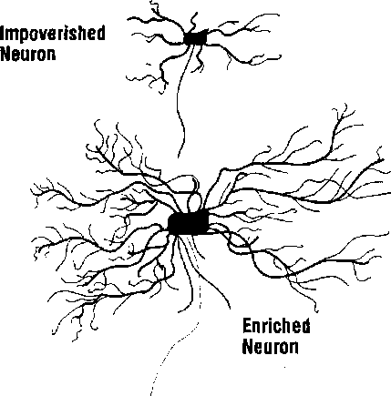

32

Wayne State neurobiologist Harold Chugani points out that the school-age brain almost "glows” with energy consumption, burning at 225 percent of the adult levels of glucose. The brain learns fastest and easiest during the early school years. It nearly explodes with spectacular growth as it*'" adapts with stunning precision to the world around it.^purin^t^|im^gtmnulatiori, repetition and novelty are essential to laying the foundations for later learning The outside world is the growing brain’s real food. It takes in the smells, sounds, sights, tastes, and touch and reassembles the input into countless neural connections. As the brain begins to make sense of the world, it creates a neural farmland.
Enrichment for Whom?
The myth for many years was that only cenain “gifted and talented” students would most benefit from enrichment programs. Nothing could be further from the truth. The human brain is bom with well over a trillion connections. Many new synapses are created with early sensory development, but any excess synapses are later shed. Gree- nough, a pioneer in enrichment studies, says that experience determines which synapses are shed or, more important, which are retained. This forms the “wiring diagram” upon which subsequent development builds (Begley 1996, p. 56). Our brain has a “baseline” of neural connectivity, and enrichment adds to it. Students can graduate from school with a “baseline" or an “enriched brain.” Can we really afford to rob all of the "nongifted” students of their biological destiny to grow an enriched brain?
Rutgers neuroscientist Paula Tallal comments on this critical learning opportunity that everyone should get. “Don’t wait. You don’t get another win
dow of opportunity like that,” she says (in Kotulak 1996, p. 33). It’s much easier, for example, to learn to play an instrument or leam a foreign language before age 10 than at any other time. But only the magnet school populations and gifted and talented students have received that kind of exposure. It’s easy to understand why parents want to have their children labeled as “gifted." To miss that chance might doom their child to a “neural wasteland.” .
What Constitutes Enrichment?
Endless experiments have been done on both animals and humans to determine what conditions predictably and precisely build a better brain. William Greenough, who has studied the effects of enriching environments for over 20 years, says two things are particularly important in growing a better brain. The critical ingredients in any purposeful program to enrich the learner’s brain are that first the learning is challenging, with new information or experiences. Often novelty will do it, but it must be challenging. Second, there must be some way to learn from the experience through interactive feedback.
Challenge is important; too much or too little and students will give up or get bored. Mental challenge can come about with new material, adding degree of difficulty, or through limiting the resources. This includes varying time, materials, access, expectations, or support in the learning process. Novelty is important, too. Change in the decor on the classroom walls every two to four weeks is valuable, but have the students do it for best enrichment. Change instructional strategies often; use computersTgroups, field trips, guest speakers, pairings, garnes^ student, teaching, jour- naUng, or multi-age projects (see fig. 4.2).

33

specific
multi-modal
timely
learner controlled
Maximizing Brain Growth

Challenge + Feedback problem solving critical thinking relevant projects complex activities
Second, maximize learner feedback. Because feedback reduces uncertainty, it increases coping abilities while lowering the pituitary-adrenal stress responses. Even in the absence of control, feedback has value (Hennessy, King, McClure, and Levine 1977). The brain itself is exquisitely designed to operate on feedback, both internal and external (Harth 1995). What is received at any one brain level depends on what else is happening at that level. And what is sent to the next level depends on the things already happening at that level. In other words, our whole brain is self-referencing. It decides what to do based on what has just been done. Without our magnificent system of feedback, we would be unable to learn. For example, after a student writes a paper in the classroom, the peer editing process is a superb way to get feedback.
Understandably, other learners can be the greatest asset in the learning environment. But many traditional environments are still not organized to take advantage of this opportunity. The best types of groups may be multi-age and multistatus groups (Caine and Caine 1994). While there may be little “hard biological research” on the value of cooperative groups, clearly they do two important things. When we feel valued and cared for, our brain releases the neurotransmitters of pleasure: endorphins and dopamine. This helps us enjoy our work more. Another positive is that groups provide a superb vehicle for social and academic feedback. When students talk to other students they get specific feedback on their ideas as well as their behaviors.
Several conditions make feedback more effective. The reaction must be specific, not general. A video game and a computer both give specific feedback, so does peer editing of a student’s story Group interaction provides feedback because it gives so much dramatic evidence, like nonverbals. Building a classroom model or playing a learning game gives interactive feedback. Feedback is ordinarily most useful for learners when it’s immediate. Occasionally, a stressed or threatened learner will prefer delayed feedback. Greenough says the ideal feedback involves choice; it can be generated and modified at will. If it’s hard to get at, or the performance cannot be altered once feedback is received, the brain doesn’t learn quickly. Immediate and selfgenerating feedback can come from many sources: having posted criteria for performance, checking against personal goals, using a computer, or when the student checks with a parent or teacher from another grade level.
What should be the content of enrichment? Fortunately the sources are endless. Here, we’ll

34

S
address just five of them: reading and language, motor stimulation, thinking and problem solving, the arts, and the surroundings.

Enrichment Through Reading and Language
Without exposure to new words, a youngster will never develop the cells in the auditory cortex to discriminate both between and among sounds well. Parents ought to read to their children beginning at 6 months, not wait until they’re 4 or 5. Before puberty, most children will learn any language without a “foreigner’s accent.” The supply of cells and connection in the brain are ready and available to be used for it. There are enough for us to learn even the lightest nuances in pronunciation.
.... But after puberty, the connections have almost disappeared, and the potential cells for language have been usurped by other more aggressive cells for other functions. Schools ought to expose children to larger, more challenging vocabularies and to foreign languages by age 12. Neuronal loss and synaptic pruning make the acquisition of second languages more difficult with each passing year.
The more vocabulary the child hears from his or her teachers, the greater the lifelong vocabulary. An easy way to get the larger vocabulary is for teachers to role model it, expect it, and make it part of the learning. Reading is also a great way to develop vocabulary, though not by forcing it early on students. For some learners’ brains, the “normal" time to learn to read is age 3 or 4. For others, the “normal” time is age 8. There can be, in fact, a spread in differences from a few months to 5 years in completely normal, developing brains. A 6-year- old who does not read might not be “developmen- tally delayed.” In many countries, including Sweden, Denmark, Norway, and New Zealand (all with
high literacy levels), formal reading instruction begins as late as age 7 or 8 (Hannaford 1995).
While reading is helpful for stimulating the growing brain, writing is another way to develop vocabulary. Usually we teach children printing before cursive. That makes little sense because the typical brain has not yet developed to make the fine visual-motor distinctions necessary. Children still have trouble with the lower case Ds arid Bs as well as H, N, A, and E. The frustration children experience is for a reason: Their brains are not yet ready for it. Cursive is much easier, and it’s better to teach that first. With the advance of technology and specifically computer keyboards, printing is less important today than 50 years ago.
The brains of children with language disorders are too balanced. That’s not good, says language expert Paula Tallal. When both sides are equal, the left hemisphere is underpowered; the left side should be physically bigger and more active than the right hemisphere. A bigger, faster left brain means if can make fine distinctions in the sounds heard. This means words are distinct, not like a running stream of watery noise. That’s what many dyslexics hear—words that run together. New software programs that stretch out the words until the brain can learn to sort them out are about 80 percent successful in retraining the brain, says Tallal (in Begley 1996, p. 62).

Enrichment Through Motor Stimulation
Is exercise or movement good for the brain? Keep in mind that repeating a movement or exercise is just doing what we already know how to do. Enrichment for brain stimulation is doing something new. Lyelle Palmer of Winona State University has been documenting the beneficial effects of

35

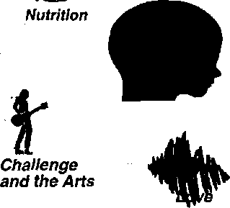
early motor stimulation on learning for many years. He has used eye-hand coordination tasks, spinning, tumbling, rocking, pointing, counting, jumping, and ball toss activities to stimulate the early neural growth patterning. Palmer^ “Chance to Leam Project" at the Shingle Creek Elementary School in Minneapolis showed positive effects on students through the Metropolitan Readiness Test, Test of Visual Perception, and the Otis Group Intelligence Test (Palmer 1980). In similar studies, the experimental group consistently outperformed the control group.
The benefits of early motor stimulation don't end in elementary school; there is tremendous value in novel motor stimulation throughout secondary school and the rest of our life (Brink 1995). Schools ought to make a planned program of specific motor stimulation mandatory in K-l grades, but they also should integrate physical activity across the curriculum. In sports, we expect learners to use their brains for counting, planning, figuring, and problem solving, Every athlete is highly engaged in cognitive functions. It makes sense that we’d expect students to use their bodies for kinesthetic learning in the academic classes (see fig. 4.3).

Enrichment Through Thinking and Problem

Solving
The single best way to grow a better brain is through challenging problem solving. This creates new dendritic connections that allow us to make even more connections. The brain is ready for simple, concrete problem solving at age 1 or 2. But the more complicated variety usually has to wait. There’s a spurt of dendritic branching in the right hemisphere between 4 and 7 and in the left hemi-

Key Factors That Influence Early Brain Development and Academic Achievement
Exercise
Uf
Feedback sphere between 9 and 12 (Hannaford 1995). Both sides are fully developed and usually ready for complex abstractions by ages 11 to 13. By then, the major bridge between left and right hemispheres, the corpus callosum, is fully matured. At that point it carries four billion messages per second across its 200-300 million nerve fibers and is ready for extra challenges. Some maturing of the brain continues into the mid-20s.
Kids need complex, challenging problems to solve. But problem solving is not limited to one area of the brain. After all, you can solve a problem on paper, with a*model, with an analogy or metaphor, by discussion, with statistics, through artwork, or during a demonstration. As a result, there are as many neural pathways as we need to ■ develop in children’s brains as there are ways to solve a problem. That means it’s critical to expose ■ students to a variety of approaches to solving prob-

36

lems (Gardner 1993). When students feel more capable of solving a problem, their thoughts change their body’s chemistry. Stanford University’s Albert Bandura found that when the feelings of competence increased, the subjects in the test released fewer catacholomines, the body’s natural chemical response to stress.
Surprisingly, it doesn’t matter to the brain whether it ever comes up with an answer. The neural growth happens because oj_thgj2iQ££S£Ulot the solution. A student could go to school for 12 years, rarely get right answers^_and^stilUiavea_ well-developed brain. Some learners "simply choose harder and harder problems to solve. That may stimulate the release of noradrenaline, and alsy create dendritic growth. Richard Haier of the Brain Imaging Center at the University of California at Irvine says, “The newer and more difficult the video game, the more neural activity” (in Marquis 1996, p. B-2), More intelligent people work their brains harder initially, then coast later on. Facing novel stimuli, higher IQ brains fire more neurons initially bringing more resources to bear (Howard 1994). There’s a much higher consumption of glucose while learning a new game versus when the game is mastered and the player is finally getting high scores. At the level of “mastery,” the brain is coasting.
All of the typical puzzles, word games, hypothetical problems, and real-world problems are good for the brain. But be patient: The ability to _succeed_atongjype of puzzle doesjnotmeanwou'll be good at another. That’s why someone is often good at crosswords but not jigsaw puzzles. Or they mifiht be good at Scrabble and jeopardy. but weak atcarrisjmd^domino^The neural pathways that help us to excel at thinking skills are so specific that the whole concept of being “smart" or “gifted
and talented” has been called into question (Gardner 1983). It makes sense to encourage youngsters to do any problem-solving activity; the more real- life, the better. Also good are science experiments or building projects. Sadly only 5 percent of all 11-year-olds have developed formal reasoning skills; that number is 25 percent by age 14. By adulthood, that percentage goes up to only 50 percent of the population (Epstein 1986).

Enrichment Through the Arts
For most of the twentieth century, a strong arts program meant you were raising a culturally aware child. But today’s biology suggests that arts can help lay the foundation for later academic and career success. A strong art foundation builds creaqiyit^_conceppr^j^njrQbl£m-SQlving- self- efficacv. coordination, and values attention and selhdisci£lj££.
The Musical Brain. We’ve all heard about the value of music as a component of enriched learning. Many schools offer music education in so- called gifted programs. But what evidence is there that daily music education ought to be universal, for every K-12 student? Is it merely anecdotal or has the new research on the brain caught up? In a nutshell, the evidence is persuasive that (1) our brain may be designed for music and arts and (2) a music and arts education has positive, measurable, and lasting academic and social benefits. In fact, considerable evidence suggests a broad-based music and arts education should be required for every student in the country.
Music is not a “right-brained frill." Robert Zatorre, neuropsychologist at the Montreal Neurological Institute, says, “I have very little doubt that when you’re listening to a real piece of music, it is engaging the entire brain” (in Shreeve 1996,
Enriched Environments and the Brain

37

p. 96). Reading music engages both sides of the brain, said the late Justine Sergent of the Montreal Neurological Institute. Once anyone learns how to read, compose, or play music, their left brain gets very involved. How does music fit with the concept of enrichment? Think of music as a tool for usage in at least three possible categories: for arousal, as a carrier of words, and as a primer for the brain. Arousal means the music either increases or decreases the attentional neurotransmitters. An example of “perk up” music could be the theme from “Rocky,” Relaxing music might include a waterfall or soft piano melodies. This type of music can significantly affect the states of the learners. And that, of course, can affect the learning. A study of 8th and 9th graders reported in Principal magazine showed that students’ reading comprehension substantially improved with background music (Giles 1991).
A second use of music is as a carrier. In this case, the melody of the music acts as the vehicle for the words themselves. You may have noticed how easily students pick up the words to new songs. It’s the melody that helps them learn the words. How did you learn the alphabet? Most likely it was through the alphabet song. You heard that song over and over as an infant. When it was time to learn the letters, you simply “glued” the letters to the notes of the melody. The result was a quickly learned alphabet.
There is a third, and quite powerful, use of music. It can actually prime the brain’s neural pathways. Neurons are constantly Bring. What distinguishes the “neural chatter” from clear thinking is the speed, sequence, and strength of the connections. These variables constitute a pattern of Bring that can be triggered or “primed” by certain pieces of music. As an example, have you ever put on a
piece of music to help you get a task done like cleaning the house or garage?
To review the evidence, we turn to Norman Weinberger, a neuroscientist at the University of California at Irvine. He’s an expert on the auditory cortex and its response to music. He says, “An increasing amount of research findings supports the theory that the brain is specialized for the building blocks of music” (Weinberger 1995, p. 6). Much research suggests that the auditory cortex responds to pitch and tones rather than simply raw sound frequencies, and individual brain cells process melodic contour, Music may, in fact, be critical for later cognitive activities.
Lamb and Gregory (1993) found a high correlation between pitch discrimination and reading skills. Mohanty and Hejmadi (1992) found that musical dance training boosted scores on the Torrance Test of Creativity. What causes the correlation? It’s all in the rate and pattern that brain cells fire. Frances Rauscher says, “We know the neural firing patterns are basically the same for music appreciation and abstract reasoning. ...” (in Mandelblatt 1993, p, 13). In the well-publicized “Mozart Effect” study at the University of California at Irvine, there were three listening conditions. One was relaxation music. The other, the control, had no music. The third had Mozart’s “Sonata for Two Pianos in D Major.” After just 10 minutes of headset listening, Rauscher, Shaw, Levine, Ky, and Wright (1993) found that the Mozart selection temporarily improved spatial temporal reasoning. Rauscher notes that it’s a causal relationship, not a correlation. This study was the first ever to show listening to music as the cause of improved spatial- intelligence. Other studies had merely shown that music was a contributing factor or had indirect correlations. Listening to Mozart before

38

testing is valuable; listening during a test would cause neural competition by interfering with the neural firing pattern.
A survey of studies suggest that music plays a significant role in enhancing a wide range of academic and social skills. For one, it activates procedural (body) memory and therefore, is learning that lasts (Dowling 1993), In addition, James Hanshu- macher (1980) reviewed 36 studies, of which 5 were published and the remaining were unpublished dissertations. He concluded that arts education facilitates language development, enhances creativity, boosts reading readiness, helps social development, assists general intellectual achievement, and fosters positive attitudes toward school (Hanshumacher 1980). After all, music is a language that can enhance the abilities of children who don’t excel in the expression of verbal thinking.
Does evidence support the value of singing? Music researcher M. Kalmar found that music has many positive school correlates. Between the two groups, only the experimental group had better abstract conceptual thinking, stronger motor development, coordination, creativity, and verbal abilities. Another study (Hurwitz, Wolff, Bortnick, and Kokas 1975) concluded that the music groups (trained only in folk songs) “exhibited significantly higher reading scores than did the control group, scoring in the 88th percentile versus the 72nd percentile.” Singing is good stimulation for the brain, “a means to promote both musical competence and full development. . .” (Weinberger 1996).
Art Enrichment. How does art research hold up? Art education has gotten a tremendous boost from discoveries in neuroscience. The old paradigm was that left-brain thinking was the home of the necessary “higher-order" thinking skills, and
right-brain activities were frills. That paradigm is dead wrong. Current research tells us that much learning is “both-brained.” Musicians usually process melodies in their left hemispheres. PET scans of problem solvers show activations in not just the left frontal lobes but other areas used to store music, art, and movement (Kearney 1996). Many of our greatest scientific thinkers, like Einstein, have talked about the integration of imagination into scientific pursuit.
There has been worldwide success of the neuropsychological art therapy model, or NAT developed by Gamer (1996; see also Parente and Anderson-Parente 1991, McGraw 1989). The use of art not just to draw but to teach thinking and build emotive expressiveness and memory has been a remarkable demonstration of the brain’s plasticity. By learning and practicing art, the human brain actually rewires itself to make more and stronger connections. Researchers learned this by using it as therapy for the brain damaged (Kolb and Whishaw 1990). Jean Houston says that arts stimulate body awareness, creativity, and sense of self. In fact, she says, “The child without access to arts is being systematically cut off from most of the ways in which he can experience the world” (in Williams 1977).
Policymakers and educators are often looking for data to support the role of arts. In Columbus, Ohio, the results were quite measurable. Talk to principal James Gardell at Douglas Elementary.
This predominately arts-centered school has achievement scores 20 points above the district norms in 5 of 6 academic areas. Demand for their program is strong; more than 100 children are on the schools “wait list." Does the art emphasis make a difference? “There's a definite link,” says Gardell

1
1
i!
(1997). Other schools in the area like Duxbury, Clinton, and Fair Avenue are experiencing similar academic success through an arts emphasis.
Norman Weinberger states emphatically that the argument that art and music are frills "finds no objective support." He summarizes, “Teachers should be encouraged to bring or increase music in the classroom” (Weinberger 1996). But do they need to be experts or music teachers? Music specialists are preferred, but in the absence of an expert, something is better than nothing.
Enrichment Through the Surroundings
.Teachers often like to share their "enriched class-, roomlwith others. They proudly show off all of the affirmations ^mobiles, posters, colors^and pictures nn thr walk
the word enrichment is obviously being used very loosely. IJememberdiatenric^^ chalJj£T££_{i}£]^yj^ka$^j2£^^ thetic enjoyment.
Does this mean that we should encourage bare-walled classrooms? Absolutely not! Vj/hilejttie busjj_{L}decorativeclassrooms_{i}£^
ajjghyyjgsJffiien^ahie^he^i^en^i^
valuablejgur^ose^^h^^nbe^a^
tion^ffyjggJiQjkjmd^conient^
ersjgel safe, comfortable, or keep up with the learning (Debes 1974). Do you think it matters what we look at? In hospitals, a controlled study found that patients with “a view room’’ recovered lastenhairthosTwho^taTedTrT^ricrwall. The stimulation apparently affects more than wellbeing; it also feeds the brain (Urich 1984). A rich classroom environment full of posters,, mobiles, maps, pictures, and graphic organizers will he taken in aLsome level bv most students.
Enriched Environments and the Brain
39
Practical Suggestions
We'ye-.cQme-lo understand the two critical inpredi-
Since what’s challenging for one student may not be challenging for another, this makes a tremendous argument for choice in the learning process, including self-paced learning, and more variety in the strategies used to engage learners better. Examples of choice include the student’s option to select the complexity or type of a project. In addition, choice may include student decisions about computers, videos, partners, seating, and the final format of the expected end result. Variety means that regardless of what students choose, it’s the educator’s imperative to expose them to a wide variety of methodology This means rotating individual and group work, drama, music, presentations, self- directed work, computers, guest speakers, and travel to new locations, even if it’s just to another classroom in the school.
To increase enrichment, it’s time to reaffirm the integration of the arts and movement into the curriculum. The national Goals 2000 statement had little mention of the arts; that makes poor sense in lieu of their long-term value. and movement ate often excellent forms of challenge and feedback. Norman Weinberger calls for “widespread educational trials” in arts and music education. Inj^^amejvayt^ testecUvithcoi^yEllfiijiUidie^^
_FDA, schools ought to conduct systematic and for-^ mally documented trials with art and movement ^Ugation^
To do that, we might • Fomibeueralliancesamongs^ local universities in order to fiet better studies initiated and tracked.
40

- Increase the appropriate use of music,
, and playing
instruments.
- Incjeas^]2£jj£}mess_andvj^
options in the environment through, for example, seating, lighting, and peripherals.
Two rules come from the field of brain research and enrichment. One is to eliminate threat, and the other is to enrich like crazy. Before we understood the collective impact of an enriched environment, it may have been acceptable to justify a minimalist classroom. Gone are the days in which any teacher could justify a barren classroom with one-way lecture as the only input. Today, the evidence is overwhelming that enriched environments do grow a better brain. In addition, the early_deyelopin^ brain grows fastest and is the most ready for change. That opportunity must be seized.
Whil^the case for enrichment is strong, what happens if we don’t enrich? In “teenage" rats, a boring environment had a more powerful thinning effect on the cortex than did a positive, enriched ^viwnimwn on thirhminp rhe rnrteyiDiamnnd 1998, p. 31). Bomdomjsmorethai^ teens—it_may_bgThinningjteir brains! Fortunately, studiesshow^the^shrmkage^c^ little as four davs in. 31).
Considering that schools provide a forum for an average of 6 hours a day, 180 days a year, for 13 years, that’s a potential exposure of over 14,000 hours. Thus, educators have a significant moral and ethical responsibility for enhancing or limiting the lifetime potential of a human being. Will those houfs be spent nurturing a better brain or literally narrowing the boundaries of that potential? The answer is easy. Let’s all enrich like crazy.

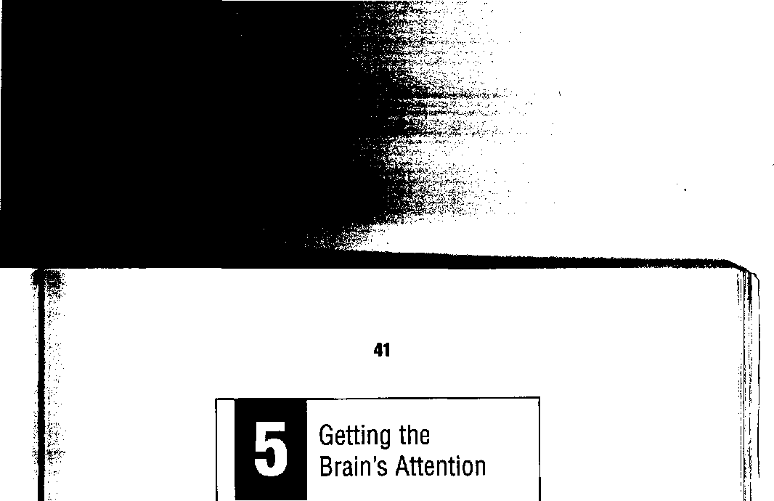
I ■
'i
Key Concepts
I The biology ol attention
» Getting attention bat not keeping It
_ :!.
I The brain’s high- and low- i
attention cycles |
» An ADD update
> Implications for classroom discipline
Getting students’ attention and keeping it has been the brass ring in the world of teaching. Many among us admire Hollywood teachers from movies like Stand and Deliver, Dead Poets Society, and Dangerous Minds. They rivet students'—and our own—attention, and we respect colleagues who can imitate their methods in real life.
But what if such a teaching model were wrong? What if getting attention ought to be the_ exception—not the rule? What if we’re placing inappropriate and often unreasonable demands on students, and the more that a teacher has a student’s attention, the less genuine learning can happen? That’s the focus of this chapter: attention and its relationship to learning in light of recent brain research,

The Attentive Brain
As each new school year begins, well-meaning teachers quickly classify students into two categories: those who pay attention and those who don’t, Translated, that means the “good kids" and the “problem kids." Consequently, an enormous
amount of energy is invested in getting kids “to be good.” The stakes are high, and the tools include promises, rewards, noisemakers, threats, raised voices, and gimmicks. Nearly every experienced teacher has surefire ways to get attention. For years, new teachers eagerly modeled these “top- gun” teacher methods. They, too, wanted to get student attention and keep it. But is that really good teaching?
For much of the 20th century, attention was the domain of psychology. But in the last decade, several strands of research have mounted a powerful case about the role biological factors play in attention and learning. We now know the purpose of attention seems to be (1) to promote survival and (2) to extend pleasurable states. For example, research has revealed;
- Attentional systems are located throughout the brain.
- The contrasts of movement, sounds, and emotions (like threat) consume most of our attention.
- Chemicals play the most significant role in attention.
- Genes also may be involved in attention.
When we are awake, we have an important
decision to make every single moment; where to turn our attention. A normal person makes this decision about 100,000 times a day. The brain is always paying attention to something; its survival depends on it. In general, when we talk about “paying attention” in an educational context, we are referring to external, focused attention. That means the student is looking at the teacher and thinking only of the material presented.
However, the brain’s attentional systems have countless other possibilities. Attention can be
external or internal, focused or diffused, relaxed or vigilant. We ask students to be able to identify appropriate objects of attention (often it’s a teacher); to sustain that attention until instructed otherwise (even if it!s a lecture that lasts for an hour); and to ignore other, often more interesting, stimuli in the environment. This request is entirely reasonable when the learning is relevant, engaging, and chosen by the learner. When those conditions are not met, classroom attention is a statistical improbability.
We now know that the two primary determinates of our attention are the sensory input (such as a threat or an appealing opportunity) and the brain’s chemical “flavor of the moment." One is focused like a laser beam, the other is scattered, more like a set of Christmas tree lights. Both are constantly regulating our attention, so let’s explore each of them.
The Pathways of Attention
The attention process consists of alarm, orientation, identification, and decision. This sequential, laser beam process is akin to, “Whoops, something's happening,” then, “Where?" and finally “What is it?” The answer to the final question will usually tell us how long we ought to attend to it.
Attention is expressed in a student when there’s greater flow of information in the specific target area of the brain's pathways relative to the surrounding pathways. In short, when specialized brain activity is up, attention is up. Figure 5.1 illustrates the various areas of the brain involved in getting and keeping attention.
How does your brain know what specifically to pay attention to in the moment? The secret is that our visual system (which sends more than 80 per-
i
|
i
42

Getting the Unfa's Attention
43

i
Areas Involved in Getting and Keeping Your Attention
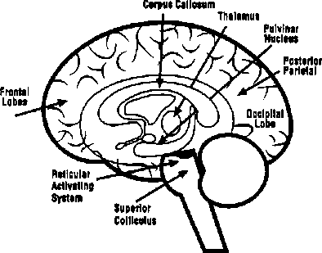

cent of information to the brain in nonimpaired learners) is not a one-way street. Information flows both ways, back and forth from our eyes, to the thalamus, to the visual cortex. This feedback is the mechanism that "shapes” our attention so that we can focus on one particular thing, like a teacher lecturing or reading a book (Kosslyn 1992). Amazingly, the number of inputs that our "attention headquarters” gets as feedback from the cortex is nearly six times as high as the original input from the retina. That volume of feedback triggers certain selective neurons along the visual pathways to fire less often because their membranes are hyper- polarized to prevent normal processing. The proper attentional functioning means not just stimulating many new neurons but also suppressing unimportant information. Somehow, the brain corrects incoming images to help you stay attentive. What we see and attend to is a two-way balancing act of
construction and feedback-maintenance of stimuli. When you are ignoring something, the brain has an innate mechanism for shutting down inputs.
The brain’s susceptibility to paying attention is very much influenced by priming. We are more likely to see something if we are told to look for it or prompted on its location. Neuroimaging methods have shown increased neuronal firing in the frontal lobes and anterior cingulate when someone is working hard to pay attention. In general, the right parietal lobe is involved in attentional shifts.
If you are looking for a teaching book you left in the classroom, your left frontal lobe tells the midbrain area how to sort incoming data. There, the lateral geniculate nucleus (LGN) suppresses the input of all other books, folders, pamphlets, boxes, and other book-sized objects that look anything like that book but are not the one you want (LaBerge 1995). Not only that, the mere thought of that book will trigger any similar book to your attention. By trying countless possibilities within seconds, the brain usually comes up with the goal: the book is found, it is declared lost, you lose interest, or you decide to continue searching.
Selective attention depends on suppression of irrelevant data and the amplification of relevant data. To a great deal, students succeed academically when they have the ability to “tune in” like a radio to an exact, focused “bandwidth." What’s outside the bandwidth must be important to get your attention. If you want attention, provide a strong contrast from what you were just doing. We get used to a new smell within seconds, so it takes a new one to again get our attention. Teachers who raise their voices in an already too-noisy classroom may get frustrated. It makes more sense to use a highly contrasting signal system like a desktop
44
bell, a raised hand, a playground whistle, or a dramatic change of location.
The Chemistry of Attention
Our brain’s chemicals are the real life-blood of the attentional system and have a great deal to do with what students pay attention to at school. The chemicals include neurotransmitters, hormones, and peptides. Acetylcholine is a neurotransmitter that seems to be linked with drowsiness. In general, its levels are higher in the later afternoon and nighttime. Clearly, we are more alert with higher adrenaline levels, Researchers suspect that of all the chemicals, norepinephrine is the most involved in attention (Hobson 1994). Studies indicate that when we are drowsy or “out of it,” our norepinephrine levels are usually tow; when we are too “hyper" and stressed, the levels are too high.
Under stress and threat, the dominant chemicals in the brain include cortisol, vasopressin, and endorphins. The first two are particularly critical to our stress and threat responses. If a student is about to be called to the principal’s office, the body’s stress and threat response kicks in. Pulse is up, skin is flushed, and the body’s “on edge.’’ A change in chemicals means a likely change in behaviors. For example, if you want creativity from students, you may have found it works to get them out of a stressed state with a walk, music, humor, or storytelling.
Roller-Coaster Attention Cycles
You may have noticed that you have natural attentional highs and lows throughout the day. These are ultradian rhythms, one of our brain’s key cycles lasting about 90-110 minutes. That means we
have about 16 cycles lasting 24-hour period. The odd thing is that while we are used to "light and deep" sleep, we rarely connect this with typical high and low arousal-rest cycles during the day Some students who are consistently drowsy in your class may be at the bottom of the their attentional cycle. Movements such as stretching or marching can help focus attention. Students should be encouraged to stand and stretch, without attracting attention, if they feel drowsy.
The brain shifts its cognitive abilities on those high and low cycles. There’s literally a change in blood flow and breathing on these cycles that affects learning (Klein, Pilon, Prosser, and Shannahoff-Khalsa 1986). Our brain becomes alternately more efficient in processing either verbal or spatial information. These periods of alternating efficiency seem to correlate with a known rhythm, “the basic rest-activity cycle” (BRAC), discovered sometime ago via sleep research. In studies by Raymond Klein and Roseanne Armitage, eight subjects were tested for 3-minute periods every 15 minutes over an eight-hour day on two tasks, one predominantly verbal, the other spatial. The differences are significant; the upswing on verbal tasks went from an average score of 165 to 215 correct answers and a simultaneous downswing from 125 to 108 on spatial (Klein and Armitage 1979). This oscillation suggests that we will get lower scores if we test students at the wrong time.
It makes a case for choice in the learning process and choice in the assessment process. Portfolios, which are compiled over time, are more inclusive and accurate than a “snapshot” test, since they may average in the highs and lows better. Figure 5.2 represents the brain’s cycles through the day and night. Figure 5.3 represents electrical activity during brain wave states.

Getting the Brain's Attention

45

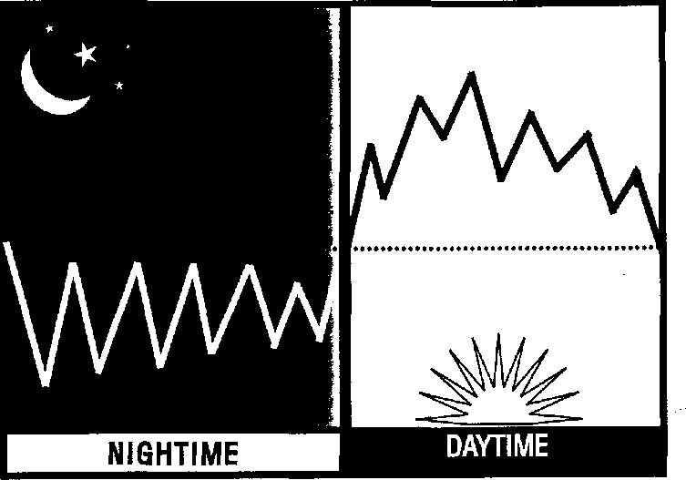
\:
;j

The Brain’s 90-110 Minute High-Low Cycles
BETA
ALPHA
THETA
DELTA
The daily low or “down” parts of the 90-110 minute cycle reflect the message from our brains: Take it easy. Several researchers say that mental breaks of up to 20 minutes several times a day increase productivity (Rossi and Nimmons 1991). Instead of fighting the lack of energy or alertness, educators can take advantage of it. Pearce Howard (1994) says that in general, workers need 5- to 10-minute breaks every hour and a half. Why would students or staff be any different? That would fit right into the “bottom” of the 90-110 minute cycle. In secondary schools, running from one classroom to another is not true “down time” for most students. These cycles make a good case for the use of block scheduling at the secondary
level. With a longer block of time, the teacher can include break activities without feeling pressured to teach content every minute,

The Role of Inattention or “Processing Time”
Generally, the brain does poorly at continuous, high-level attention. In fact, genuine “external” attention can be sustained at a high and constant level for only a short time, generally 10 minutes or less. This leads us to the biological question,
“What smart adaptive benefits might there be to having a shorter attention span?" Researchers suggest that there may be several good reasons. You are able to react quickly to predators and prey It allows you to update your priorities by rechoosing

Brain Wave States Are Measures of Electrical Activity (cps = cycles per second)

46
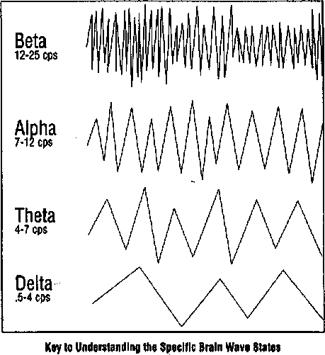
Bela... High activity: debate, exercise, complex projects, competition Alpha...Relaxed alertness: reading, writing, watching, problem solving Theta...Deep susceptibility: drowsy, meditative, processing time Delta...Nonconscious: deepest sleep, 'dead to the world'

the object of your attention (LaBerge 1995). This affirms the value of focused learning time followed by diffused activities like reflection.
In the classroom, there are three reasons why constant attention is counterproductive. First, much Of what we learn cannot be processed consciously; it happens too fast. We need time to process it. Second, in order to create new meaning, we need internal time. Meaning is always generated from within, not externally. Third, after each new learning experience, we need time for the learning to “imprint.”
In fact, new physical skills can take up to six hours to solidify. Henry Holcomb of Johns
Hopkins University asserts that other new learning contaminates the memory process. “We’ve shown that time itself is a very powerful component of learning,” he adds (in Manning 1997). Our visual capacity, measured by bits per second and carried by the optical nerve, is in the tens of millions (Koch 1997). That’s far too much to process consciously (Dudai 1997). In order to either proceed or figure it all out, a student must “go intemal” and give up that “external” attention. We can’t process it all consciously, so the brain continues to process information before and long after we are aware that we are doing it. As a result, many of our best ideas seem to pop out of the blue. As educators, we must allow for this creative time if we want new learning to occur. After completely new learning takes place, teachers should consider short, divergent activities like a ball toss or a walk that builds communication skills.
Humans are natural meaning-seeking organisms. But while the search is innate, the end result is not automatic. Because meaning is generated internally, external input conflicts with the possibility that learners can turn what they have just learned into something meaningful. You can either have your learners’ attention or they can be making meaning, but never both at the same time. Therefore, teachers might allow students to have a small group discussion after new material is introduced to sort it out, generate questions, and propose what-if scenarios. Synapses strengthen when they are given time for neural connections to solidify because they don’t need to respond to other competing stimuli. Cellular resources can be preserved and focused on critical synaptic junctions (see fig. 5.4).
Alcino Silva at Cold Spring Harbor Laboratory discovered that mice improved their learning with short training sessions punctuated by rest intervals

47

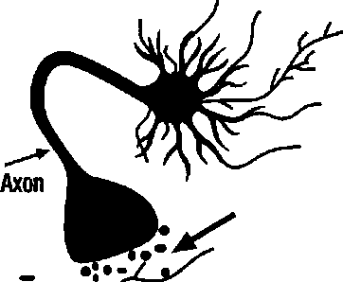
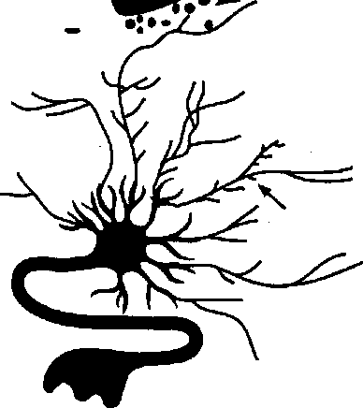
Dendrites

Allow Time for the Brain’s Connections to Solidify
Synapse is strengthened when there are no competing neural stimuli for several minutes
(Lasley 1997). He says the rest time allows the brain to recycle CREB, an acronym for a protein switch crucial to long-term memory formation. Other research also suggests that periods of purposeful processing time, as an incubation for learning, may be ideal (Scroth et al. 1993). It may be the down time, which we now know is not really down, thats most important for new information processing. Learning can become more functional when external stimuli is shut'down and
the brain can link it to other associations, uses, and procedures. This association and consolidation process can only occur during down time, says Allan Hobson of Harvard University. This finding suggests that we may want to allow for several minutes of reflection time after new learning. Writing in journals or discussing the new learning in small groups makes good sense for the learning brain.
The essential point here is that teachers must encourage personal processing time after new learning for material to solidify. The variety of options above reflect different student needs, learning styles, and intelligences. Cramming more content per minute, or moving from one piece of learning to the next, virtually guarantees that little will be learned or retained. In fact, many teachers who complain of having to do so much reteaching are the same ones trying to cram too much. How much processing time depends on the difficulty of the material and background of the learner. Teaching heavy, new content to novice learners may require processing time of 2 5 minutes every 10 15 minutes. But a review of old-hat material to well-rehearsed learners may require only a minute or so every 20 minutes. (See fig. 5.5.)
This old notion of continuous attention also is a problem for teachers themselves. Teachers need more personal and better quality down time during the day. With schedules that rarely allow for more than a moment of solitude or quiet, stress is the order of the day. The work schedule wreaks havoc on the teachers high- and low-brain cycles. To stay alert, teachers often become caffeine junkies, consuming a steady stream of coffee and soft drinks. It makes sense for teachers to find a few moments for quiet time, if possible. If not, they should reduce their intake of carbohydrates that induce drowsiness and stay as physically

48
Factors That Influence Attention for Learning
©

Increase intrinsic motivation Hook attention for 10-90 minutes
Increase apathy and resentment Hook attention for 10 minutes or less

Choices vs. Required
Provide choices: content, timing, work partners, Directed 100%, no student input, resources
projects, process, environment, or resources. restricted—for example, working alone
Relevant vs. Irrelevant
Make it personal: relate to family, neighborhood, city, Impersonal, useless, out of context, and life stages, love, health, and so on done only to pass a test
Engaging vs. Passive
Make it emotional, energetic; make it physical; use Disconnected from the real world, low learner-imposed deadlines and peer pressure interaction, lecture, seatwork, or video
■ '?■ ■u
todays K-2 teacher, its fairly acceptable to have $
active as possible with movement, stretching, and deep breathing.
Edison was famous for taking short, quick naps during the day. Some sleep experts now encourage employees to take a daily catnap. The Nike offices in Beaverton, Oregon, have a “relaxation room” for it. Even the FAA, which has banned pilot “catnaps,” is considering a plan to allow power napping, Cornell University sleep researcher James Maas prescribes a 20-minute afternoon nap to combat fatigue. He says power nappers think more clearly and perform far better than their overtired colleagues. (Wallis 1996), For
down time or nap time. For students age 8 and older, a 15-minute quiet “choice time” might allow -i? for a nap, reading, reflection, writing, or drawing. )
The critical ingredient to down time or personal processing time is choice. If a teacher uses this time to assign seatwork or deadline-centered projects, it is not rest for the brain. j
t
How Attention Affects Discipline
A classroom that is plagued by discipline problems
may have many overlapping causes. One of the
first places to start is with attention. Cut the length !

i ! !:'i
i
r ’■ ,
of focused attention time expected or required. Remember that the human brain is poor at nonstop attention. As a guideline, use 5-7 minutes of direct instruction for K-2, 8-12 minutes for grades 3-7, and 12-15 minutes for grades &-12. After learning, the brain needs time for processing and rest. In a typical classroom, this means rotating mini-lectures, group work, reflection, individual work, and team project time.
The causes of quick-tempered, short-attention span behaviors are currently being explored by neuroscientists. Dopamine is a neurotransmitter known to regulate emotion, movement, and thought. Researchers have discovered that there’s a genetic link between quick-tempered, noveltyseeking, and inattentive behaviors and a specific receptor gene for dopamine. Those students who have a longer DNA sequence in this gene score much higher on tests that measure novelty seeking and impulsiveness. The implications for this are significant: Some students will be out of control, but the cause of their behavior may be genes, not poor parenting (Hittman 1996). Teachers should set aside the label of misbehavior and simply deal with the behavior. Sometimes adding more active learning strategies is all it takes.

Attention Deficit
We’ve learned the brain is poorly designed for continuous, focused attention. The opposite, too much attention, is a form of attention deficit, too. Trying to pay attention to everything is as much a problem as not paying enough attention when appropriate. In the United States, attention deficit disorder (ADD) accounts for almost half of all child psychiatric referrals (Wilder 1996). Studies indicate that 1 of 20 children aged 6 to 10 and about 3 percent of all children under 19 are on ADD med
ications like Ritalin or Cylert. Prescriptions are currently at 1.5 million and climbing dramatically (Elias 1996). Some schools have as many as 10 percent on Ritalin.
ADD is not without controversy While some researchers believe it is a specific medical disorder, others believe that the label masks many other more narrowly defined problems like poor hearing, bad eyesight, or inadequate nutrition, The current research on the biological underpinnings of ADD associates the disorder with several factors. A large sample of 102 children diagnosed with ADD found evidence of smaller attentional structures in the outermost right frontal lobe areas and basal ganglia (Wilder 1996). Those two areas are thought to be essential for directing focus and blocking out distractions. Second, there’s evidence of faulty regulation of glucose metabolization and of the neurotransmitter norepinephrine. Finally, S. Milberger, Joseph Biederman, and their colleagues at Massachusetts General Hospital have discovered a striking connection between ADD and maternal smoking (George 1996).
Research suggests that other psychiatric disorders frequently occur with ADD making detection confusing. These include inability to form close relationships, anxiety, and stress trauma. Those who do have ADD are often fidgety, with scattered attention. The critical qualifying symptoms for a child to be diagnosed with ADD are that the symptoms must be both excessive and long term, The ability to focus attention and restrain inappropriate motor acts demonstrates not that children with ADD can’t pay attention; they are paying attention to everything. They continually disengage from one signal in favor of the next irrelevant signal. Their system is low on norepinephrine, so the drug intervention (when appropriate) is to give it a stimulant.
Ritalin is a central nervous stimulant that inhibits the reuptake of dopamine and norepinephrine. ADD medications are usually amphetamines, which boost the “signal” of the more important information and help inhibit some of the distracting motor movements. Some students will outgrow the behavior; others won’t. Researchers are uncertain what percentage of children with ADD are likely to continue into adulthood with the disorder. Hill and Schoener’s model predicts a 50 percent decline every 5 years beyond childhood (George 1996).

50
Most psychiatrists today specify ADD symptoms as “predominantly inattentive,” “predominantly hyperactive,” or “combined." The most common characteristic, according to researchers, is “comorbidity." That’s the phenomenon of finding more than one psychiatric disorder at a time. Frequently, the disorder co-occurs with conduct, anxiety, and learning disorders (Biederman et al. 1996). While most of the medical community has ruled out poor parenting, bad environments, or lack of nutrition, others feel differently. One of the most vocal, Thomas Armstrong, is the author of The Myth of ADD. He suggests many other variables are suspect, including a mismatch of teaching and learning styles, poor nutrition, and poor parenting (Armstrong 1995).
Many researchers believe that ADD is overdiagnosed, Too often kids are prescribed Ritalin after one short visit with their GP and no input from parents or teachers. But one might be equally distressed over the few kids who do have ADD and don’t gel help. For them, tile Is u horror movie they can't escape.
Detection and diagnosis of ADD is difficult. First, many students are misdiagnosed as ADD when their problem may be crowded classrooms,
discipline difficulties, a teacher who demands an inappropriate amount of classroom attention, or a lack of self-discipline skills. Many times diet or allergies are contributing factors. The best solutions may be to make sure that the intervention assessing team and the student have first exhausted nonprescriptive options including changing classes or teachers. When medications are used, they should be monitored carefully to ensure results are in line with expectations.
Practical Suggestions
The old notion about attention was get it and keep it. Today you can have students’ attention 20-40 percent of the time and get terrific results. We know how to get attention: use contrast. In fact, nearly everything that is novel will gamer attention; the contrast alone is enough. As classroom teachers well know, a student who cracks a joke, an uninvited visitor, threats, shocks, or bodily sounds will all get our attention. But that’s not the kind of attention we have in mind.
A change in location is one of the easiest ways to get attention, because our brain’s posterior attention system is specialized to respond to location rather than other cues like color, hue, shape, or motion (Ackerman 1992). For example, teachers can move to. the back or side of the room during instruction. Students can move to the back of the room, the side, or even go outside for a moment. If it’s appropriate, switch classrooms with another teacher for just one class or a day Field trips are the greatest change of location and well worth it when organized well.
Overall, you’ll want to provide a rich balance of novelty and ritual. Novelty ensures attentional bias,

51

and ritual ensures that there are predictable structures for low stress. For novelty, use a surprising piece of music one day, ask students to bring in something that makes music the next. Have students present their learning to one another, then in small groups. Bring in a guest speaker from your own school. Use fun, energizing rituals for class openings, closings, and most of the repetitious classroom procedures and activities. A double clap and foot stomp may introduce an important daily summary.
A change in voice tonality, tempo, volume, or accent gets attention. Props, noisemakers, bells, whistles,
costumes, music, or singing can get attention. You can also include attention-getting rituals like raising a hand or a daily group clap. Then, intersperse the novelty to ensure the higher attentional bias.
These suggestions are for use once or twice a day, of course. Teachers need not become circus performers. To the contrary, in the best classrooms, the students are the “show.” But teachers must recognize that constant changes in tempo and time for reflection are critical in learning. Once you have attention, make the most of it; otherwise you’ll have to start over again.
I!,¹""

How Threats and Stress Affect Learning
Apart of the Hippocratic Oath says that the first rule in medicine is to do patients no harm. That may well apply to educators, too. Excess stress and threat in the school environment may be the single greatest contributor to impaired academic learning. That’s a strong statement, but when you understand the many potential threats for students and how the brain reacts to- each, it makes sense. This chapter focuses on the negative impact of threats and high stress on the brain, behavior, and learning.
Key Concepts
0 What Is stressful to the brain?
0 Now does stress affect students?
I How threats affect learning
I What Is learned
0 Reducing the impact of stress and threat

Why Common Threats Fail
Threats have long served as the weapon of choice to regulate human behavior. When schools were optional, threats were less relevant; a student who was upset might have simply left. But today, students find that they must endure threats because their presence at school is mandated by law.
Teachers’ most common threats to students include detention, lowered grades, or loss of school privileges. Detention has clout only if one of two variables is present: either the student could better use the time or staying after is a miserable experi-

53

Typical Neuron from
One in a Subordinate Role
ence. Many students don’t have a better use of their time than staying after class. And if staying after is a miserable experience, the bad feelings “contaminate” the student’s overall opinions about the teacher, classroom, and school. That damage can be deadly to long-term motivation and morale, so generally it’s not worth it to detain students. Many students don’t respond to lowered grades or a loss of privileges, so those threats can be tenuous. In short, on a purely behavioral level, threats make little sense. But what is happening on a more . biological level?
Stress and Learning
When we feel stressed, our adrenal glands release a peptide called cortisol. Our body responds with cortisol whether it faces physical, environmental, academic, or emotional danger. This triggers a string of physical reactions including depression of the immune system, tensing of the large muscles, blood-clotting, and increasing blood pressure. It’s the perfect response to the unexpected presence of a saber-toothed tiger. But in school, that kind of response leads to problems. Chronically high cortisol levels lead to the death of brain cells in the hippocampus, which is critical to explicit memory formation (Vincent 1990).
These physical changes are significant. Stanford scientist Robert Sapolsky found that atrophy levels in the hippocampus of Vietnam veterans with PTSD (post-traumatic stress disorder) ranged from 8 to 24 percent above the control group. Chronic stress also impairs a student’s ability to sort out what’s important and what’s not (Gaz- zaniga 1988). Jacobs and Nadel (1985) suggest that thinking and memory are affected under
stress; the brainfc short-term memory and ability to form long-term memories are inhibited.
There are other problems. Chronic stress makes students more susceptible to illness. In one study, students showed a depressed immune system at test time; they had lower levels of an important antibody for fighting infection (Jermott and Magloire 1985). This may explain a vicious academic cycle: More test stress means more sickness, which means poor health and missed classes, which contribute to lower test scores. Figure 6.1 illustrates the differences between a stressed and an unstressed neuron. The stressed one has fewer and shorter dendrites. This deficiency impairs communications with other dendrites. What caused this dramatic difference?

How Social Stress Can Affect Neurons
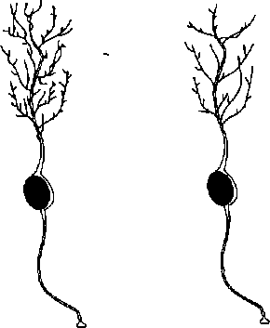

Typical Neuron Taken from an Animal in a Dominant Role
Copyright © 1989-97 by Techpool Studios, Inc., USA.

54

Social position changes both attitude and behaviors. Part of the body and brain’s reaction to these changes are elevated serotonin levels and changes in neural structure. This evidence suggests the value of varying the leadership in class groups.
A stressful physical environment is linked to student failure. Crowded conditions, poor student relationships, and even lighting can matter. Optometrist Ray Gottlieb says that school stress causes vision problems. That in turn impairs academic achievement and self-esteem. He says that, typically, a stressed child will constrict breathing and change how he or she focuses to adapt to the stress. This pattern hurts learning in the short and long run. Under stress, the eyes become more attentive to peripheral areas as a natural way to spot predators first. This makes it nearly impossible to track across a page of print, staying focused on small areas of print. Is this an exception or typical?
To find out, psychiatrist Wayne London switched the lighting in three classrooms at a Vermont elementary school. For the test, half had regular fluorescent bulbs and the other half had bulbs that simulated natural light (full-spectrum lights). The students in the full-spectrum classes missed 65 percent fewer school days from illness. Why? The regular fluorescent lighting has a flickering quality and barely audible hum that are scarcely noticeable but very powerful. Apparently the brain reacts to that visual-auditory stimulus by raising the cortisol levels in the blood and causing the eyes to blink excessively, both indicators of stress. In another study, elementary school children in rooms with the natural and full-spectrum lighting missed fewer school days and reported better moods (Hdelston 1995).
Using classroom computers or watching videos also may be stressful for the eyes. It’s tough on all
ages but for a different reason when students are young. Their eyeballs are very soft and can get distorted by the continual near focusing, which is harder on the eyes than the more relaxed, distant vision. Neurophysiologist Dee Coulter says the task of keeping the eyes focused on a flat backlit screen is stressful (McGregor 1994). Many children spend up to five hours a day watching television, playing video games, or using a computer. As a result, ado_{T} lescents and teenagers need glasses years earlier than they used to, Coulter says.
Social situations can be a source of stress, too. While stress hormones like cortisol are commonly released during stress, serotonin levels are affected, too. Diminished serotonin levels have been linked to violent and aggressive behaviors. For example, students who are “top dog” in their home life and just “one of many” in a classroom become more impulsive. Some of these students suddenly flourish when given roles like a team leader. Studies suggest that classroom status or social hierarchies can and do change the brain’s chemistry This makes a good case for the importance of changing roles often to ensure everyone has a chance to lead and follow.
Another source of environmental stress is the fact that our predictions rarely match reality For adults, it’s a day full of dissatisfaction with noise, erratic drivers, broken copy machines, colleagues who forget their promises, and computer glitches. It's no different for students. A typical schoolday is filled with expectations and disappointments, projects that don’t work out, scores that are lower than usual, and classmates who don’t act the way predicted. All of these "glitches” can be a source of stress. The brain often reacts to these as threats. What is the solution? Provide predictability through school and classroom rituals. A predictable event like a graded paper returned when

55

promised or a peer cheer for celebration sets the unsettled brain at ease (Calvin 1996).
Some stress is not necessarily bad for learning. At Stanford University, Seymour Levine showed that young rats exposed to stressful shock experiences performed better as adults than the nonstressed controls (Thompson 1993). But the rats were not being asked to write a research paper. Those studies remind us that the military is well known for purposely creating stressful environments. Navy and Marine boot camps demand an endless list of perfectly executed chores. To force recruits to meet the standards, threats of physical retribution are commonplace (push-ups, laps, extra duties). But all this purposeful stress is for a good reason: Actual combat is both stressful and threatening. More important, the recruits are rarely asked to think creatively, which is impaired by stress. In short, for most learning conditions, low to moderate levels of stress are best. High stress or threat has no place in schools.
Threat and Learning
It should be noted that outwardly we all respond to potential threats differently. Some dismiss them, while others consider them a challenge and rise to the occasion. For others, they’re devastating. However, the brain responds to threats in predictable ways. The moment a threat is detected, the brain jumps into high gear (see fig. 6.2).
The amygdala is at the center of all our fear and threat responses (LeDoux 1996). It focuses our attention and receives immediate direct inputs from the thalamus, sensory cortex, hippocampus, and frontal lobes. Neural projections (bundles of fibers) from the amygdala then activate the entire sympathetic system. Normally, it triggers the

Simple Functional Reaction to Threat
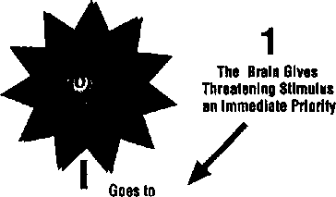

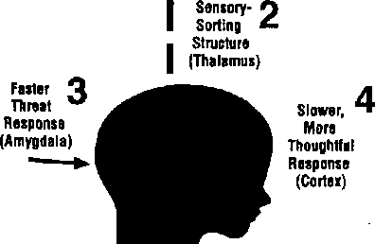

release of adrenaline, vasopressin, and cortisol. These immediately change the way we think, feel, and act. Figure 6.3 summarizes the more detailed biological pathways of stress and threats.
Alan Rozanski reported in the New England Journal oj Medicine that even harsh comments and sarcasm can trigger heart irregularities in patients predisposed to them (Rozanski 1988). New research reveals that threatening environments can even trigger chemical imbalances. Serotonin is the ultimate modulator of our emotions and subsequent behaviors. When serotonin levels fall, violence often rises. Not only can these imbalances trigger impulsive, aggressive behavior, but they also can lead to a lifetime of violence.
Students who have had early and constant childhood exposure to threat and high stress, particularly those who have come from families of vio-

¹ p

56

Complex Pathways to Threat Response

This shortcut ensures that threat-evoking stimuli will get immediate priority
Amygdala
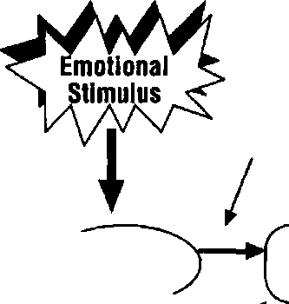
Excitatory (If associated with threat) ^
i
 | ( Sensory VThalamus^
Hippocampus | /sensory
acts as an ^ Inhibitor | k Cortex
 | ^^Transitional
 | V Cortex

Hypothalamus releases CRF

I
Pituitary releases ACTH

I
Adrenal Cortex releases CORT
The result is that the body is now flush with chemical responses that enable it to fight, freeze, or flee. The measurable residue from this single biochemical response can last up to 48 hours.
i

lence, are often the ones for whom it is the most difficult to gain attention. Their vision and voice shift constantly, scanning the room for potential predators or ^{u}prey.” They often swing or swat at other students as a way of establishing “rank.” This tenitorialism is the source of the comments some kids make to others; “Don’t look at me that way!” What they're doing is fending off potential problems. Their brains’ receptor sites have adapted to a
survival-oriented behavior. While this behavior makes for frustrated teachers, it makes perfect sense to the student whose life seems to depend on it.
The list of possible threats for students is endless. Threats may exist in the student’s home, on the way to school, in the hallways, and in the classroom. Threats might include an overstressed parent who threatens with violence, a loss of privileges at school or at home, a boyfriend or girlfriend who

57

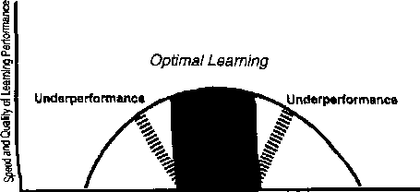
Sleep'Apathy Concern* Relaxed Alertness * Anxiety • Distress • Chaos
threatens to break up the relationship, or a bully who barks harsh words in the hallways. In the classroom, it could be a rude classmate or an unknowing teacher who threatens a student with humiliation, detention, or embarrassment before peers. Any of these events, and a thousand others, can put the brain on alert. It can’t be repeated enough: Threats activate defense mechanisms and behaviors that are great for survival but lousy for learning.
Threats carry other costs. You get predictable, knee-jerk behaviors when the brain senses any threat that induces helplessness. Survival always overrides pattern-detection and complex problem solving. Students are less able to understand connections or detect larger levels of organization.
This fact has tremendous implications for learning. Learning narrows to the memorization of isolated facts. Learners with lower stress can put together relationships, understand broad underlying theories, and integrate a wider range of material. Stress, threat, and induced learner helplessness must be removed from the environment to achieve maximum learning (see fig, 6.4).

Impact of Stress on Learning Performance

lower Stress Levels higher
-4 — ►
Learned Helplessness
Contrary to a temporary unmotivating state, learned helplessness is a chronic and devastating condition. It’s often overdiagnosed, but it's nonetheless worthy of significant discussion. We see its symptoms in student comments like, “I’m stupid (or unlucky), so why bother?” Students demonstrate nearly complete apathy and persistent passivity. Learned helplessness is fairly rare in most classrooms, but when it occurs, it’s quite discouraging. In order to "qualify” as learned helplessness, the following conditions have usually occurred.
- Trauma. The student was in a circumstance involving an important uncontrollable event. Although the most common events are severe threat or trauma, learned helplessness will result even if the uncontrollable event is positive or neutral (Peterson, Maier, and Seligman 1993). The event could be verbal, physical, or psychological. What does not qualify would be a teacher politely telling a student to quiet down or there will be a private discussion after class. What does often qualify is a bully in the hallways, an abusive home- life, or an insensitive teacher who embarrasses or humiliates a student in front of classmates. Under some conditions, the trauma can happen secondhand. For example, when there’s a shooting at a school, counseling teams often need to help students who witnessed the trauma,
- Lack of Control. The student must have had the experience of no control over the traumatic threat and no skills in handling it. An example is the student who is put down harshly in class and feels immobilized by the embarrassment. Thai’s different from the case of an abusive parent, where the student develops skills to deal with the problem and copes by fighting back, getting help, or

58

running away. In that case the student realized the danger and made proactive choices. Some argue that asking students to accomplish tasks for which they lack the resources can also contribute to immobilization.
• Decision. The student must have made a paralyzing decision to explain the event and his or her reaction to it. Usually it takes the form of “1 can’t do anything right” or “I’m to blame" or “I’m bad luck.” These conclusions are the precursor to forming such a negative expectation about the future that the result is no effort. These conclusions can also originate from repeated teacher criticisms like, “You’re hopeless” or “You just don’t try" (Peterson et al. 1993).
Which students are most susceptible to the condition of learned helplessness? The at-risk learners—those who come from threatening home lives and exhibit aggressive street survival behaviors in the classroom—may be most likely to be affected. This notion suggests that we might take a new look at the so called “lack of motivation” in the discouraged learner. The kids at school who seem to be the most able to deal with failure, students who are outgoing and verbal, may in fact, be the ones most unable to deal with it.

The Biology of Learned Helplessness
Here, the evidence is pervasive: Certain traumas can literally rewire the brain. The resulting stresses on students from lack of control “are typically so potent that they alter the activity of almost every neurotransmitter in some particular brain region and some neurotransmitter in almost every brain region,” say Peterson and colleagues (1993). Right now, scientists have collected a great deal of “prob
able biological suspects” yet still don’t have the collective “gang." It’s as if they know the notes but not the whole symphony. When a serious condition is present, intervention is necessary. Some students can be helped with prescription drugs, either stimulants or depressants.
A series of telling animal experiments (Maier and Geer 1968) illuminates the seriousness of lack of control. Dogs were placed in separate cages. They were given mild shocks through the grid floor, with no chance to escape. After their resignation became chronic, the shock was eliminated on half the cage. The dog was then dragged across to the safe area to let it feel the altered grid and see the light indicating safety. But the dog went right back to the shocked side and curled up in fear again. This is similar to a student who has learned to fail and simply won’t even try.
How long do you think it took to get the dog to reengage actively in choice-making again? Five or 10 draggings? “After 30 to 50 such draggings, the dogs began to respond on their own,” say Peterson and colleagues (1993). If you think humans are different, think again. When the brain’s been rewired by experience, lives are changed. To see for yourself, visit a shelter for abused women. Or, visit most high schools and you’ll see many laid-back “I don’t care and it doesn’t matter” kids. Unknowingly, teachers often give up on these students after 5 or 10 positive attempts. In fact, students who have learned to be helpless may need dozens of positive choice trials before becoming mobilized again. The brain must rewire itself to change the behavior.
Amazingly, a single exposure to trauma can produce changes to receptor sites in the brain. Remember, though, it’s the issue of control, which

59

is at the heart of learned helplessness , that has powerful biological consequences. If the student is in a traumatic situation and he makes choices, the condition will not occur, regardless of the outcome. This may be why, time and again, educational reformists have pushed the notion of student control. At a typical school, nearly every decision, from length of time on learning to whom to work with, is dictated and managed outside student control.

The Results of Learned Helplessness
What conclusions can be drawn from these biological changes? Two researchers R Villanova and C. Peterson (cited in Peterson et al. 1993) analyzed 132 studies of learned helplessness that included several thousand human subjects. Part of the analysis compared human effects versus animal effects. The study notes, “[Calculations suggest that the effect in people may be even stronger than the analogous effect in animals. , . (p. 107).
Human experience with uncontrollable events disrupts performance at test tasks. Impaired problem solving is only the tip of the iceberg. The words the authors used to describe the impact were not trivial: they were “moderate” and “robust.” In “researcher language,” these words indicate compelling data. The suggestion is that we might take strong steps to reduce the occurrence of learned helplessness conditions and be proactive in dealing with it.
The emotional responses invoked in the subjects vary from anxiety to anger to depression. Humans who were stimulated to helplessness often became anxious, depressed, and restless, too. Trice (1982) found that exposure to helplessness increased a liking for hostile, as opposed to innocent, humor. You may have noticed that some of
your colleagues or students use excessive sarcasm and make hurtful comments to others. Students can be made helpless by being asked to work (even as a group) on tasks that can’t be solved.
This is an example of where the learned helplessness does not require an initial traumatic event (Peterson et al. 1993). Fortunately, specific strategies can reduce stress, eliminate threat, and head off learned helplessness.
Practical Suggestions
There are two approaches for reducing stress for students. One is to manage the conditions that can induce it, and the other is to use personal strategies that mediate and release it. Help students learn about what induces stress and what to do about it. Teach them stress management tech- niques like time management, breathing, the role of down time, relationships skills, and getting peer support. In the classroom, stress might be released through drama, peer support, games, exercise, discussions, and celebrations'. Physical exercise triggers the release of a brain-derived neurotropic factor (BDNF) that enhances neural communication, elevates mood, and assists in long-term memory formation (Kinoshita 1997). A neurotropic factor is any agent that affects brain functioning, These include internal factors like hormones or external agents like caffeine or valium.
Work on the following three variables: threats from outside of class, threats from other students, and threats from yourself. You have little control on the outside environment, so be sure to establish a start of class transition time for students. It , . allows them to shift gears from the possibly dangerous outside world (a bully in the hallway, fights
\\

60
on the way to school, threats on the way to class). The transition time might include something physical; stretching, dance, manipulatives, a game, or a walk. It could be interpersonal, such as discussion with a small or large group or a neighbor. Finally, it might be personal, including journal writing, reflection, and creative writing.
Reduce threats from other students in class by setting up clear expectations about classroom behavior. Role model appropriate emotional intelligence. Discuss and use conflict resolution strategies. Follow through and enforce classroom rules. Never tolerate students threatening or hurting one another. Talk about what language is appropriate to use in school. Let students role play acceptable and inappropriate behaviors. Encourage the use of partners, work groups, and teams. Change them every three to six weeks to ensure everyone has a chance to meet and work with others in a variety of leadership and support roles.
It takes special vigilance to reduce threats.
Avoid maintaining unrealistic deadlines by simply asking partway through an activity, “How many could use another few minutes?” Or, “How many of you think the one week due date is realistic?”
Ask for what you want without adding a threat on the end. Instead of saying, “Kenny, keep it down, or I’ll have to ask you to stay after,” say, “Kenny, we’re short on time today Can you keep it down, please?” Never threaten misbehaviors with trips to the office. Either send someone or don’t. Involve students in the class disciplining so that peers can help with the process.
Also avoid finger-pointing. Help students locate key resources like materials and work partners. Help students set specific, realistic, and measurable goals. Finally, ask students what is getting
in their way of learning. Sometimes it’s a second language, a learning style, or even the student sitting next'to them. As the teacher and adult, you’re not saying to students you’ll do anything they ask. However, it’s important to show a willingness to listen and learn from them. As you include them in your planning, their participation and morale goes up and their requests for change will become more reasonable.
Several strategies are effective for reducing the impact oflearned helplessness. Fortunately, the destructive effects often go away with time, say Young and Allin (1986). How much time depends on many factors including how often the stressor is retriggered and if any intervening “therapy” is administered. It can vary from a few days to several years. It’s critical that educators recognize the situation early. Why? Surprisingly, students can be “immunized” against the possibility of learned helplessness (Altmaier and Happ 1985). The process is simple, but not easy.
Help students see the connections between their actions and the outcomes. Simply provide them with rich experiences of choice in school, particularly under stressful situations. If an impending test is becoming paralyzing, turn it into a “teachable” moment. Explain to the students how our bodies often react to stress. Give them ways to destress as well as options and resources for reaching their academic objectives. Visualization, managing negative self-talk, and test-taking strategies can be helpful. Students might need to know how to better manage their time, find information in the media center, or arrange to spend time with a study buddy
Also, encourage students to explore alternative possibilities to explain a seemingly simple failure. Finally, put them in situations where they can liter-

61

ally relearn to mobilize themselves in the face of threat. Team activities and sports can contribute, as can theater or drama with public performances.
For many students, the Outward Bound type challenge or ropes courses provide a great vehicle to learn to choose in the face of perceived threat.
Biology is giving us another way to approach some of the persistent problems educators face.
The role of excess stress helps us understand why so many students have problems with discriminating between what’s important and what’s not. Stress contributes to more illness, poor pattern recognition, and a weaker memory. The impact of threat reminds us to be careful. We can’t afford to allow environmental threats, and we certainly must eliminate our own threatening behaviors and policies.

Motivation

Rewards

and
Key Concepts
l What’s the new research on motivation?

Nearly all educators deal with the issue of motivation. In fact, in the first few weeks of school, teachers often mentally group students into the categories of “motivated” and “unmotivated.” The rest of the school year usually plays out these early perceptions of who is “ready to learn” and who isn’t. A slew of tools, strategies, and techniques are marketed to a hungry audience of frustrated educators who work with “hard to reach" or perpetually “unmotivated” students.
Does our new understanding of the brain tell us anything about learner motivation? Is there really such a thing as an unmotivated learner? Why are some learners intrinsically motivated? And what does brain research tell us about using rewards? While the previous chapter focused on the role of stress and threat, it also highlighted chronic demotivation; the condition called learned helplessness. This chapter focuses on temporary motivation difficulties, the role of rewards, and developing intrinsic motivation.
Students and Motivation
The popularity of behaviorism in the 1950s and 1960s inspired a generation of educators to
I What causes temporary demotivation?
t What does brain research
tell us about rewards?
I How can we boost intrinsic motivation?

*

63

pursue rewards as a teaching strategy. We knew very little about the brain at that time, and rewards seemed cheap, harmless, and often effective. But there was more to the use of rewards than most educators understood. Surprisingly much of the original research by Watson and Skinner was misinterpreted.
For example, the stimulus-response rewards popularized by behaviorism were effective only for simple physical actions. But schools often try to reward students for solving challenging cognitive problems, writing creatively and designing and completing projects. There’s an enormous difference in how the human brain responds to rewards for simple and complex problem-solving tasks. Shortterm rewards can temporarily stimulate simple physical responses, but more complex behaviors are usually impaired, not helped, by rewards (Deci, Vallerand, Pelletier, and Ryan 1991, Kohn 1993).
In addition, the behaviorists made a flawed assumption: that learning is primarily dependent on a reward. In fact, rats—as well as humans—will consistently seek new experiences and behaviors with no perceivable reward or impetus. Experimental rats responded positively to simple novelty Presumably, novelty-seeking could lead to new sources of food, safety or shelter, thus enhancing species preservation. Choice and control over their environment produced more social and less aggressive behaviors (Mineka, Cook, and Miller 1984). Is it possible that curiosity or the mere pursuit of information can be valuable by itself? Studies confirm that this happens, and humans are just as happy to seek novelty (Restak 1979).
We have all looked for solutions to “motivate” learners. The long-term promise of better grades, pleasing others, graduation, and future employment are common “hooks.” Short term, teachers
offer choice, privileges, and getting out on time or early. These kinds of rewards seem to work with some, but not all, students. A study of 849 Los Angeles County 8th graders found that they scored 13 percent higher when offered $1 for every correct answer on a national math exam. This study suggests, among other things, that some students may actually know the material but be unmotivated to demonstrate it, according to study researcher Harold O'Neill (Colvin 1996).
A student can be momentarily in an apathetic state, or the demotivation may be chronic and debilitating. It takes a bit of detective work to make the distinction between the two. If the student goes in and out of “motivating” states and occasionally engages in learning, it's probably a temporary condition. This state has an enormous array of possible causes, but the solutions are relatively easy Learned helplessness, the more chronic and severe demotivation, is quite different, (It was addressed in the previous chapter.)
Temporary Demotivation
Students who make it to school each day have
demonstrated a certain amount of motivation.

I
!

64
(LeDoux 1996), When they’re triggered, the brain acts as if the incident were occurring in the
moment. The same chemical reactions are triggered, and adrenaline, vasopressin, and ACTH are released into the bloodstream from the adrenal glands.
fe^elft^T^ller^lntideDi (Peterson, Maier, and Selig- man 1993).

$K£$^6&Ua$Uiiab^^

bwtteg j|Ja^.9{,fhefe cui^
^batk^poorvnutiition, prejudice, *pOQrdighting, bad_{i}i seating,;thewrpng temperature, fear of failure, a
intori ntr* rtf *-^{hn}iff afiim
,(Wlodkowski 1985). Each of these can be dealt with as the symptoms indicate.
If students are visual learners, they will do better the more that they can see, look at, and follow with their eyes. If students can’t understand the teacher’s language, they’ll do better when the teacher gives strong nonverbal communications or “ when they work with others in a cooperative group approach.
■ A third factor in the student’s motivation is his. or her relationship with the future. This includes the presence of clear, well-defined goals (Ford 1992). The learner’s content beliefs (“I have the ability to learn this subject") and context beliefs (“1 have the interest and resources to succeed in this class with this teacher”) aiso are critical. These ' goals and beliefs create states that release powerful
brain chemicals. Positive thinking engages the left frontal lobe and usually triggers the release of pleasure chemicals like dopamine as well as natural opiates, or endorphins. This self-reward reinforces the desired behavior.
Students in any of the three categories above are simply in a temporary unmotivated state, States are a snapshot of the mind-body in one moment: your brain's chemical balance, body temperature, . posture, eye pattern, heartbeat, EEG, and a host of other measures. Because anyone can go into a plethora of states at any time (happy, hungry, anxious, curious, satisfied), the state called apathy may simply be one of many very appropriate responses to the environment. After all, we all go in and out of thousands of states per day Our states change with what we eat, humidity, fatigue, special events, good or bad news, success, and failure. In the classroom, the teacher who understands the importance of states can be quite effective. Apathy often disappears with a simple engaging activity, listening or sharing, or the use of music or group activities.
Rewards and the Brain
Dean Wittrick, head of the Division of Educational Psychology at the University of California at Los Angeles (UCLA), says that today’s classroom instruction is based on a flawed theory "For a long time, we’ve assumed that children should get an immediate reward when they do something right,” he said. “But the brain is much more complicated than most of our instruction; it has many systems operating in parallel” (p. 2). The brain is perfectly satisfied to pursue novelty and curiosity, embrace relevance, and bathe in the feedback from successes. He suggests extended applications of proj-

65

ects and problem solving where the process is more important than the answer. That’s the real reward, he says (Nadia 1993).
Yet the old paradigm of behaviorism told us that to increase a behavior, we simply need to reinforce the positive. If there’s a negative behavior exhibited,' we ought to ignore or punish it. This is the "outside- in” point of view. It’s as if we are looking at the student as the subject of an experiment. This approach says that if demotivation is an established condition, then there are causes and symptoms. This way of understanding classroom behavior seemed to make sense for many. But our understanding of motivation and behavior has changed. Tokens, gimmicks, and coupons no longer make sense when compared with more attractive alternatives.
Neuroscientists take a different view of rewards. First, the brain makes its own rewards. They are called opiates, which are used to regulate stress and pain. These opiates can produce a natural high, similar to morphine, alcohol, nicotine, heroin, and cocaine. The reward system is based in the brain’s center, the hypothalamic reward system (Nakamura 1993). The pleasure-producing system lets you enjoy a behavior, like affection, sex, entertainment, caring, or achievement. You might call it a long-term survival mechanism. It’s as if the brain says, “That was good; let's remember that and do it again!” Working like a thermostat or personal trainer, your limbic system ordinarily rewards cerebral learning with good feelings on a daily basis. Students who succeed usually feel good, and that’s reward enough for most of them. Figure 7.1 summarizes the brain’s internal reward system.
Does all of this mean that external rewards are also good for the brain? The answer is no. That’s because the brain’s internal reward system varies
from one student to the next. You’d never be able to have a fair system. How students respond depends on genetics, their particular brain chemistry, and life experiences that have wired their brains in a unique way. Rewards work as a complex system of neurotransmitters binding to receptor sites on neurons. These sites act like ports for the docking of ships. Here, the neurotransmitters will either deliver an excitatory message to a NMDA (N-methyl-D-aspartate) receptor site or an inhibitory message to a GABA (gamma-aminobutyric acid) receptor. Without these “on” and “off” switches in the brain, the brain cells would fire indiscriminately. That would give all life experiences the same weight, and learning would be either impaired dramatically or nearly impossible. Most teachers have found that the same external reward is received differently by two different students. However, when a learning experience is positive, nearly all students will respond favorably in their unique biological ways. That makes rewards unequal from the start.
Steven Hyman of Harvard Medical School says “genetic susceptibility runs through the reward system” (cited in Kotulak 1996, p. 114),
But researchers are unsure to what degree. Life experiences play an even more important role. Bruce Perry at the University of Chicago says that early childhood experiences that involve violence, threat, or significant stress actually rewire the brain. To survive, these brains have usually developed more receptor sites for noradrenaline. Behaviors include overarousal, strong attention to nonverbal clues, and aggressiveness. But in a classroom, there’s no reward for displaying impulsive behaviors, threatening others, or interpreting nonverbals as aggressive. These students’ brains are not

66

The Brain’s Internal Reward System

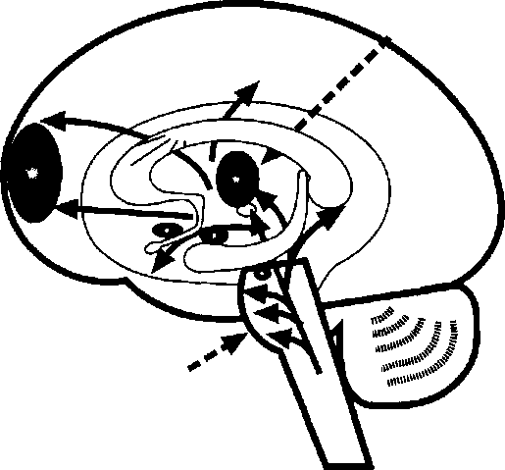
Prefrontal
cortex
Receptor sites for the molecules that trigger pleasure are distributed throughout the body but are concentrated in this "reward circuit"
Thalamus is a key the brain involved sensory input and self-reward
/
area of in
Dopamine is produced at the top of the brain stem and pushed outward

rewarded by the satisfaction of completing homework. They have learned to thrive just by surviving. The discipline strategies used by most teachers will fall short unless they understand why such students behave as they do. They will thrive when put in multiple team and cooperative roles where they can be both a leader and follower the same day. They also need emotional literacy skills in reading nonthreatening nonverbats.
From a social and educational context, rewards have already been studied and, to a large degree, rejected as a motivating strategy (Kohn 1993). But educators disagree on what constitutes a reward. A. useful definition is that rewards need two ele
ments: predictability and market value. Let’s say a teacher’s class puts on a play for the school and parents once a year. At the end of the play, the audience offers a standing ovation. The kids come off stage, and the proud teacher announces that she’s taking everyone out for pizza. Is that a reward? No, it’s a celebration. Had she said to the students right before the opening curtain, “Do well and you’ll all get pizza,” it would have been a reward. Pizza, candy, stickers, privileges, and certificates all have market value. Research suggests that students will want them each time the behavior is required, they’ll want an increasingly valuable reward, and rewards provide little or no last-
ing pleasure. Amabile (1989) has documented extensively how the use of rewards damages intrinsic motivation. While most schools know that even grades are themselves a form of rewards, only a select few have moved to a credit/no credit system.

67
Promoting Intrinsic Motivation
While it’s been fashionable to label students as “motivated" or “unmotivated,” the reality is much different. Most students are already intrinsically motivated; it’s just that the motivation is very context dependent. The same student who is lethargic in a traditional math class can become quite energetic when figuring out paycheck deductions from her first job. Thus, we can infer that we have been looking in the wrong places for motivation.
This may lead many educators to ask, “If we can’t reward positive behaviors, how do we motivate learners?" Maybe a better question to ask is, “When students are motivated, what’s going on in the brain?" Or, “What conditions are present that foster that precious inner drive?” Researchers tell us that several factors are present: compelling goals, positive beliefs, and productive emotions (Ford 1992). Any discussion about intrinsic motivation must also include the learner’s natural search and subsequent construction for meaning. Meaning will be explored in a later chapter. While neuroscientists haven’t yet figured out the biological correlates of goals and beliefs, we do know much more about the factor of emotions.
The emotions of stress and threat may either mobilize us or render us passive. On the positive side, several neurotransmitters are involved in natural, intrinsic motivation. If it’s mild, cognitive motivation, we may see increased levels of norepinephrine, or dopamine. If it’s stronger, more active
motivation, it.may be increased levels of the peptide vasopressin or adrenaline. The artificial manipulation of these chemicals often happens through medications and food. At school, teachers can do many things to encourage the release of those motivating chemicals. Figure 7.2 presents five key strategies to help students uncover their intrinsic motivation.
The first strategy is to eliminate threat. It takes time and a strong intent, but it’s worth it. Some teachers have asked students to meet in small groups to brainstorm a list of the things that inhibit their learning. The groups could then discuss how some of the problems could be alleviated. Use an anonymous class survey to ask students what would make learning more potent and enjoyable.
Second, goal-setting (with some student choice) on a daily basis can provide a more focused attitude. Prepare students for a topic with “teasers” or personal stories to prime their interest. For example, “Today we’re going to explore your body’s own highway system for the movement of nutrients, the circulatory system. The last time you got sick, this system was part of the solution to getting better.” This ensures that the content is relevant to them.
Third, influence positively in every way you can, symbolically and concretely, students’ beliefs about themselves and the learning. This includes the use of affirmations, acknowledging student successes, positive nonverbals, teamwork, or positive posters.
Fourth, manage student emotions through the productive use of rituals, drama, movement, and celebration. Teach students how to manage their own emotions, too.
Finally, feedback is one of the greatest sources of intrinsic motivation. Set up learning that stu-

Practical Alternatives to Using Rewards

Activate and Engage Positive Emotions
Drama, Music, Art Celebrations, Service Work Games/Win-Win Competition

Eliminate Threat
Uncover problems Add transition time w, Avoid demands m

Set Goals
Meaning-Making Student Choices Valid Reasons Clear Purpose

^Create Strongly W Positive Climate
Acknowlegments Rich Environment Policies/Rituals Relationship Building

Increase

Feedback
Peers/Family Projects Computers Self-Evaluation Natural Results

dents can do with endless, self-managed feedback. A computer does this perfectly, but so do well- designed projects, group work, checklists, drama, peer editing, and rubrics.

The SuperCamp Model
One academic program incorporates all five of these suggestions. Co-founded by the author (Eric Jensen) and Bobbi DePorter, SuperCamp is a 10- day academic immersion program for students aged
12-22. Many students arrive at the program with a history of chronic demotivation. Yet long-term follow-up studies suggest that after attending for just 10 days, students become insatiable learners who improve grades, school participation, and selfesteem (Dryden and Vos 1994). SuperCamp has become a model for schools around the world by demonstrating how to bring out the best in kids.
The SuperCamp staff is thoroughly trained to eliminate threat from the camp environment. They
ask the question, “What do kids experience and what is threatening to them?” As a result, it’s quite exciting to see the elimination of threat in practice. You might want to get your staff together and brainstorm factors that might contribute to threat and high stress. Some of the likely sources are threatening comments, “score keeping” discipline strategies, sarcasm, unannounced “pop” quizzes, a lack of resources, unforgiving deadlines, and cultural or language barriers.

69
Create “emotional bridges” from students’ worlds outside the classroom to the start of learning. Make the assumption (even though it won’t always be true) that your students need transition time from their personal lives to the their academic lives and from one teacher to the next. You never know what happens out in the hallways. At the start of class, students could still be reeling from an insult, a break-up with a close friend, a fight, or the loss of something valuable. Using dependable activities that trigger specific, predictable states can be the perfect way to bridge into learning. Appropriate rituals keep the stress levels low and can even eliminate threat responses.
For example, each morning at SuperCamp starts with “getting ready to learn” time. These predictable, safe rituals include a morning walk with a partner, time with teammates to discuss personal problems, reviewing the previous day’s learning, and stretching during morning physical activity. Such built-in transitions allow for the brain to change to the right chemical state needed for learning. It also allows everyone to “synchronize” their clocks to the same learning time. Follow-up studies indicate that this threat-reducing process works (DePorter and Hernacki 1992),
During the day at SuperCamp, high levels of novelty movement, and choice enrich a highly rel
evant curriculum (how to run your own brain, problem solving, conflict resolution, and learning to learn). The end of the day follows the same routine as the start, almost in reverse. Closure rituals help students put learning from the day in its new cognitive-emotional place.
You might consider arrival and beginning rituals that include music fanfare, positive greetings, special handshakes, hugs, or sharing time. Certain songs can be used to bring students back from a break and let them know it’s time to start up. (Music sure beats a bell!) Group and organizational rituals also help, such as team names, cheers, gestures, and games. Successful situational rituals include applause when learners contribute, a song to close or end something, affirmations, discussion, journal writing, cheers, self-assessment, and gestures. These opportunities to influence-the affective side of learning make a strong case for longer teaching blocks at the secondary level. This way, a teacher can practice some of these strategies and still have adequate time for content.
The SuperCamp environment provides extensive opportunities for students to get personal and academic feedback. Students usually get this feedback 10 to 20 times a day though the purposeful use of sharing time, goal setting, group work, question-and-answer time, observation of others, and journals. Teachers who specifically design their learning to have dozens of methods of learner- generated feedback—not one or two—find that motivation soars. Peer feedback is more motivating and useful than teacher feedback in getting lasting results (Druckman and Sweets 1988).
The whole issue of learned helplessness is dealt with at SuperCamp in a dramatic way Studies indicate that the best way to treat the condition is to use multiple trials of compelling or “forced”
positive choice (Peterson et al. 1993). In other words, if you always let a student do whatever he or she wants, he’ll often do nothing. At camp, the double-edge sword of strongly bonded teamwork and an Outward Bound style “ropes course” with a particular goal usually does the trick. On the allday course, students are put in the position of having to make dramatic choices. “Do I climb another step up this 50-foot ladder? Do 1 jump off this trapeze bar? Do I trust others and fall backwards into their arms?” These decisions are made over and over throughout the day. They help students realize that they do matter to others and that they can choose good decisions and get support from their team. You most likely won’t be able to use a “ropes course" with your students, but drama, goal setting, physical activities, and classroom responsibility have proven helpful.

70
Practical Suggestions
Temporary demotivation is common and should ordinarily not be considered a crisis. The causes could be many, and the solutions are fairly easy to
administer. They include better staff training in the areas of cultural awareness, learning styles, and state management, and more resources such as peer help, computers, and criteria lists. Also helpful are reduced language barriers, greater use of student choice, and elimination of any kind of embarrassment or use of sarcasm. In addition, take the time to provide more quantity, variety, and quality of feedback and encourage better nutrition. It also helps if students generate clear, well-defined goals and learn the skills of positive thinking.
Researchers are developing better tools to understand the inner workings of the motivated brain. In whole, the collected research leads us to understand that part of the problem is the way we treat students. They are not factory workers who need to be prodded, cajoled, and motivated by bribes, management, or threats. Instead of asking, “How can 1 motivate students?”, a better question would be, “In what ways is the brain naturally motivated from within?” Can you encourage better teaming this way? The answer is a definite yes, and educators around the world already are succeeding with it every day.

Emotions and Learning

Key Concepts
I The role of emotions in the thinking and learning process
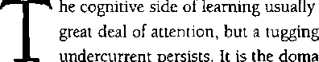
gets a
I Why use the more emotionally laced learning?
in of
emotions, the so-called affective side of learning. We all know it’s there, but it’s commonly thought
of as a distraction to learning. In fact, some still believe that learning and emotions are at opposite
» Specific strategies for emotional engagement
ends of the spectrum. It’s time for all of us to catch up on the research.
Biologically, emotions are not only very current science, but also very important science. Neuroscientists are now breaking new ground in mapping out this important learning component. The affective side of learning is the critical interplay between how we feel, act, and think. There is no separation of mind and emotions; emotions, thinking, and learning are all linked. This chapter makes the case that emotions have an important and rightful place in learning and in schools.
Western Culture and Emotions
Western culture has had a peculiar attitude about human emotion. Though we acknowledge that emotions exist, they have always held lower court,

72

Literature has portrayed the world of emotions as erratic, flighty, uncontrollable, whimsical, and even sinister. The stable, dependable, “scientific” path has been that of reason and logic.
But what if what we considered logical was actually emotional? What if it was more rational to include emotions in our thinking and decision making? For many, the mere thought is outrageous. Science is about facts, not feelings. As a result, most scientists, particularly biologists and neuroscientists, considered it professional suicide to study emotions as a serious topic. “Better left to the psychiatrists” was the prevailing view.
In fact, you might say emotions have been the black sheep of the brain family Peter Stearns says our society has gone “anti-intensity," trumpeting a new low emotionality; otherwise, you’re portrayed as being “out of control” (Atlas 1996). This view may have been brought on by the media’s portrayal of violent individuals as lacking self-discipline. But what are the scientific links between emotions and learning? Could it actually be smarter to organize learning around emotions?
Emotions Make the Mainstream
While several researchers made references to, and even did occasional studies on, emotions, no one made it a career path for the longest time. It remained that way until the mid-1980s. Then, five highly respected neuroscientists—-Joseph LeDoux of New York University Candace Pert of Georgetown University Medical Center, Jerome Kagan of Harvard, and Antonio Damasio and Hanna Damasio of the University of Iowa—emerged with important research. Each has made meaningful contributions that helped change the way we think of emotions.
Emotions drive attention, create meaning, and have their own memory pathways (LeDoux 1994). You can’t get more related to learning than that. Kagan says, “The rationalists who are convinced that feelings interfere with the most adaptive choices have the matter completely backwards. A reliance on logic alone, without the capacity to feel. . . would lead most people to do many, many more foolish things" (1994, p. 39). The old way of thinking about the brain is a separateness of mind, body and emotions. That idea’s history, Antonio Damasio reminds us; “The body . . . may constitute the indispensable frame of reference for . , . the mind” (1994, p. xvi); and in fact, “reduction in emotion may constitute an equally important source of irrational behavior” (p. 53). Emotion helps reason to focus the mind and set priorities. Many researchers now believe that emotion and reason are not opposites. For example, our logical side says, “Set a goal.” But only our emotions get us passionate enough even to care enough to act on that goal.
One of the original scholars to construct the theory of emotional intelligence, Jack Mayer believes that emotions convey information, just like data or logic. Psychology has been too atomized in the sense that it divided intelligence, motor behavior, and emotions into different areas, rather than considering the inseparable links among them (Marquis 1996, p, B-2). The popularity of the bestselling Emotional Intelligence (Goleman 1995) has raised emotions to an acceptable, if not reputable, level, Some are now calling it an entirely new discipline in neuroscience (Davidson and Sutton 1995). You never would have found this kind of scientific support for the role of emotions 10 years ago. What caused the change?
Three discoveries in the field of emotions have changed the way we think of them. First is the discovery of the physical pathways and priorities of emotions. Second are findings about the brain’s chemicals involved in emotions. Third is a link between these pathways and chemicals to everyday learning and memory

73
The first element gave emotions something “solid,” some kind of grounded reality that we could measure. It was concrete information you could see in an autopsy or on a screen. The second discovery helped us understand the pervasive nature of emotions. The third was the researcher’s jackpot; the critical link that our very survival is dependent on emotions.
The Measurement of Emotion
Neuroscientists usually separate emotions and feelings. Emotions are generated from biologically automated pathways. They are joy (pleasure), fear, surprise, disgust, anger, and sadness. Cross- cultural studies indicate that these six expressions are universal. The only emotions that researchers have found specific sites for in the brain are fear and pleasure. That’s why the earlier, biologically linked models of learning were dominated by studies on threats and rewards. Feelings are different; they’re our culturally and environmentally developed responses to circumstances. Examples include: worry, anticipation, frustration, cynicism, and optimism. Emotions are very real. When we say the emotions are involved, we have a vast array of highly specific and scientific ways to measure precisely what is happening, including skin responses, heart rate, blood pressure, and EEG activity. It’s easy to get readings on a student’s response

The Objective Nature of Emotions
We can use information from the autonomic (sweat glands, heart activity, blood pressure, and gastrointestinal); central (electrical activity of the brain’s neurons); or sensorimotor systems (respiration, eye movements, etc.) to measure emotions.
SCR... skin conductance response Pulse... heartbeats per minute
EGG... electrogastrography...gastrointestinal system measures
BP... blood pressure
SEAM... brain electrical activity mapping
SPR... skin-potential response
ERP... central nervous system, the event-related potentials
tMRI... functional magnetic resonance imaging
EEG... electroencephalography
BR... breathing rates
RCBF... regional cerebral blood flow
MT... muscle tension
HRPSA... heart rate power spectrum analysis
MEG... magnetoelectroencephalography
PET... position emission tomography blood flow measurements
SC... skin color, flushed skin to fear, but we don’t yet have a way to measure feelings of sympathy, for example. Figure 8.1 shows information we can use to measure emotions.
The Pathways of Emotion
General feeling states and intense emotions of fear and pleasure take separate biological pathways in the brain (LeDoux 1996). (Fig. 8.2 summarizes the areas of the brain involved with emotion,) While feelings travel a circuitous, slower route throughout the body the emotions always take the brain's “superhighways.” In the mid-brain area, LeDoux (1992) found a bundle of neurons that lead directly from the thalamus to the amygdala. Some

Areas of the Brain Strongly Activated by Emotions

74
Hormonal
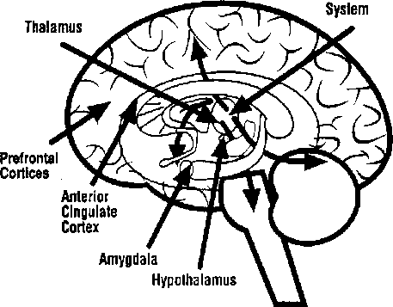

Note: Other areas of the body are also activated. See Figure 8.4.
information will get emotional priority before measured thinking takes place. Any experience that evokes threat or activates our brain’s pleasure circuits activates specific neurons that respond only to these events.
In an emergency, prolonged evaluation may cost you your life. Any life-or-death situation needs immediate resources, not reflection and contemplation. This allows us to become, as Goleman suggests, “emotionally hijacked” by our responses (1995, Chapter 2). While our emotional system is acting independently, it’s also acting cooperatively with our cortex. For example, a student who’s getting threatening looks from another student may strike back at the perceived threat before even thinking about it. The teacher’s “behavior improvement lecture" after the event usually does little to change the next “automatic" occurrence of hitting.
Students need to be taught emotional intelligence skills in a repetitive way that makes positive behaviors as automatic as negative ones. This point is particularly important because although today’s students have no saber-toothed tigers to fight off, they have equivalent threats. These include fear of embarrassment, being a failure to their peers, or getting bullied in the hallway. Their brain has adapted to treat those emotional, psychological, and physical threats as if they are life-threatening.
According to Jeff Tooby of the University of California at Santa Barbara (Marquis 1996), the expression circuitry of emotion is widely distributed in our brain. While the old model linked the entire mid-brain (the limbic system) to emotions, the amygdala, an almond-shaped structure, seems most involved. There’s no evidence that other areas of the so-called “limbic system” are heavily involved in direct emotions. That’s why the phrase “limbic system” makes no sense according to LeDoux (1996).
The amygdala has 12 to 15 distinct emotive regions on it. So far, only two, the ones linked to fear, have been identified. Other emotions may be linked to other areas. The amygdala exerts a tremendous influence on our cortex. There are more inputs from the amygdala into the cortex than the reverse. Yet, information flows both ways. The design of these feedback circuits ensures that the impact of emotions will usually be greater. It becomes the weight to all our thoughts, biases, ideas, and arguments. It is in fact an emotional flavor that animates us, not a logical one. When classroom teachers evaluate student performance, it’s all about how they feel about what they see and hear. The feelings strongly flavor the evaluation.
We call it a professional opinion, but to say there’s no emotion would be a case of serious denial.
Our emotions are our personalities and help us make most of our decisions. When researchers remove areas of the frontal lobe (the area of so- called highest intelligence), human performance in standard tests of intelligence usually drops very little. The removal is often necessary in the case of brain tumors that grow, then compress and kill nearby tissue. Generally patients can recover quite well and retain thinking skills (Damasio 1994, p. 42; Pearce 1992, p. 48). Removing the amygdala, however, is devastating. That destroys the capacities for creative play, imagination, key decision making, and the nuances of emotions that drive the arts, humor, imagination, love, music, and altruism. These are many of the qualities that we assign to those who make great contributions to our world. The genius of Quincy Jones, Martha Graham, Stephen Hawking, Eddie Murphy, and Mother Teresa are all examples of emotions driving creativity.

75
The Chemistry of Emotion
Brain chemicals are transmitted not only from the commonly cited axonal-synapse-dendrite reaction but also are dispersed to wide areas of the brain. The person who is depressed is often treated with Prozac, a medication that modulates serotonin levels. Caffeine boosts amine levels, which boosts alertness. When you experience a gut feeling, it’s because the same peptides that are released in your brain are also lining your gastrointestinal tract. Memory is regulated by acetylcholine, adrenaline, and serotonin levels.
These active chemicals are pushed out from areas such as the medulla, adrenals, kidneys, and pons. This allows the chemicals of emotions to influence most of our behaviors. These chemicals
linger and often dominate our system. That’s why once an emotion occurs, it is hard for the cortex to simply shut it off. From choosing curriculum to monitoring the lunchroom, how we feel is usually how we act (fig. 8.3). The old paradigm was that our brain was managed by the physical connections made at the site of the synapse. But the newer, emerging understanding is that messenger molecules known as peptides are not only distributed throughout the brain and body, but exert a far greater influence on our behaviors than previously thought. Miles Herkenham of the National Institute of Mental Health says that 98 percent of all communication within the body may be through these peptide messengers (in Pert 1997, p. 139). This view implies a far greater role for the understanding and integration of emotions in learning.
The reason these states are so powerful is because they are produced and modulated throughout the body. Every cell has countless receptor sites on it for receiving information from other areas of the body; the bloodstream is the body’s second nervous system! Figure 8.4 shows how ligands (the peptide messenger molecules) fit into receptor sites, transfer their information, and a new cell behavior begins. Multiply that by millions of cells, and a student simply feels differently.
Emotions as Mind-Body States
Emotions affect student behavior because they create distinct, mind-body states. A state is a moment composed of a specific posture, breathing rate, and chemical balance in the body. The presence or absence of norepinephrine, vasopressin, testosterone, serotonin, progesterone, dopamine, and dozens of other chemicals dramatically alters your frame of mind and body. How important are states

76

The Chemical Influences on Attention and Behavior

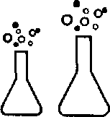

;:i::
Serotonin
"the brakes'¹
♦

High-Level Risks
- tearfulness
- obsessive-compulsive
- low self-confidence
- withheld aggression

Low-Level Risks
- depression
- impulsive aggression
- alcoholism
- explosive rage
- suicide
Noradrenaline
the gas pedal"
t

High-Level Risks
- overarousal
- rapid pulse
- increased likelihood of impulsive violence

Low-Level Risks
- underarousal •thrill-seeking
- risk-taking
- increased likelihood of cold-blooded violence

Note: The levels indicated are high or low compared to the norm. Generally, males have 20-40% lower serotonin levels than females. Human behavior is complex, and there are other influencing factors besides chemical imbalances.

to us? They are all that we have; they are our feelings, desires, memories, and motivations. A change of state is what your students use money for: They buy food to get out of the hunger state and buy Nike shoes to feel more confident or to be liked by classmates. They even buy drugs to change their
state, either to feel better or to simply feel something. Educators need to pay attention to this. Teachers who help their students feel good about learning through classroom success, friendships, and celebrations are doing the very things the student brain craves.

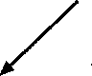
How Emotions Influence the Learner: They Are the Body’s Second Nervous System
Chemical Messengers Central Nervous System
(Peptides to Receptor Sites) (Axon-Synapse-Dendrites)
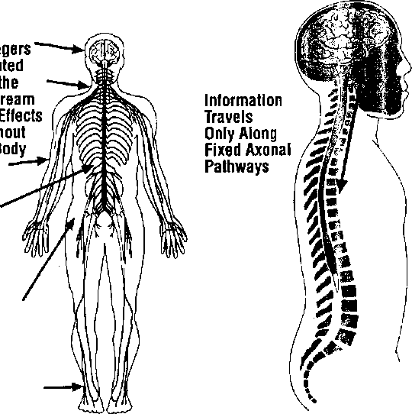
Messen Distribu Within 1
Feeling states powerfully influence the learner's meaning-making, motivation, everyday behavior, and cognition. As an example, even if you like to go out dancing, if you’re tired, you might pass on the opportunity.
Copyright © 1989-97 by Techpool Studios, Inc., USA.
more like a gland than a computer It produces hormones, is bathed in them, and is run by them.
Neurosurgeon Richard Bergland says, [Tihought is not caged in the brain but is scat-
tered all over the body” (Restak 1993, p. 207). He Emotions trigger the chemical changes that alter
adds that he has little doubt the brain operates our moods, behaviors, and, eventually, our lives. If

78

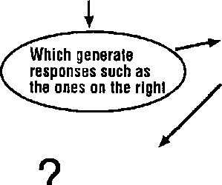
/'Fear Anger Surprise Disgust Sadness Joy
Anticipation
CjHttMftK
Optimism
Confidence
Frustration
Confusion
people and activities are the content in our lives, emotions are both the contexts and the values we hold. We simply cannot run a school without acknowledging emotions and integrating them into daily operations. Many schools do this already They have pep rallies, guest speakers, poetry readings, community service efforts, storytelling, debates, clubs, sports, and dramatic arts.
Emotions, Learning, and Memory
For years we’ve been brainwashed into thinking it’s our frontal lobes that give us our brilliant, “best of humanity” thoughts. While the frontal lobes allow us to elaborate on the details of our goals and plans, it’s emotions that generate them and drive their execution in our lives (Freeman 1995, p. 89). That’s why it’s important to ask students to explain why they want to reach the goals they set. You might say, “Write down three good reasons why reaching your goals is important to you.” Then, have the students share their responses with others. The reasons are the emotions behind the goals and the source of the energy to accomplish them (see fig. 8.5).
Emotions are a distillation of learned wisdom; the critical survival lessons of life are emotionally hardwired into our DNA. We have been biologically shaped to be fearful, worried, surprised, suspicious, joyful, and relieved, almost on cue. We must cease the long-standing habit of thinking of emotions as always irrational or having nothing to do with the ways we think, hmotions are a critical source of information for learning (LeDoux 1993). What if you ignored your feelings every time you did something dangerous or ill-advised? If you feel frustrated and tell off your boss, you might jeopardize your career very quickly: Fortunately, feelings

How Emotional States Affect Learning

^{r} Generate Emotions
\ -
Which
Generate
Thoughts,
Opinions,
Decisions

Which strongly influence whether a student will be motivated to take action or not
of guilt or remorse are likely to prevent that. Students who feel tentative or afraid to speak in front of their peers are that way for a “logical” reason: to fail may cost them significant social status.
Making daily decisions based on emotions is not ah exception; it's the rule. While extremes of emotion are usually harmful to our best thinking, a middle ground makes sense. Appropriate emotions speed up decision making enormously (Damasio 1994). If you’re asked to join a colleague for lunch, you’ll make your decision based on quick gut feel-

79

ings; yes or no. To gather sufficient information might be rude or time consuming. Where are we going for lunch? What’s the food like? Who else will be there? What’s the agenda? Who’s paying? Will it be fun? Who’s driving? Is the car safe?
When will we be back? Is' there a better offer? It’s far more useful, most of the time, to have a feeling about what to do next, then do it.
Emotions not only help us make better decisions faster, but we make better quality, value-based decisions. In fact, we make thousands of micro-decisions daily that shape our character as either on time or late, honest or sleazy gossipy or noble, creative or unimaginative, and generous or stingy Each of those decisions is made with a guiding hand—our values. All values are simply emotional states. If my value is honesty, then I feel badly when I’m dishonest. Conversely 1 feel good when I do honest things. In a sense, our character is shaped by the conscience of our emotions. While too much or too little emotion is usually counterproductive, our everyday normal emotions are an important part of living.
While all of us acknowledge that we have emotions, few of us realize that they are not the cards at the game table but the table itself. Everything we experience has an emotional tone to it, from calm to rage, from pain to pleasure, and from relaxed to threatened. And, because emotions mediate our meaning, our emotions are, in fact, the framework for our day. Every day how our day goes is how our emotions go. Even if you use a logic-driven rubric to evaluate every student’s project, emotions still rule. On a bad day, your feelings about certain students or a particular rating criteria will lead you to rate one project as more creative, another as more organized, another as meeting the standards, and another as inadequate.
In addition, we remember that which is most emotionally laden. That happens because all emotional events receive preferential processing (Christianson 1992) and the brain is overstimulated when strong emotions are present. Emotions give us a more activated and chemically stimulated brain, which helps us recall things better. The more intense the amygdala arousal, the stronger the imprint (Cahill, Prins, Weber, and McGaugh 1994), says Goleman (1995). In fact, Larry Squire—a neurobiologist and memory expert at the University of California at San Diego—says that emotions are so important, they have their own memory pathways. James McGaugh, a neurobiologist at the University of California at Irvine, and fellow researchers agree. When emotions are suppressed or expressed in inappropriate ways, we get discipline problems. As teachers, we can purposely engage productive emotions. It’s common for students to remember the death of a friend, a field trip, or a hands-on science experiment far longer than most lectures. Good learning does not avoid emotions, it embraces them.
Emotions researcher and prize-winning neuroscientist Candace Pert of Georgetown University Medical Center says that “when emotions are expressed . . . all systems are united and made whole. When emotions are repressed, denied, not allowed to be whatever they may be, our network pathways get blocked, stopping the (low of the vital feel-good unifying chemicals that run both our biology and our behavior” (Pert 1997, p. 273).
Practical Strategies
Triggering emotions randomly is counterproductive. In addition, extremes of emotion are generally counterproductive to school goals. A lack of emo-

80

tion is just as dangerous as uncontrollable emotion. The old adage was, “First, get control of the students, then do the teaching.” Today, neuroscientists might tell you to engage emotions appropriately at every chance you get. Engage emotions as a part of the learning, not as an add-on. You may have already used music, games, drama, or storytelling to engage emotions. Here are five more simple ways.

Role Model
Teachers ought to simply model the love of learning, and they should show enthusiasm about their job. For example, bring something with great excitement to class. Build suspense, smile, tell a true emotional story, show off a new CD, read a book, or bring an animal. Get involved in community work whether it's for a holiday disaster relief, or ongoing service. Let students know what excites you.

Celebrations
Use acknowledgments, parties, high-fives, food, music, and fun. A celebration can show off student work in different ways, For example, when students are finished mind-mapping something, ask them to get up and show their poster-sized mind- map to eight other pairs of students. The goal is to find at least two things they like about it. As they carry around their mind-map, they point out things to students and they learn from their classmates. Play some celebration music, and everyone has a good time. Ideally celebrations will be made “institutional" so students celebrate without a teacher prompt every time.

A Controversy
Setting up a controversy could involve a debate, dialogue, or an argument. Any time you've got two
sides, a vested interest, and the means to express opinions, you’ll get action! Have students prioritize a list by consensus, and you’ll get emotions. Afterward, split up sides for a tug-of-war outside. Research indicates that when emotions are engaged right after a learning experience, the memories are much more likely to be recalled and accuracy goes up (McGaugh, Cahill, Parent, Mesches, Coleman- Mesches, and Salinas 1995). The debate could be in pairs of students, or turn it into an academic decathlon or game show. Theater and drama can create strong emotions: the bigger the production, the higher the stakes, the more the emotions engaged. For example, if your group volunteers to put on a schoolwide play, there are rehearsals, stress, fun, anxiety, anticipation, suspense, excitement, and relief.

Purposeful Use of Physical Rituals
Rituals in your class can instantly engage learners. Those rituals could include clapping patterns, cheers, chants, movements, or a song. Use these to announce arrival, departure, a celebration, and getting started on a project. Make the ritual fun and quick, and change it weekly to prevent boredom. Each time teams complete their tasks, they could give a team cheer. Or they could have a special cheer for each member upon arrival and another for the close of the day. Obviously, rituals should be age appropriate.

Introspection
The use of journals, discussion, sharing, stories, and reflection about things, people, and issues engages students personally If there is a disaster in the news, ask students to write or talk about it. Current events or personal dramas work well, too.

81

If appropriate, students can share their thoughts with a neighbor or peer groups. Help students make personal connections to the work they do in class. For example, if students are writing journals, have them read "Letters to the Editor” in a local newspaper and discuss or even critique them. Students can choose an issue they are passionate about and submit letters to be printed.
Good learning engages feelings. Far from an add-on, emotions are a form of learning. Our emotions are the genetically refined result of life
times of wisdom. We have learned what to love, when and how to care, whom to trust, the loss of esteem, the exhilaration of success, the joy of discovery, and the fear of failure. This learning is just as critical as any other part of education. Many activities have powerful lifelong effects, yet there are few results to show on a daily scorecard. Emotions encompass one such area. Research supports the value of engaging appropriate emotions. They are an integral and invaluable part of every child's education.

Movement and Learning

Key Concepts
I The mind-body link
In times of diminishing financial resources, educators must make hard choices. Do dance, theater, and physical education belong in the budget? Are they frills or fundamentals? What exactly does brain research tell us about the relationship between the body and mind?
For years it seemed that the educational and scientific communities believed that thinking was thinking and movement was movement, and never the twain would meet. Maverick scientists envisioned links between thinking and movement for decades—but with little public support. Today we know better. This chapter reveals the strong links between physical education, the arts, and learning.
I What does research say about the links between movement and cognition?
I Physical states; how does
our body actually learn?
> The specific roles for movement, the arts, and physical education
k Why movement makes sense

Mind and Body
If we want to address drug education, second languages, diversity education, multiple intelligences, improving reading scores, reducing dropouts, encouraging girls in math and science, thematic instruction, and AIDS education, that’s great. But what will we eliminate to make time for those things? Anything deemed a frill is likely to go first. For some short-sighted officials, that means physi-

83

I?
is
i t
it ■’
■
!
cal education. Recent brain research tells us that’s a mistake.
Part of the reason for the outdated separation of mind and body comes from simple observation. If the brain is in the head and the body is below the head, how could there be any links? What would happen if the cerebellum, an area most commonly linked to movement, turned out to be a -virtual switchboard of cognitive activity? The first evidence of a linkage between mind and body originated decades ago with Henrietta Leiner and Alan Leiner, two Stanford University neuroscientists. Their research began what would eventually redraw “the cognitive map” (S. Richardson 1996).
The Leiners’ work centered on the cerebellum, and they made some critical discoveries that spurred years of fruitful research. First, the cerebellum takes up just one-tenth of the brain by volume, but it contains over half of all its neurons. It has some 40 million nerve fibers, 40 times more than even the highly complex optical tract. Those fibers not only feed information from the cortex to the cerebellum, but they feed them back to the cortex. If this was only for motor function, why are the connections so powerfully distributed in both directions to all areas of the brain? In other words, this subsection of the brain—long known for its role in posture, coordination, balance, and movement—may be our brain’s sleeping giant. (Fig. 9.1 shows the location of key areas of the brain involved in movement.)
In the past, the cerebellum was thought to merely process signals from the cerebrum and send them to the motor cortex. The mistake was in assuming the signals went only to the motor cortex. They don’t (S. Richardson 1996, p. 100). The last place information is processed in the cerebellum,

Location of Key Brain Areas Involved in Movement
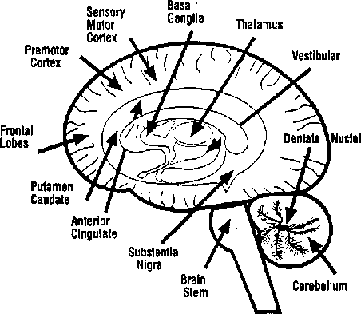

before it is sent to the cortex, is the dentate nucleus. Though the dentate nucleus is missing in most mammals, it is largest in primates with the highest learning capabilities. A smaller area, the neodentate nucleus is present only in humans and may have a significant role in thinking. Neurologist Robert Dow of Portland, Oregon, was one of the first to make the links. One of his patients had cerebellar damage and—surprisingly—impaired cognitive function (S. Richardson 1996, p. 102). Suddenly, linking movement and thinking became inescapable.
just how important is movement to learning? Ask neurophysiologist Carla Hannaford and she’ll spend all day telling you. She says the vestibular (inner ear) and cerebellar system (motor activity) is the first sensory system to mature. In-this system, the inner ear’s semicircular canals and the vestibular nuclei are an information gathering and
feedback source for movements. Those impulses travel through nerve tracts back and forth from the cerebellum to the rest of the brain, including the visual system and the sensory cortex. The vestibular nuclei are closely modulated by the cerebellum and also activate the reticular activating system (RAS), near the top of the brain stem. This area is critical to our attentional system, since it regulates Incoming sensory data. This interaction helps us keep our balance, turn thinking into actions, and coordinate moves. That’s why there’s value in playground games that stimulate inner ear motion like swinging, rolling, and jumping.

84
Peter Strick at the Veteran Affairs Medical Center of Syracuse, New York, made another link. His staff has traced a pathway from the cerebellum back to parts of the brain involved in memory, attention, and spatial perception. Amazingly, the part of the brain that processes movement is the same part of the brain that’s processing learning.
Here’s another example. Neuroscientist Eric Courchesne of the University of California at San Diego says autism may be related to cerebellar deficits (L. Richardson 1996). His brain-imaging studies have shown that autistic children have smaller cerebellums and fewer cerebellar neurons. He also has linked cerebellar deficits with impaired ability to shift attention quickly from one task to another. He says the cerebellum filters and integrates floods of incoming data in sophisticated ways that allow for complex decision making.
Once again, the part of the brain known to control movement is involved in learning. Surprisingly, there is no single “movement center" in our brain (Greenfield 1995). Movement and learning have constant interplay.
In Philadelphia, Glen Doman has had spectacular success with autistic and brain-damaged chil
dren by using intense sensory integration therapy. Over the years, many teachers who integrated productive “play" into their curriculum found that learning came easier to students.
At the 1995 Annual Society of Neuroscience Conference, W.T. Thatch Jr. chaired one of the most well-attended symposiums: “What Is the Specific Role of the Cerebellum in Cognition?’’
He’s a researcher at the Washington University School of Medicine who’s been pulling together data for years. The 800 attendees listened carefully as the panel made a collective assault on a neuroscience community blinded by years of prejudice. Nearly 80 studies were mentioned that suggest strong links between the cerebellum and memory, spatial perception, language, attention, emotion, nonverbal cues, and even decision making. These findings strongly implicate the value of physical education, movement, and games in boosting cognition.
Motor Development and Learning
There is, in fact, substantial biological, clinical, and classroom research that supports this conclusion. The area known as the anterior cingulate is particularly active when novel movements or new combinations are initiated. This particular area seems to tie some movements to learning. Prescott’s early studies (1977) indicate that if our movements are impaired, the cerebellum and its connections to other areas of the brain are compromised. He says the cerebellum also is involved in “complex emotional behavior" (emotional intelligence). His rat experiments bear out his conclusions. Rats with cerebellar deficits did worse on maze testing.
Our brain creates movements by sending a deluge of nerve impulses to either the muscles or

85

the larynx. Because each muscle has to get the message at a slightly different time, it’s a bit like a well-timed explosion created by a special effects team. This amazing brain-body sequence is often referred to as a spatiotemporal (space-time) pattern. Researcher William Calvin calls it a cerebral code. While simple movements like gum chewing are controlled by basic brain circuits nearest the spinal cord, complex movement—like dance steps, throwing a ball, or doing a science experiment—is quite different. Some simple movements, like those with sequences, are controlled at the subcortical levels, like the basil ganglia and cerebellum. But novel movements shift focus in the brain because it has no memories to rely on for execution. Suddenly we engage the prefrontal cortex and the rear two-thirds of the frontal lobes, particularly the dorsolateral frontal lobes. This is an area of the brain often used for problem solving, planning, and sequencing new things to learn and do (Calvin 1996).
Many researchers (Houston 1982, Ayers 1972, Hanna ford 1995) verify that sensory motor integration is fundamental to school readiness. In a study done in Seattle, Washington, 3rd grade students studied language arts concepts through dance activities. Although the districtwide reading scores showed a decrease of 2 percent, the students involved in the dance activities boosted their reading scores by 13 percent in 6 months (Gilbert 1977). A complete routine included spinning, crawling, rolling, rocking, tumbling, pointing, and matching. Lyellc Palmer of Winona State University has documented significant gains in attention and reading from these stimulating activities (Palmer 1980). While many educators know of this connection, nearly as many dismiss the connection once children pass 1st or 2nd grade. Research sug
gests the relationship between movement and learning continues throughout life. The drama class at Garfield High School in Los Angeles gives students new hope for life skills success. The sensory-motor skills learned as children, through both play and orchestrated school activities, mean the proper neural pathways have been laid (Miller and Melamed 1989).
How critical is early movement? There may be a link between violence and lack of movement. Infants deprived of stimulation from touch and physical activities may not develop the movement- pleasure link in the brain. Fewer connections are made between the cerebellum and the brain’s pleasure centers. Such a child may grow up unable to experience pleasure through usual channels of pleasurable activity. As a result, the need for intense states, one of which is violence, may develop (Kotulak 1996). W'ith sufficient supply of the needed “drug” of movement, the child is fine. Deprive him or her of it, and you get problems.
Physical Education and Learning
An astonishingly high 64 percent of K-12 American students do not participate in a daily physical education program (Brink 1995). In William Gree- nough’s experiments at the University of Illinois, rats who exercised in enriched environments had a greater number of connections among neurons than those who didn’t. They also had more capillaries around the brain’s neurons than the sedentary rats (Greenough and Anderson 1991). In the same way that exercise shapes up the muscles, heart, lungs, and bones, it also strengthens the basal ganglia, cerebellum, and corpus callosum, all key areas of the brain. We know exercise fuels the brain with oxygen, but it also feeds it neurotropins

86

(high-nutrient food) to enhance growth and greater connections between neurons. Aerobic conditioning also has been known to assist in memory (Brink 1995). Figure 9.2 illustrates the key pathways between movement and learning.
Researchers James Pollatschek and Frank Hagen say, "Children engaged in daily physical education show superior motor fitness, academic performance and attitude toward school as compared to their counterparts who do not participate in daily physical education” (1996, p, 2). Aerobic and other forms oi “toughening exercises” can have enduring mental benefits. The secret is that
jmm

Neural Relationships Between Movement and Learning
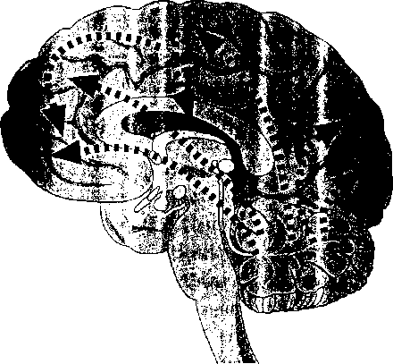

Projections of axons are far greater from areas associated with the storage and production of movement to areas of cognition than the reverse. This suggests that movement may influence cognition more than earlier believed.
Copyright © 1989-97 by Techpool Studios, Inc., USA.
physical exercise alone appears to train a quick adrenaline-noradrenaline response and rapid recovery. In ether words, by working out your body, you’ll better prepare your brain to respond to challenges rapidly. Moderate amounts of exercise, 3 times a week, 20 minutes a day, can have very beneficial effects,
Neuroscientists at the University of California at Irvine discovered that exercise triggers the release of BDNF, a brain-derived neurotrophic factor (Kinoshita 1997). This natural substance enhances cognition by boosting the ability of neurons to communicate with one another. At Scripps College in Claremont, California, 124 subjects were divided equally into exercisers and nonexercisers. Those who exercised 75 minutes a week demonstrated quicker reac: ions, thought better, and remembered more (Michaud and Wild 1991). Because studies suggest that exercise can reduce stress, there's a fringe benefit too. Chronic stress releases the chemicals that kill neurons in the critical area of the brain for long-term memory formation, the hippocampus. Brink (1995) says that physical exercise is still one of the best ways to stimulate the brain and learning (Kempermaun, Kuhn, and Gage 1997).
There’s other evidence for the potency of physical movement. We know that much of the brain is involved in complex movements and physical exercise—it’s not just “muscle work.” In fact, depending on the type of workout, the part of the brain involved in almost all learning, the cerebellum, is in high gear (Middleton and Strick 1994). In a Canadian study with more than 500 school- children, those who spent an extra hour each day in a gym class far outperformed at exam time those who didn’t exercise (Hannaford 1995). Dustman’s research (Michaud and Wild 1991) revealed that

87

among three test groups, the one that had the vigorous aerobic exercise improved snort-term memory, reaction time, and creativity. All K-12 students need 30 minutes a day of physical movement to stimulate the brain, says the President’s Council on Fitness and Sports. The Vanves and Blanshard projects in Canada revealed something even more dramatic. When physical education time was increased to one-third of the school day, academic scores went up (Martens 1982).
The Movement Arts
Three countries near the top in rar kings of math and science scores (japan, Hungary, and Netherlands) all have intensive music and art training built into their elementary curriculums. In Japan, every child is required to play a musical instrument or be involved in choir, sculpture, and design. Teaching students art also has been linked to better visual thinking, problem solving, language, and creativity (Simmons 1995). Many studies suggest that students will boost academic learning from games and so-called “play" activities (Silverman 1993). The case for doing something physical every day is growing. Jenry Seham of the National Dance Institute (NDI) in New York City says she has observed for years the measurable and heartwarming academic and social results of schoolchildren who study dance. Seham bubbles with enthusiasm over positive charges in self- discipline, grades, and sense of purpose in life that her students demonstrate. She’s new in the process of quantifying the results of over 1.500 kids who dance weekly at NDI.
Researchers know certain movements stimulate the inner ear. That helps physical balance, motor
coordination, and stabilization of images on the retina. David Clarke at Ohio State University’s College of Medicine has confirmed the positive results of a particular type of activ ity—spinning (1980). With merry-go-rounds and swings disappearing from parks and playgrounds as fast as liability costs go up, there’s a new worry: more learning disabilities. Clarke’s studies suggest that certain spinning activities led to alertness, attention, and relaxation in the classroom. Students who tip back on two legs of their chairs in class often are stimulating their brain with a rocking, vestibular- activating motion. While i: s an unsafe activity, it happens to be good for the brain, We ought to give students activities that let mem move safely more often like role plays, skits, stretching, or even games like musical chairs.
Give a school daily dance, music, drama, and visual art instruction in which there is considerable movement, and you might get a miracle. In Aiken, South Carolina, Redcliffe Elementary test scores were among the lowest 25 percent in the district. After a strong' arts curriculum was added, the school soared to the top 5 percent in 6 years (enough for the students to progress from 1st through 6th grade). This Title 1 rural school with a 42 percent minority student base showed that a strong arts curriculum is ai the creative core of academic excellence—not more discipline, higher standards, or the three Rs (Kearney 1996).
Arthur Stone of the State University of New York at Stony Brook says having fun may be good for your health. It decreases stress and improves the functioning of the immune system for three days after the fun. Most kids enjoy, dance, arts, and games. It’s not just good for the brain, it feels good, too. Through primate experiments, neurophysiolo-

88

gists James Prescott and Robert Heath found that there’s a direct link from the cerebellum to the pleasure centers in the emotional system (Hooper and Teresi 1986). Kids who enjoy playground games do so lor a good reason; Sensory-mo tor experiences feed directly into their brains’ pleasure centers. This is not of trivial importance; enjoying school keeps students coming back year after year.
Practical Suggestions
Today’s brain, mind, and body research establishes significant links between movement and learning. Educators ought to be purposeful about integrating movement activities into everyday learning. This includes much more than hands-on activities. It means daily stretching, walks, dan me, theater, drama, seat-changing, energizers, and physical education. The whole notion of using only logical thinking in a mathematics class flies in the face of current brain research. Brain-compatible learning means that educators should weave math, movement, geography social skills, role play, science, and physical education together. In fact, Larry Abraham in the Department of Kinesiology at the University of Texas at Austin, says, “Classroom teachers should have kids move for the same reason that PE. teachers have had kies count” (1997). Physical education, movement, drama, and the arts can all be one continual theme. Don’t wait for a special event.
Here are examp.es of easy-to-use strategies.

Goal Setting on the Move
Start class with an activity where everyone pairs up. Students can charade or mime their goals to a partner or go for a short walk while setting goals. Ask them to answer three focusing questions such as
- What are my goals for today and this year?
- What do I need to do today and this week in this class to reach my goals?
- Why is it important for me to reach my goals today?
You can invent any questions you want or ask students to create some, too.

Drama, Theater, and Role Plays
Get your class used to daily or at least weekly role plays. Have students do charades to review main ideas. Students can organize extemporaneous pantomime to dramatize a key point. Do one-minute commercials adapted from television to advertise upcoming content or review past content.

Energizers
Use the body to measure things around the room and report the results. For example, “This cabinet is 99 knuckles long.” Play a Si mon-Says game with content built into the game: “Simon says point to the South. Simon says point to five different sources of information in this room.” Do team jigsaw processes with huge, poster-sized mind-maps. Get up and touch, around the room, seven colors in order on seven different objects. Teach a move- around system using memory cue words. For example, “Stand in the room where we first learned about. . .
Ball toss games can be used for review, vocabulary building, storytelling, or self-disclosure. Students can rewrite lyrics to familiar songs in pairs or on a team. The new words to the song are a content review; then they perform the song with choreography,
Get physical in other ways, too. Play a tug-of- war game where everyone chooses a partner and a

89

topic from a list t person forms an r is for each studeri onds why his or i the verbal debate, giant tug of war ft ners are on oppo^{r}
. all have been learning. Each nion about the topic. The goal convince a partner in 30 sec- . , :uc is more important. After e pairs form two teams for a a physical challenge. All part- ' sides,

Cross-Laterals
Learn and use an,, and leg crossover activities that can force both brain hemispheres to “talk" to each other better. "Pat head and rub your belly” is an example of a c ever. Other examples include marching in place hiic patting opposite knees, patting yourself on the opposite shoulder, and touching opposite elbows or heels. Several books highlight these ac ities, including Brain Gym by Paul Dennison ar, :. ivirt Moves and The Dominance Factor by ( .a i lannaford.

Stretching
To open class, or :ytime that you need some more oxygen, gei eryone up to do some slow stretching. Ask students to lead the group as a whole or let teams do their own stretching. Allow learners more mobility in the classroom during specific times. C. - them errands, make a jump rope available, or simply let them walk around the back of the class as long as they do not disturb other students.
In general, you need to do all that you can to support physical education, the arts, and movement activities in your classroom. Make it a point
to stand up for these activities in your school and district, too.
We are in a time when many children don’t participate in physical education. Budget cuts often target the arts and physical education as “frills.” That’s a shame because there’s good evidence that these activities make school interesting to many students and the}- car. help boost academic performance. “Physical activity is essential in promoting normal growth ol. mental function,” says Donald Kirkendall (Pollatschek and Hagen 1996, p. 2). Carla Hannaford says, “Arts and athletics are not frills. They constitute powerful wavs of thinking, and skilled ways of communicating with the world. They deserve a greater, not lessor portion of school time and budgets” (1995. p. 88).
While it’s counterproductive to make it more important than school itself, movement must become as honorable and important as so-called “book work.” We need to better allocate our resources in ways that harness the hidden power of movement, activities, and sports. Norman Weinberger, a scientist in the Department of the Neurobiology of Learning and Memory at the University of California at Irvine, says, “Arts education facilitates language development, enhances creativity, boosts reading readiness, helps social development, general intellectual achievement, and fosters positive attitudes towards school” (1995, p. 6). This attitude has become more and more prevalent among scientists who study the brain. It’s time for educators to catch on.

The Brain as a Meaning-Maker
Key Concepts
ft The natural mechanisms of making meaning

When students say, “School is boring,” part of the comment reflects a common adolescent feeling. Yet there’s more to it: Learners want school to be worthwhile and meaningful. With so many different personalities, cultures, and types of students, how can school be meaningful for everyone? The theme of this chapter is that you can make learning richer and more appealing by purposely arranging the conditions For greater meaning.
!]■
The Search for Meaning
► Three Ingredients for optimal learning
i How to encourage these three ingredients

Traditionally, schools were a social arena and a delivery system for information. There wasn’t much thought about whether the information was meaningful or not. The Information Age changed all that. While a 1950s learner was exposed to a few textbooks, three network television channels, some novels, and several magazines, today it’s very different. The sheer volume of accessible information makes us recoil. Hundreds of television channels and multitudes of magazines and books are readily available, There are thousands of Web sites, countless Internet contacts, e-mail, faxes, cell phones,
'3 v

